Encircle OMS Design Document

Hold:

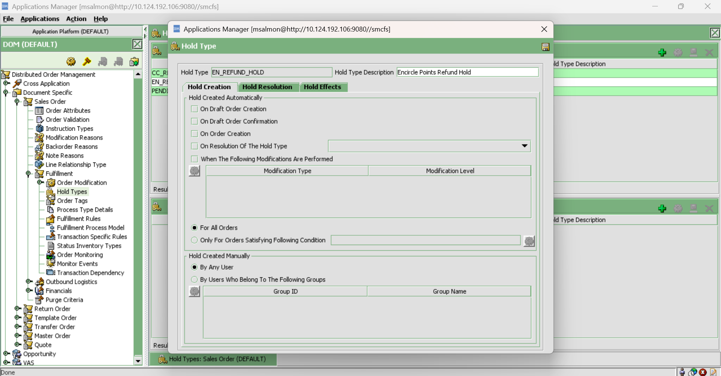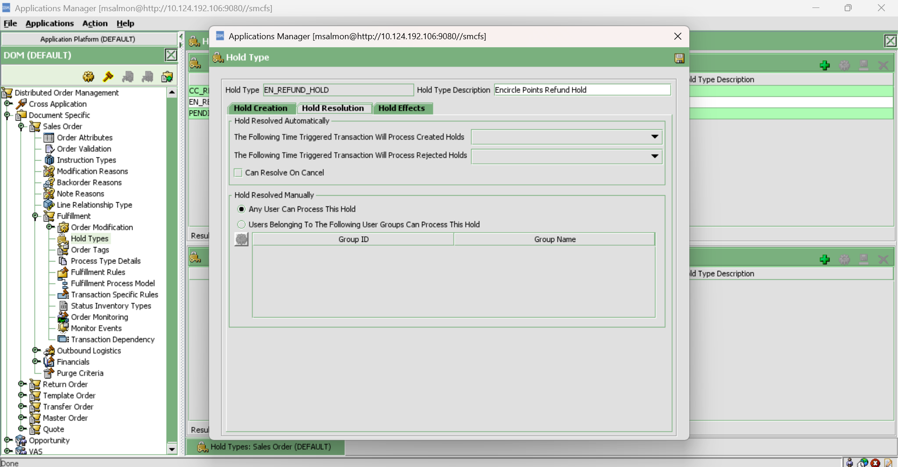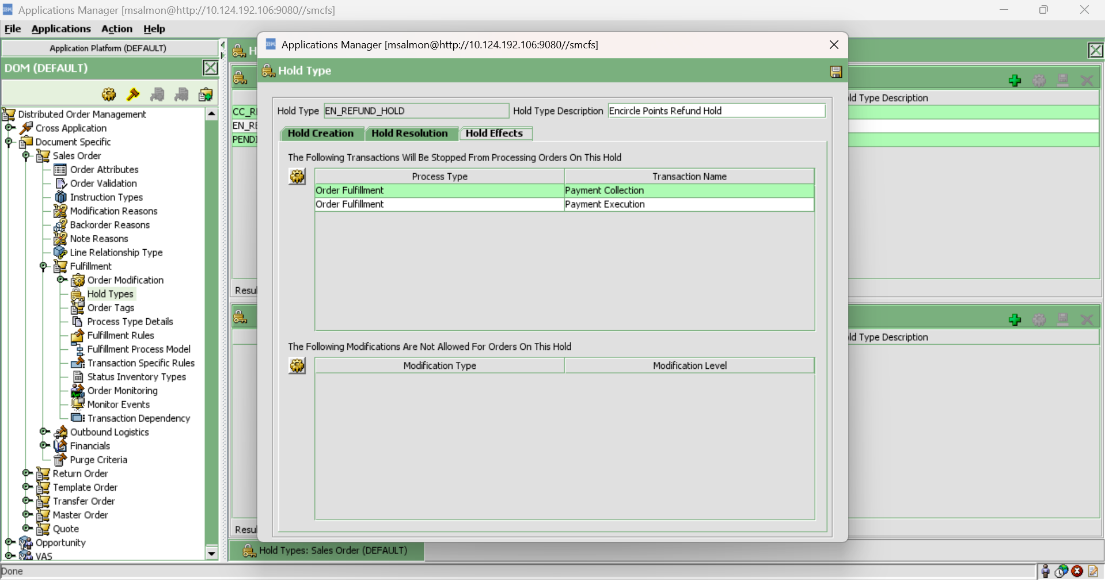

Encircle reversal configurations:

Order Fullfillment -> Change Order -> On Cancel -> IBD_CancelOrder ->

IBD_PostCancelMsg

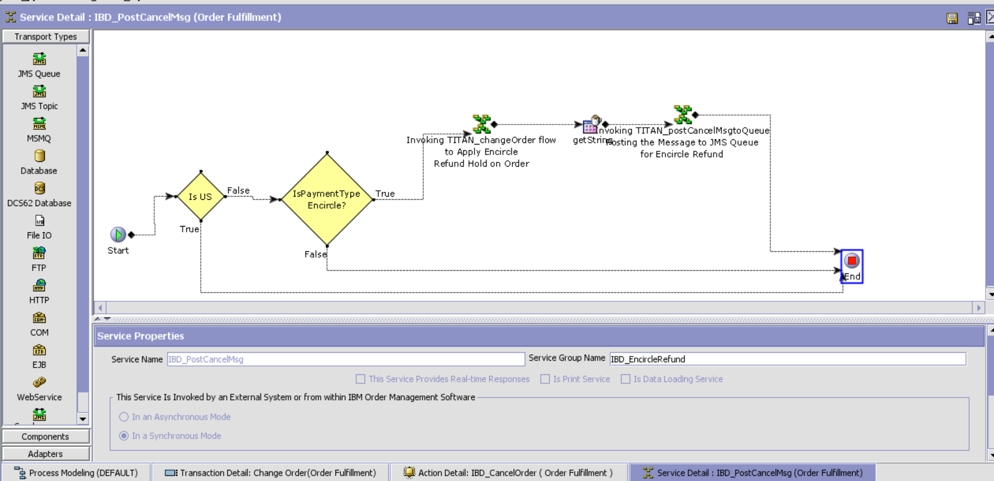

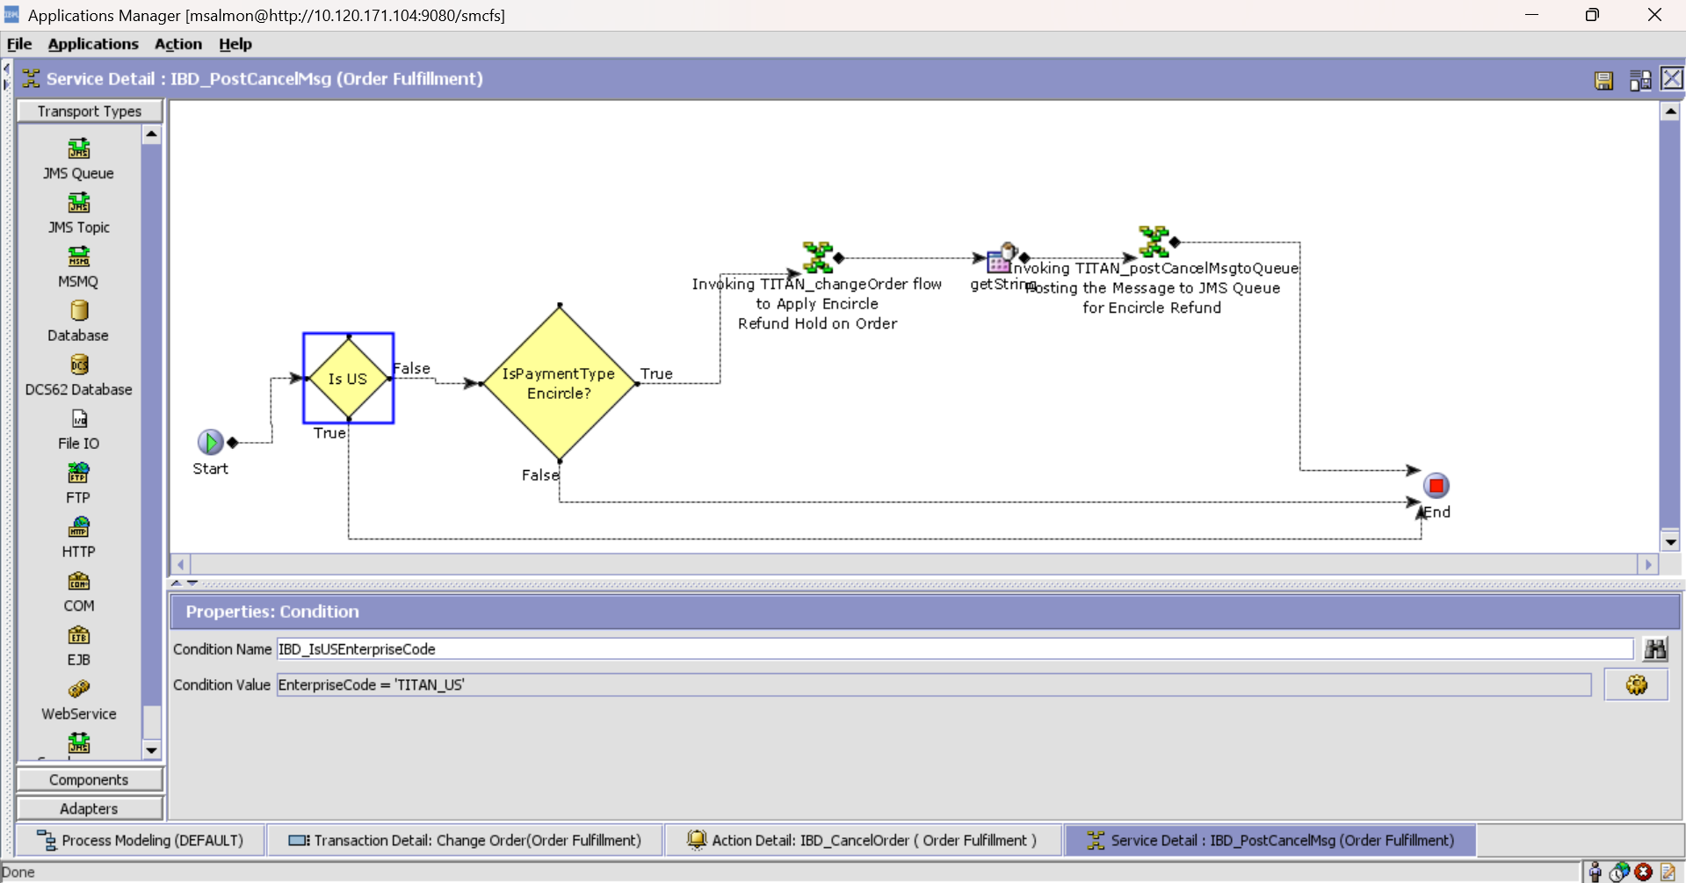

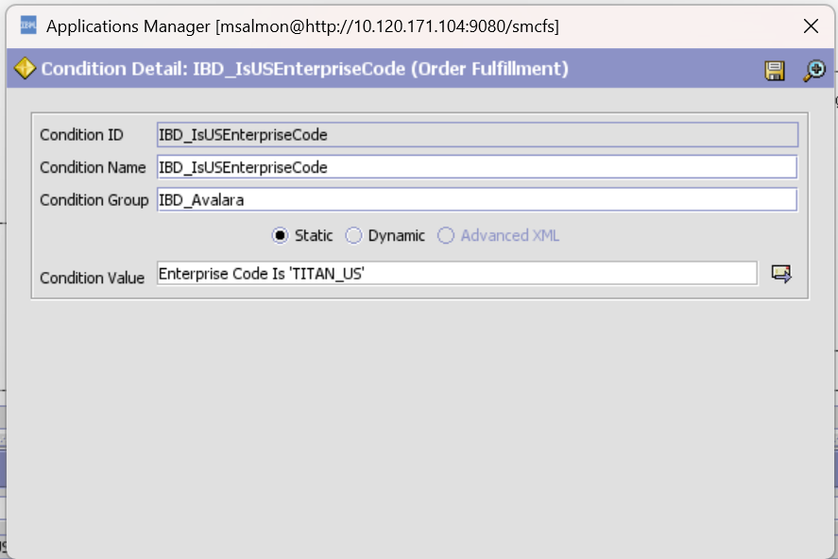

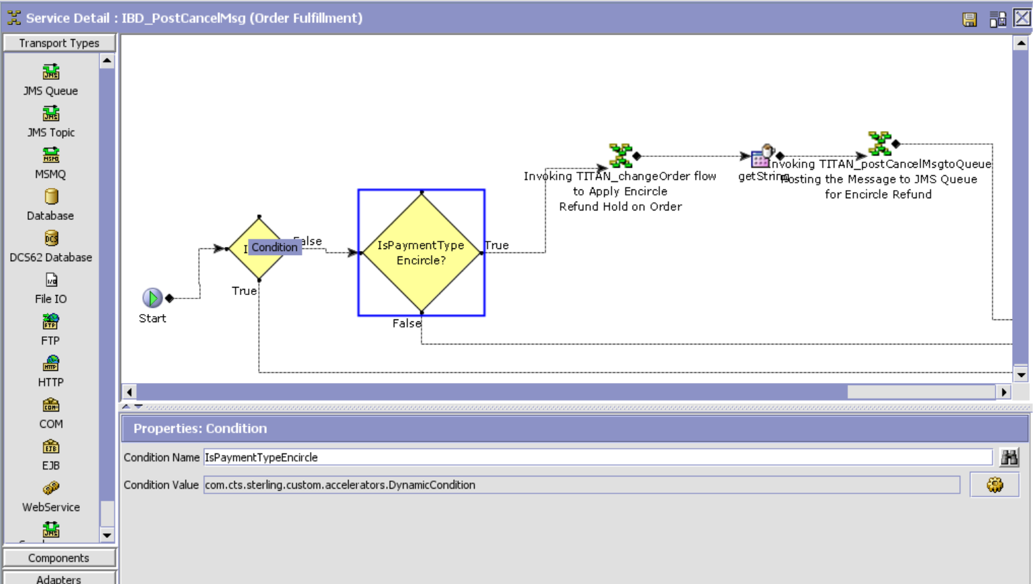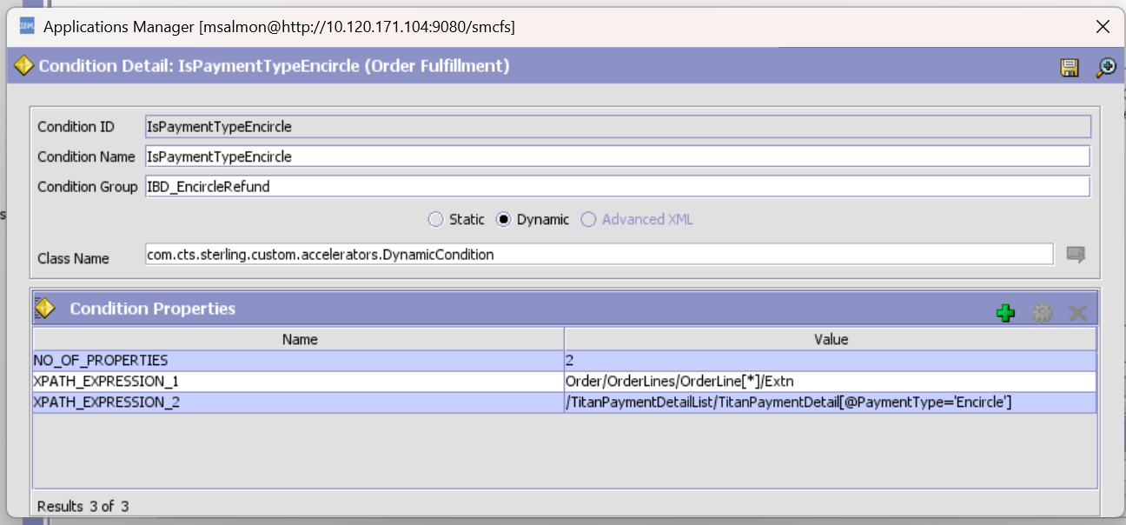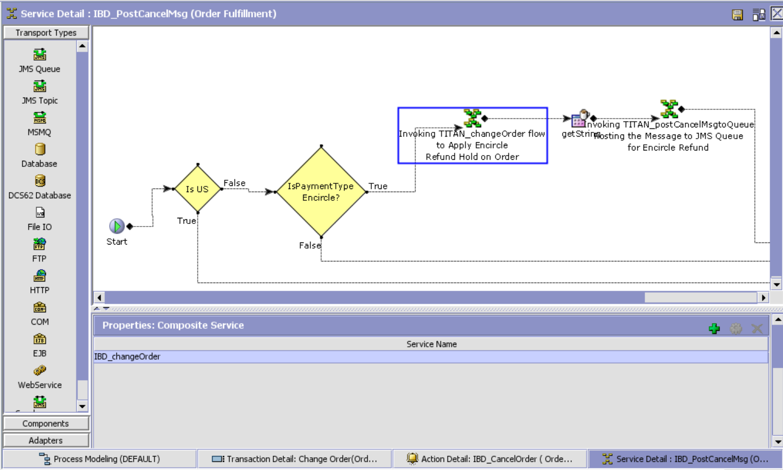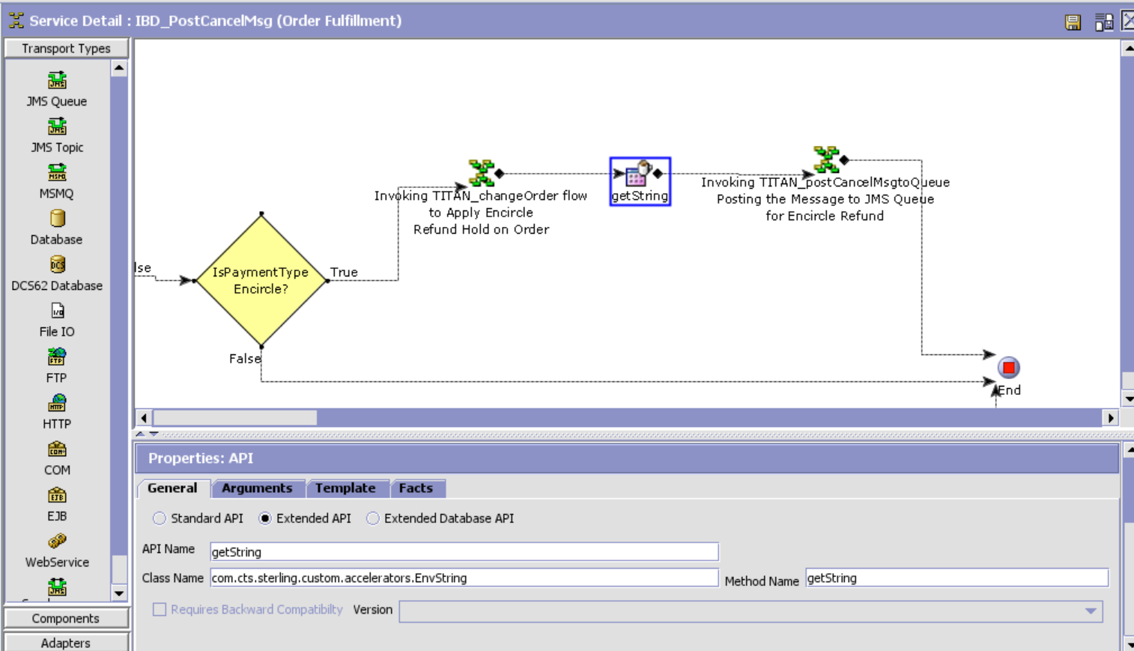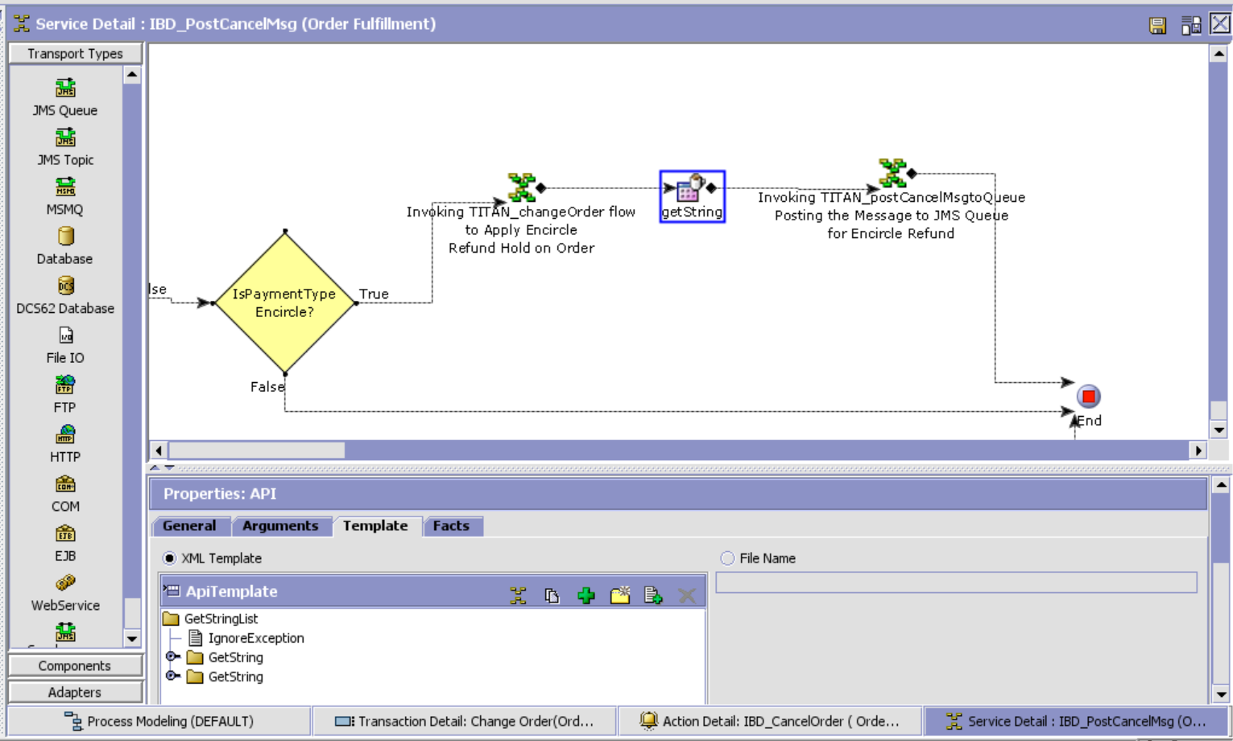

XSL Template:

<?xml version="1.0" encoding="UTF-8"?>

<GetStringList IgnoreException="Y">

<GetString AttributeName="FullOrderCancel" XpathToAppend="/Order"/>

<GetString AttributeName="PartialCancel" XpathToAppend="/Order"/>

</GetStringList>

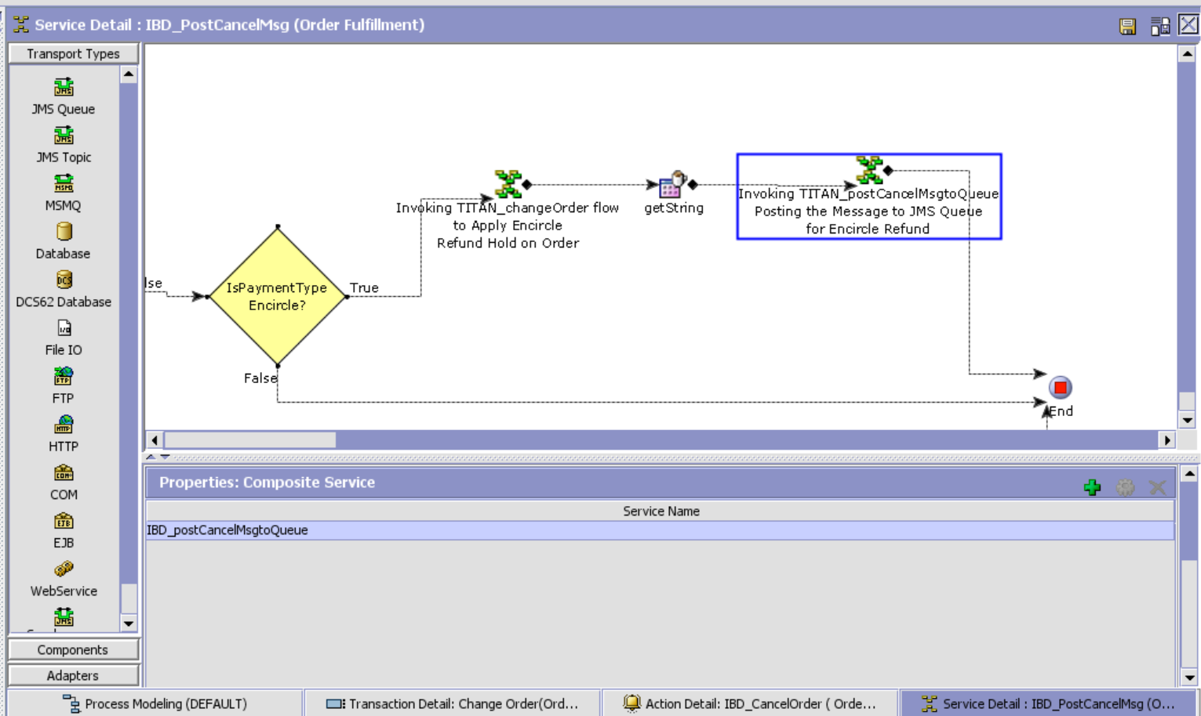

For US Enterprise: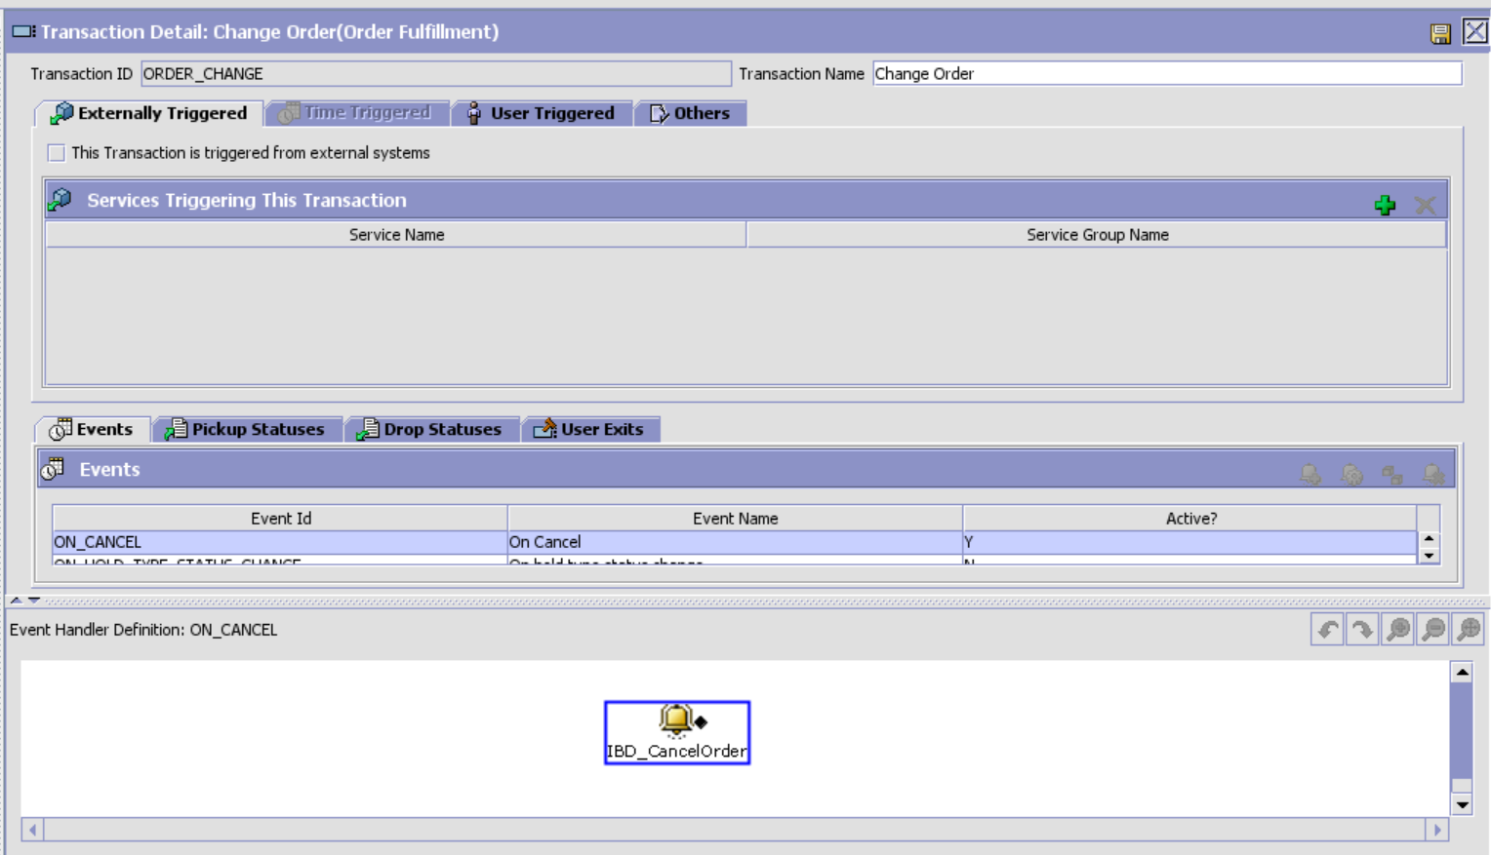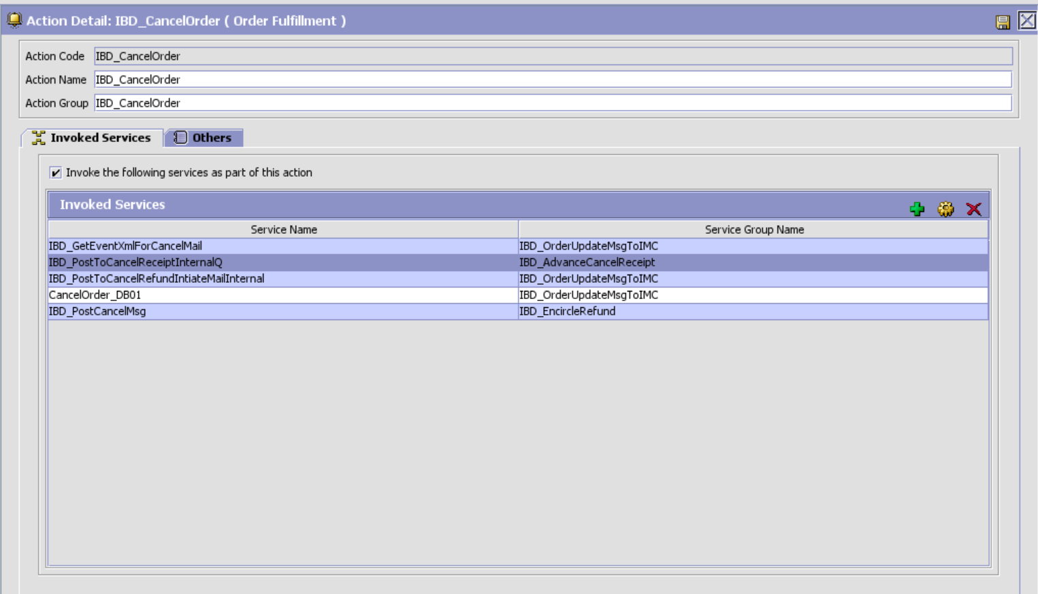

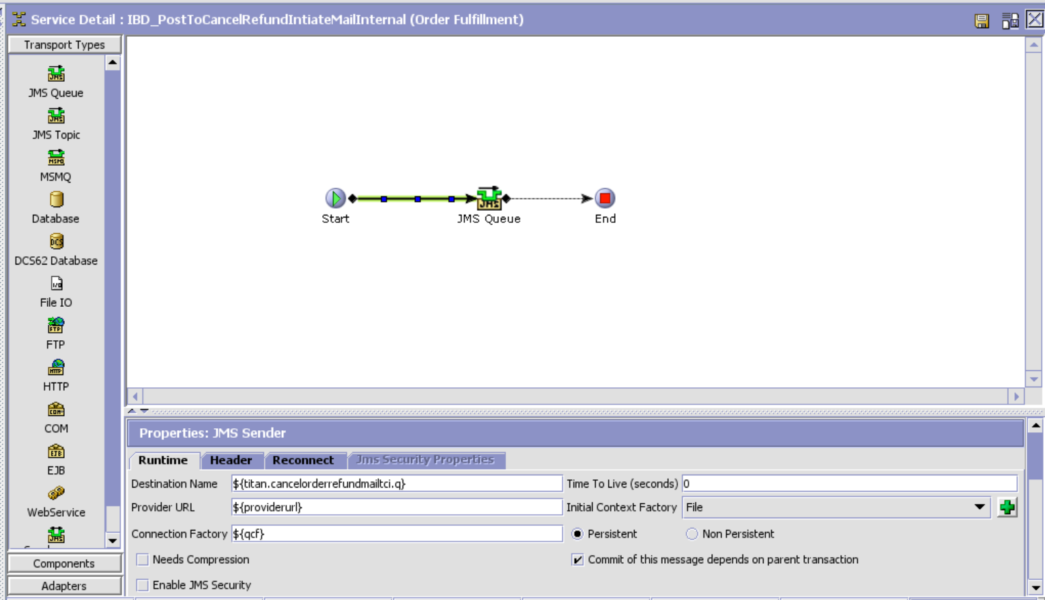

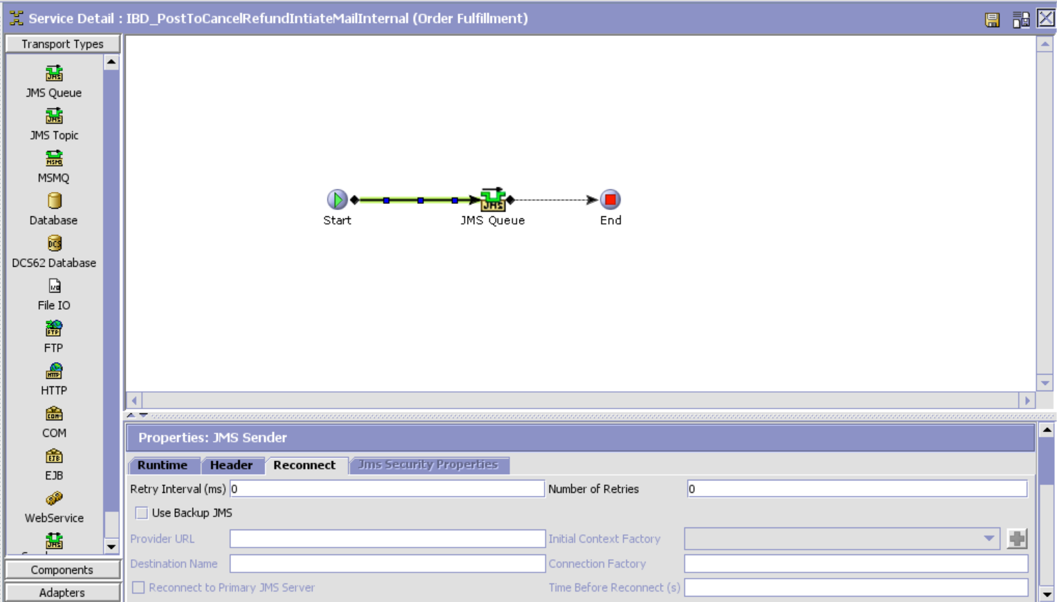

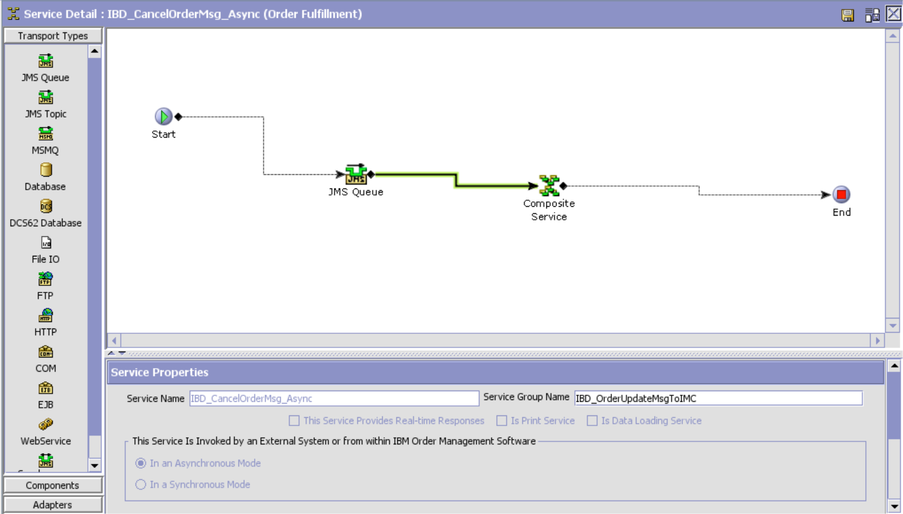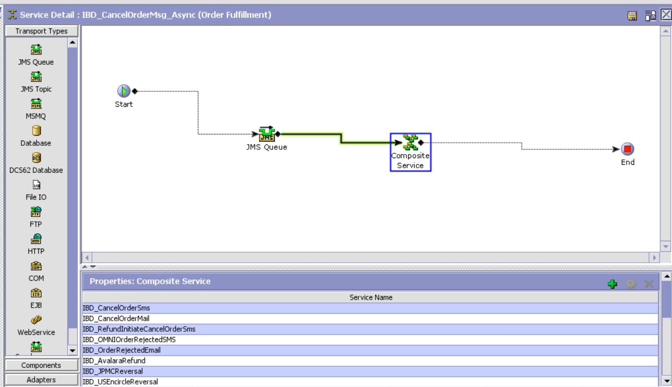

IBD_USEncircleReversal

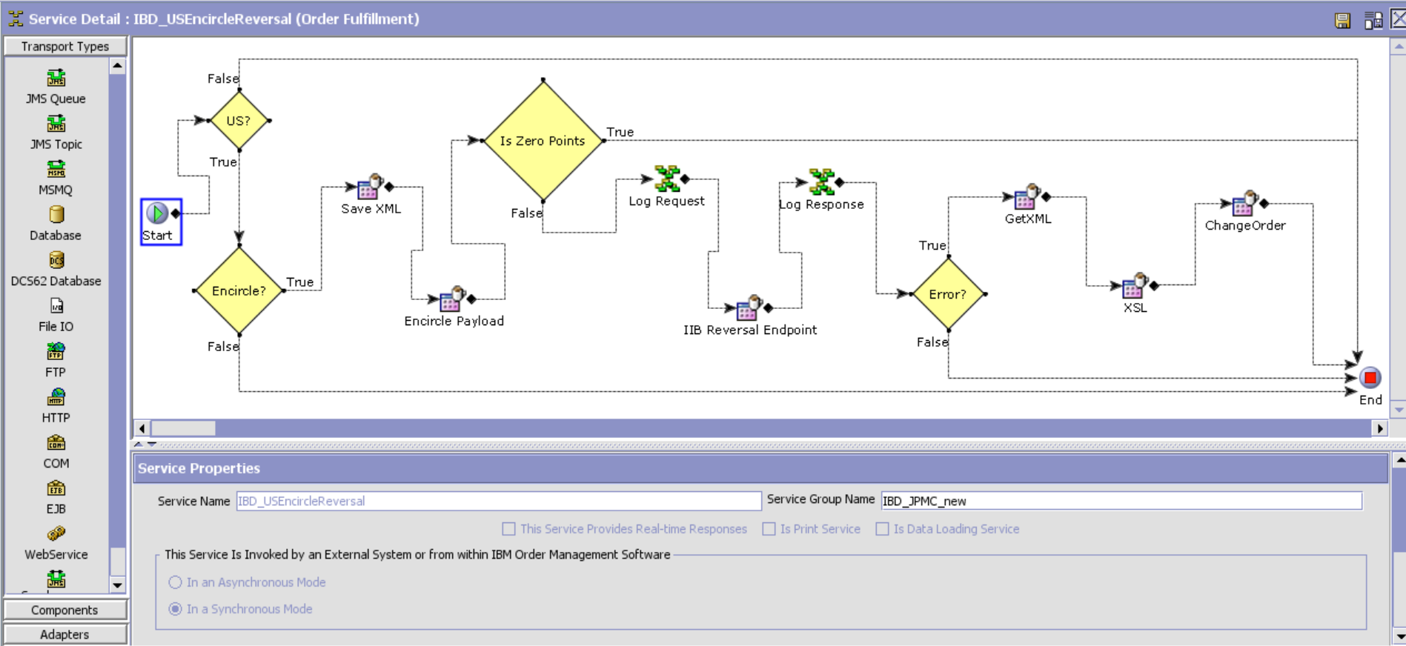

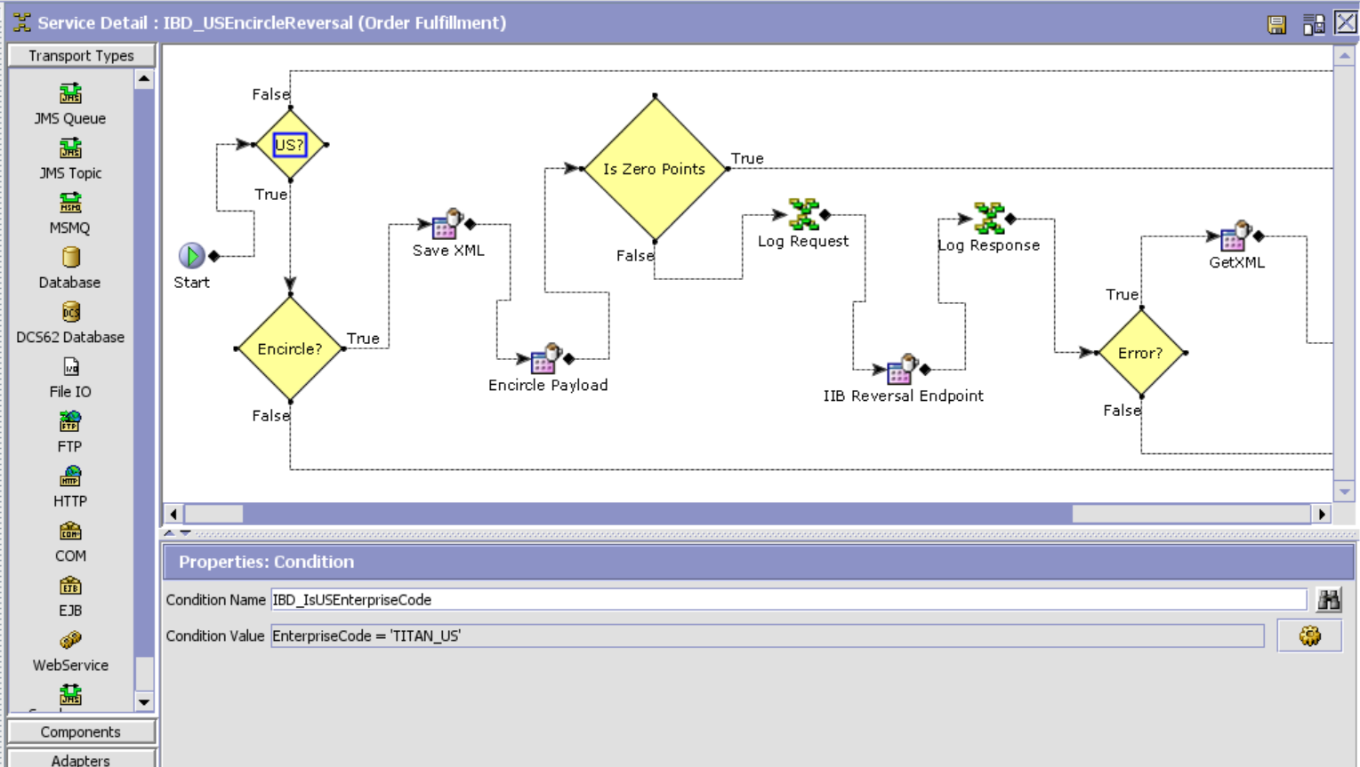

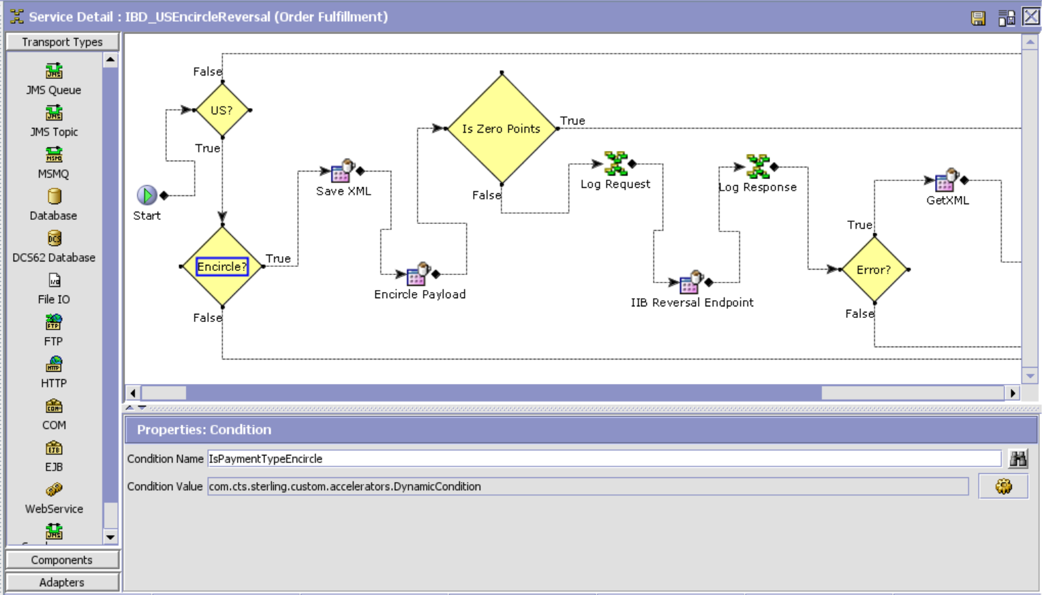

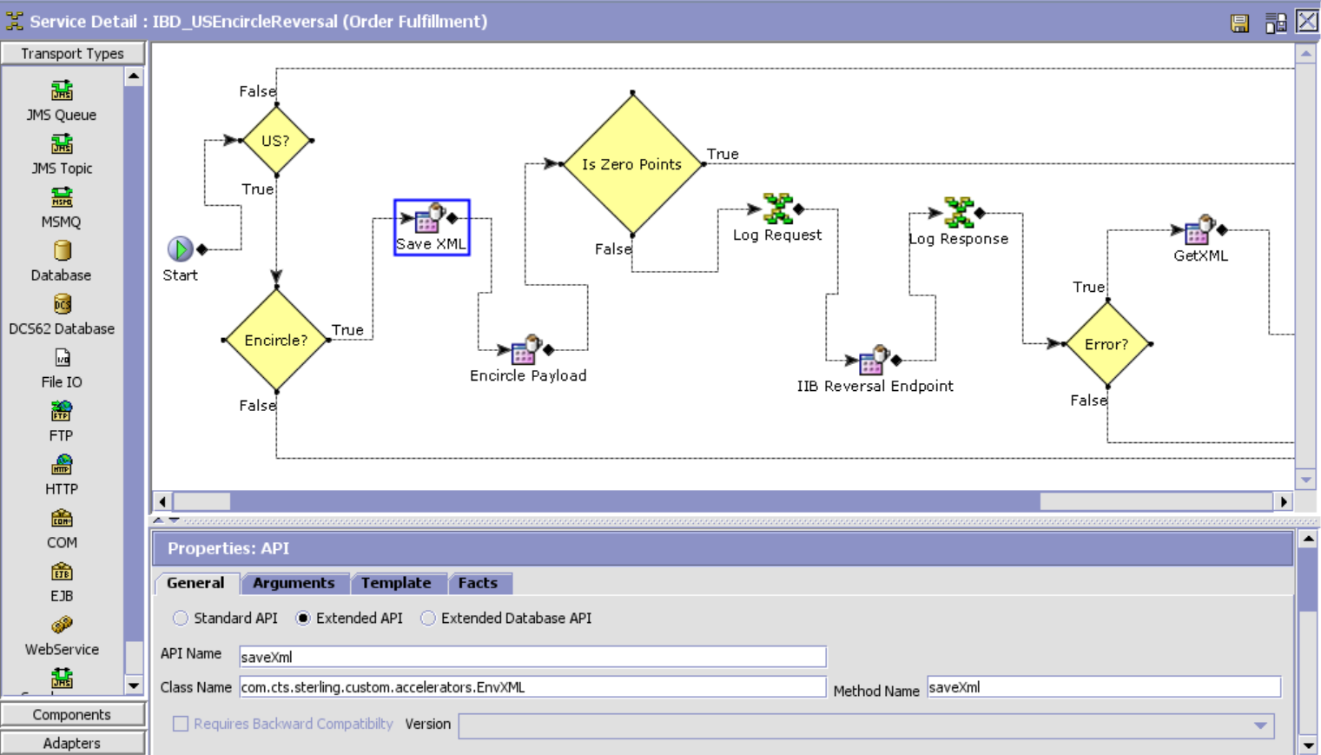

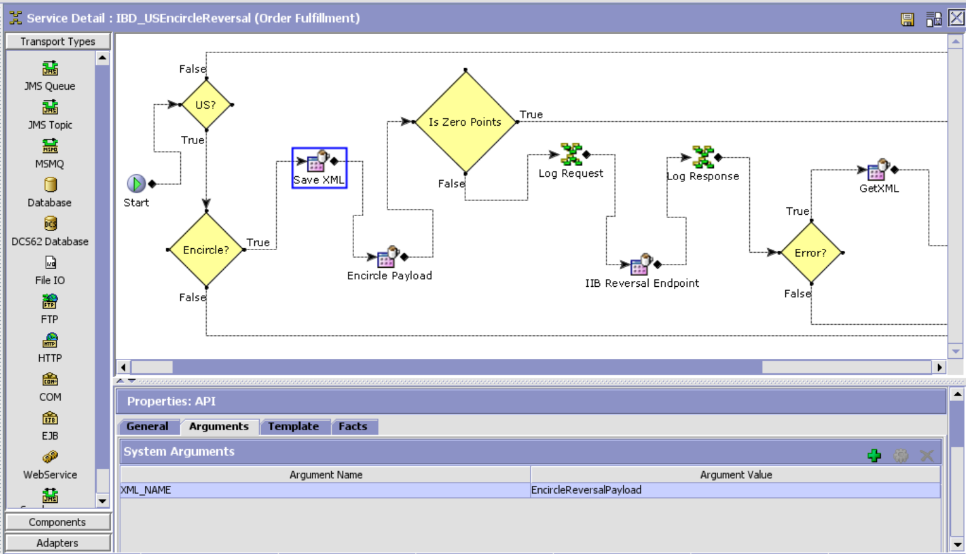

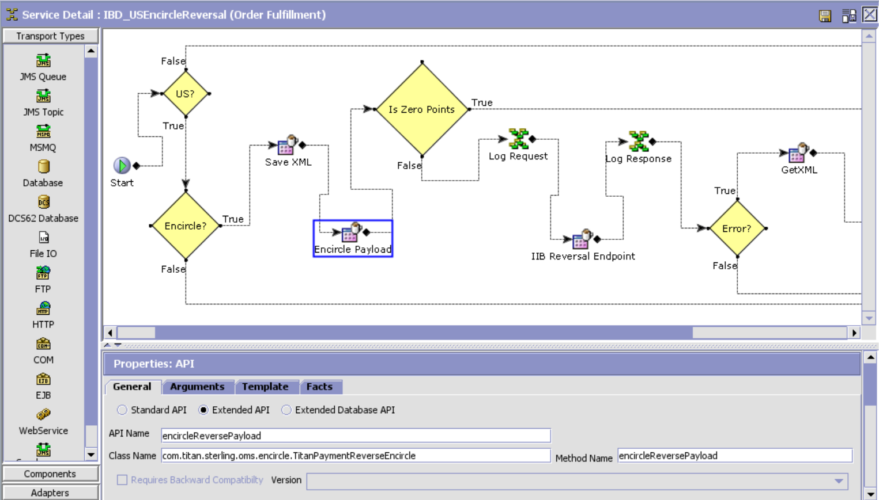

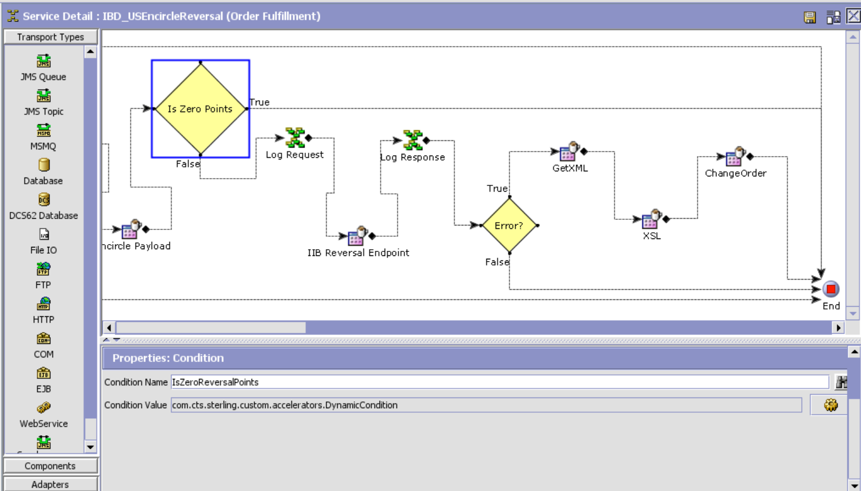

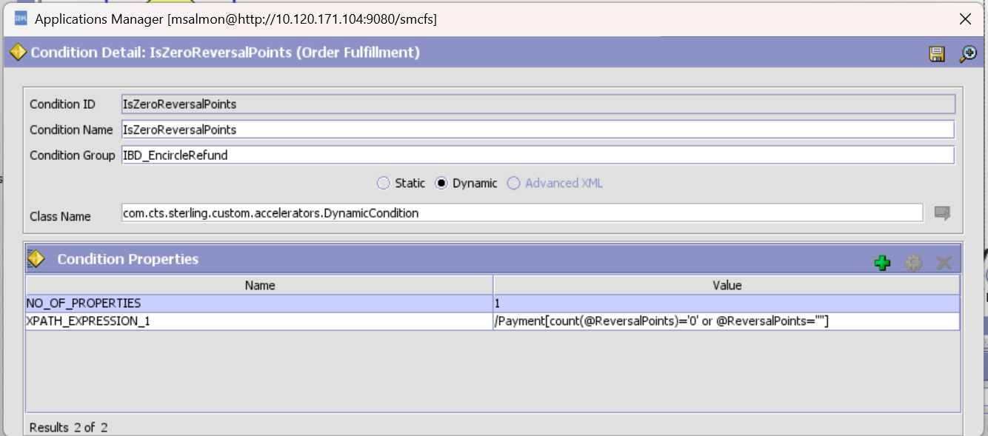

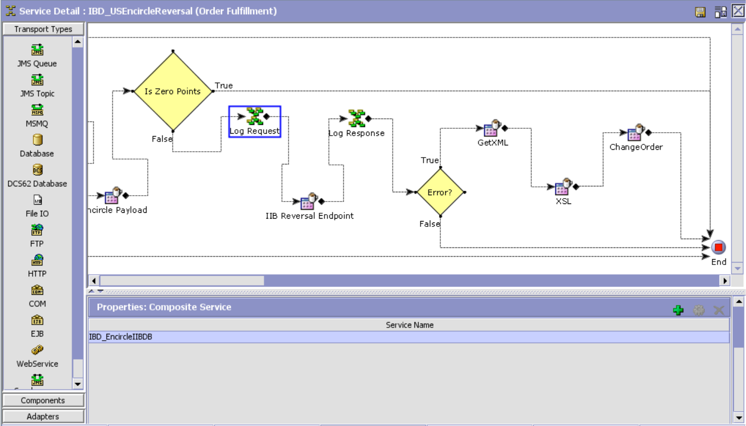

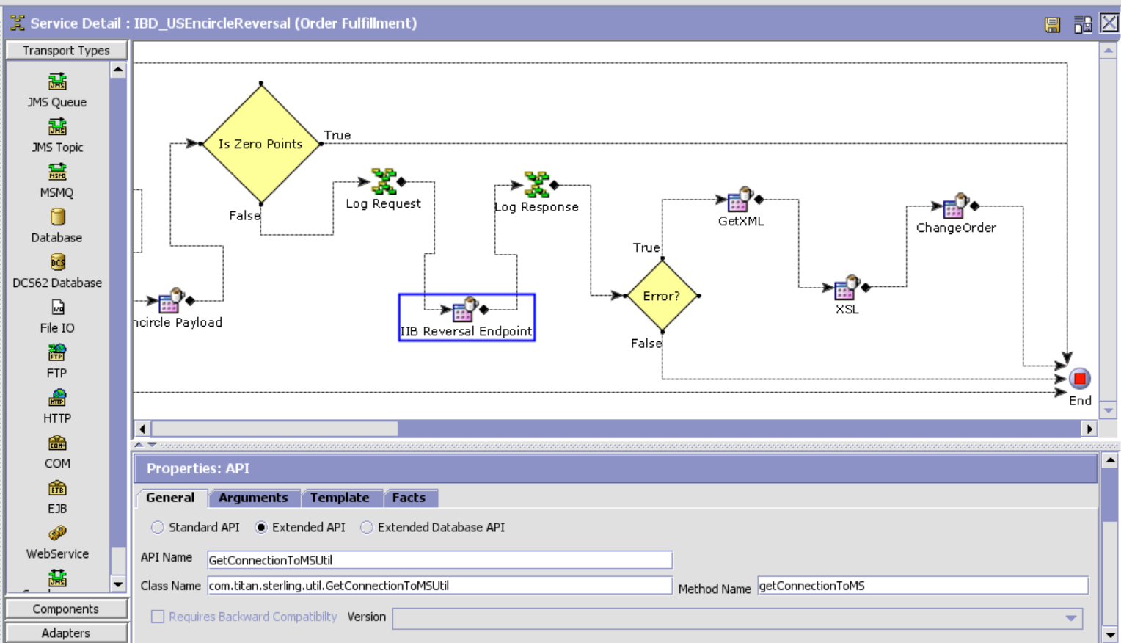

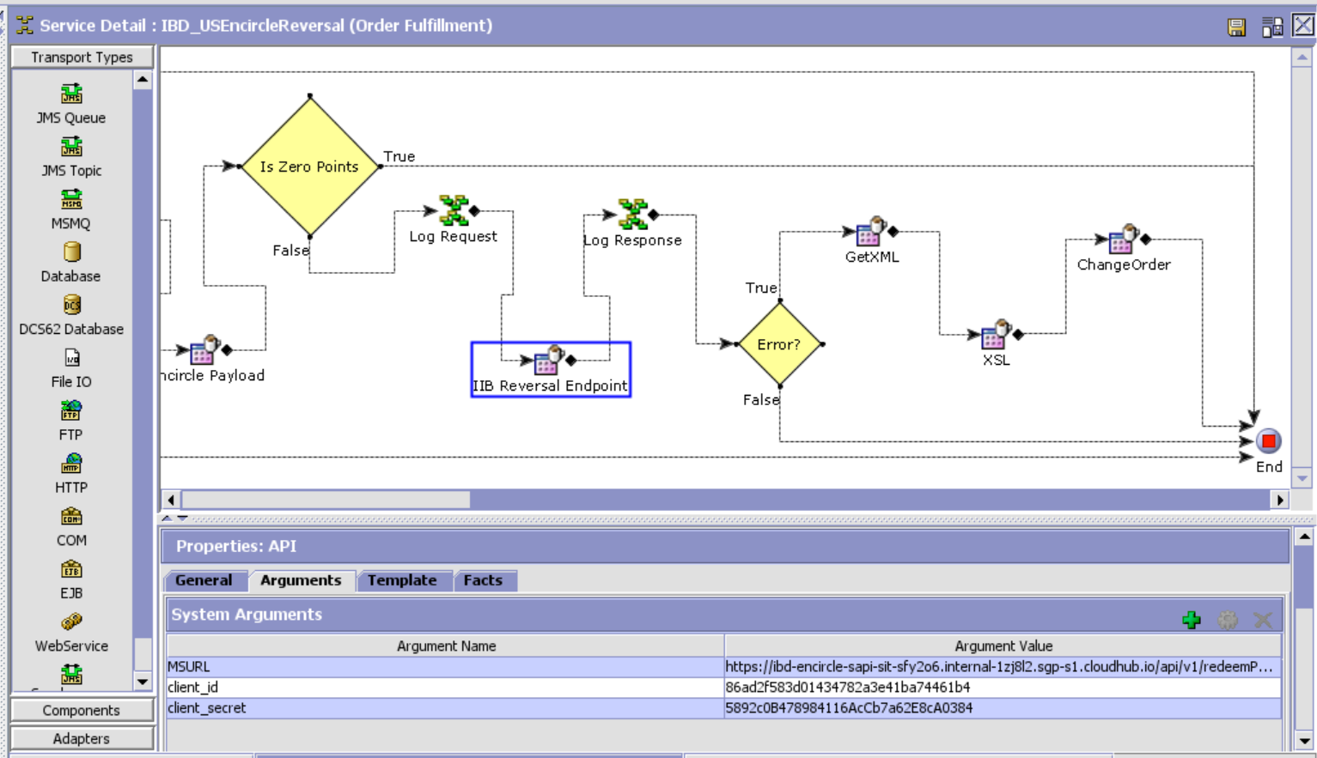

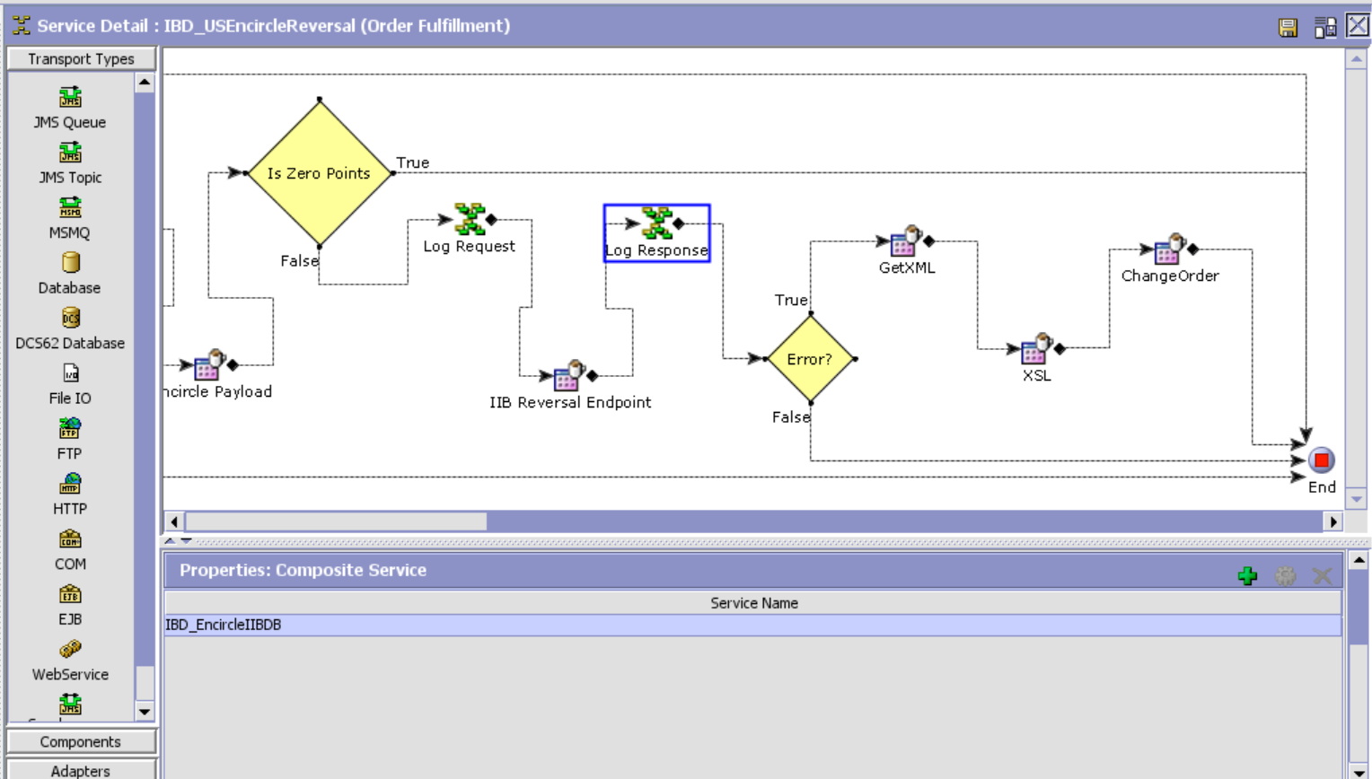

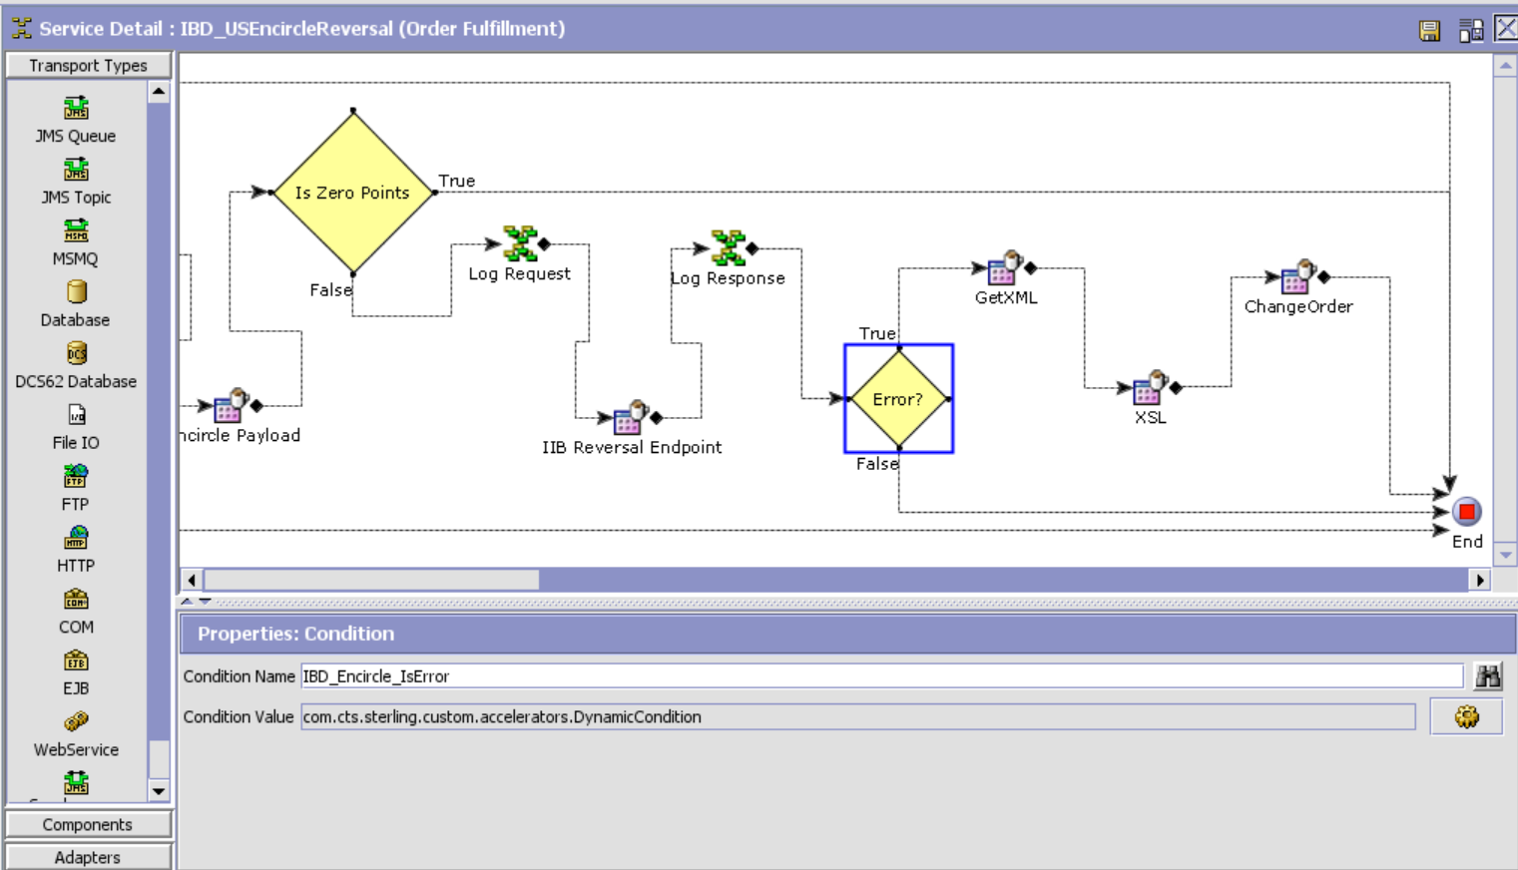

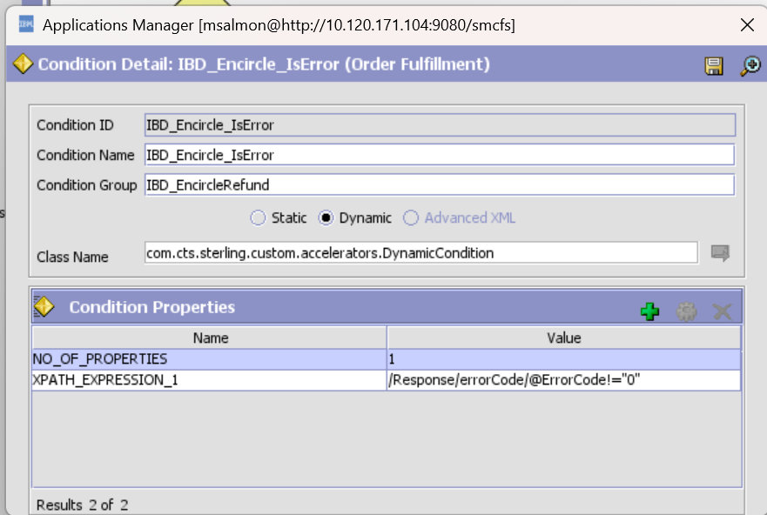

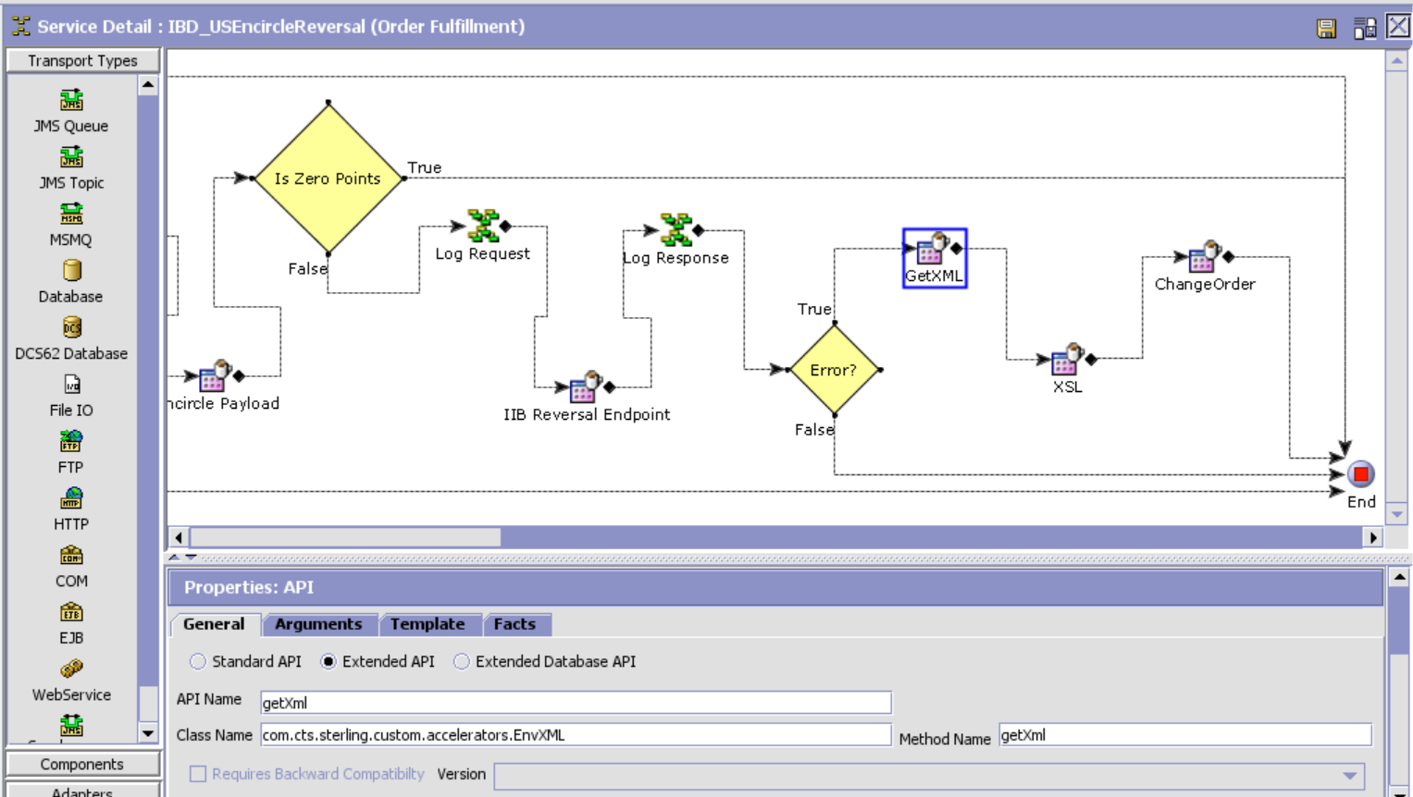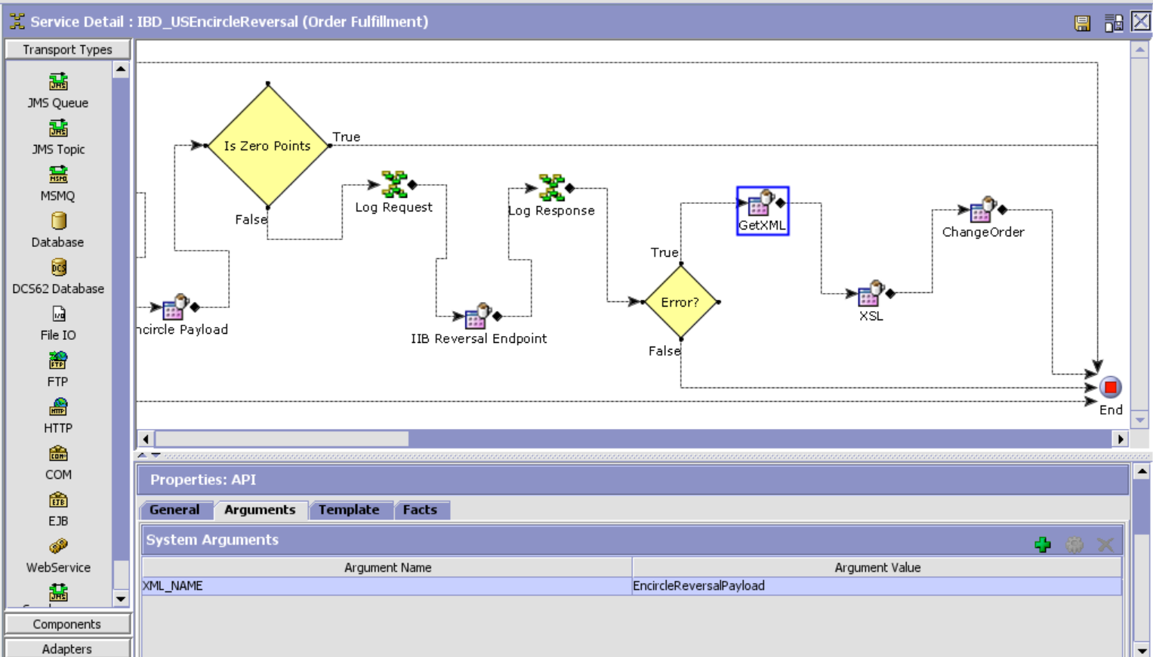

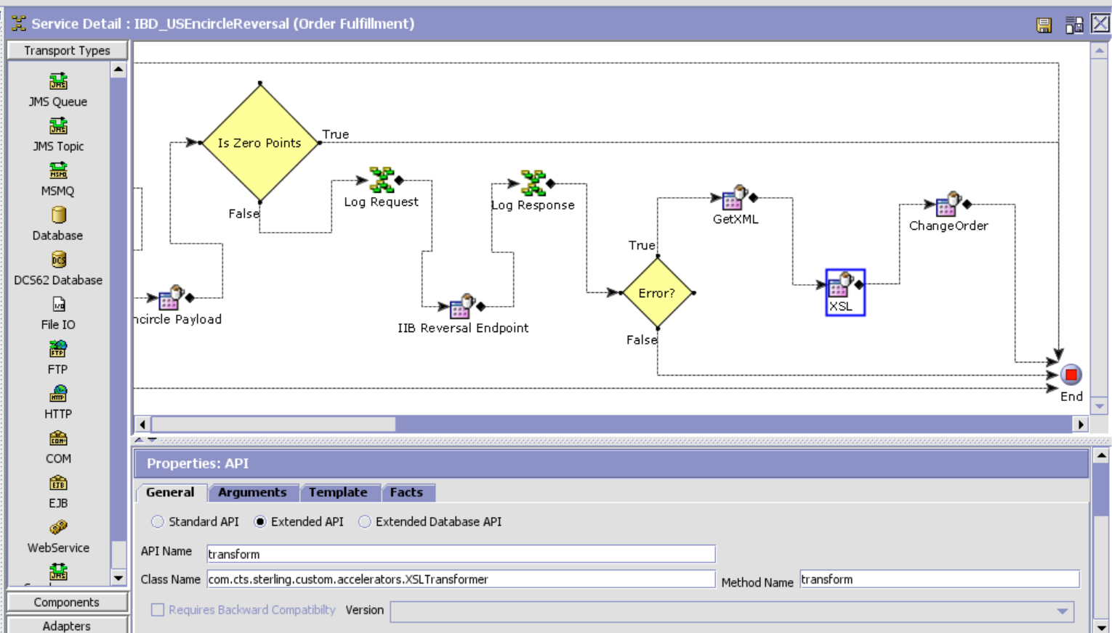XSL Template:

<?xml version="1.0" encoding="UTF-8"?>

<xsl:stylesheet version="1.0" xmlns:xsl="http://www.w3.org/1999/XSL/Transform">

<xsl:template match="/">

<xsl:element name="Order">

<xsl:attribute name="OrderNo">

<xsl:value-of select="Response/Order/@OrderNo"/>

</xsl:attribute>

<xsl:attribute name="Action">MODIFY</xsl:attribute>

<xsl:attribute name="DocumentType">0001</xsl:attribute>

<xsl:attribute name="EnterpriseCode">TITAN_US</xsl:attribute>

<xsl:attribute name="Override">Y</xsl:attribute>

<xsl:element name="OrderHoldTypes">

<xsl:element name="OrderHoldType">

<xsl:attribute name="HoldType">EN_REFUND_HOLD</xsl:attribute>

<xsl:attribute name="Status">1100</xsl:attribute>  
 </xsl:element>  
 </xsl:element>  
 </xsl:element>  
</xsl:template>

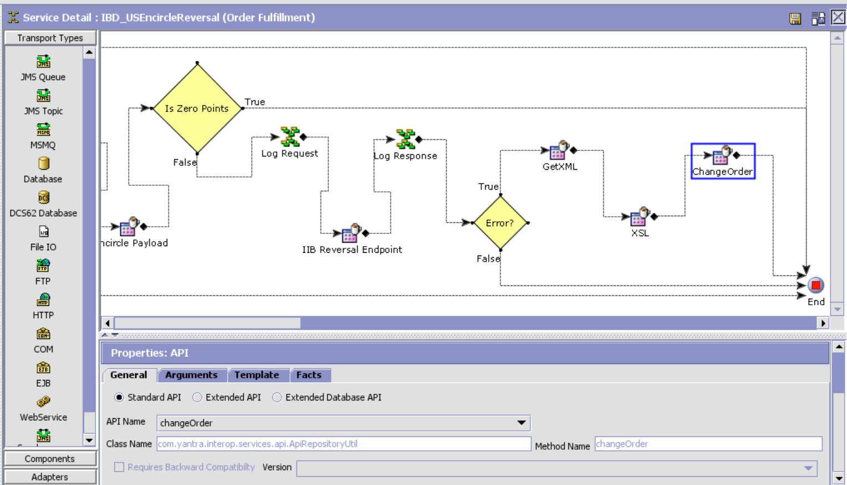

For GCC Enterprise:

IBD_ChangeOrder Service:

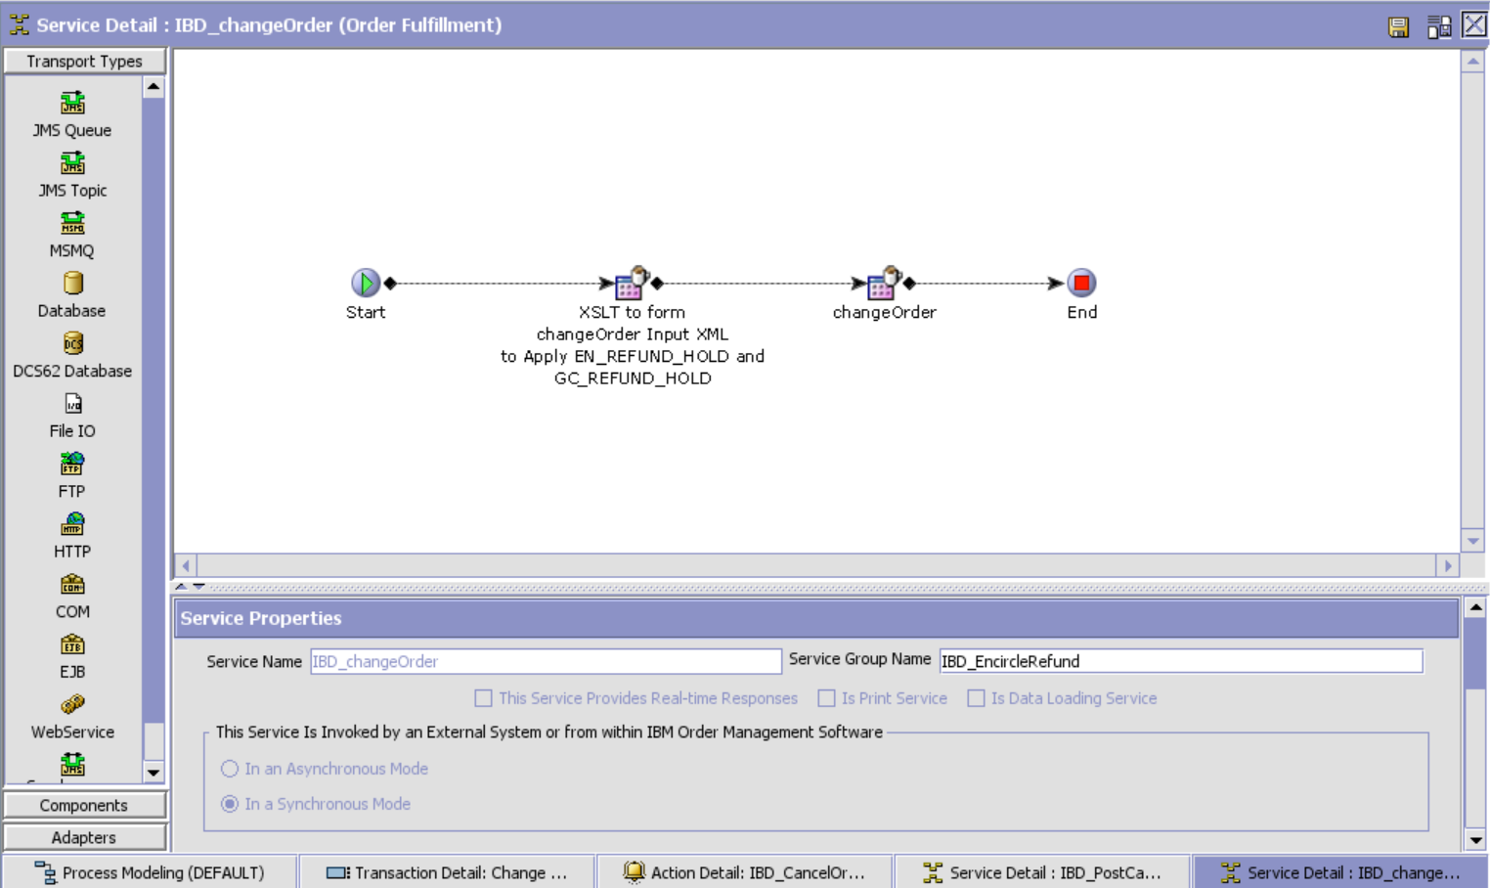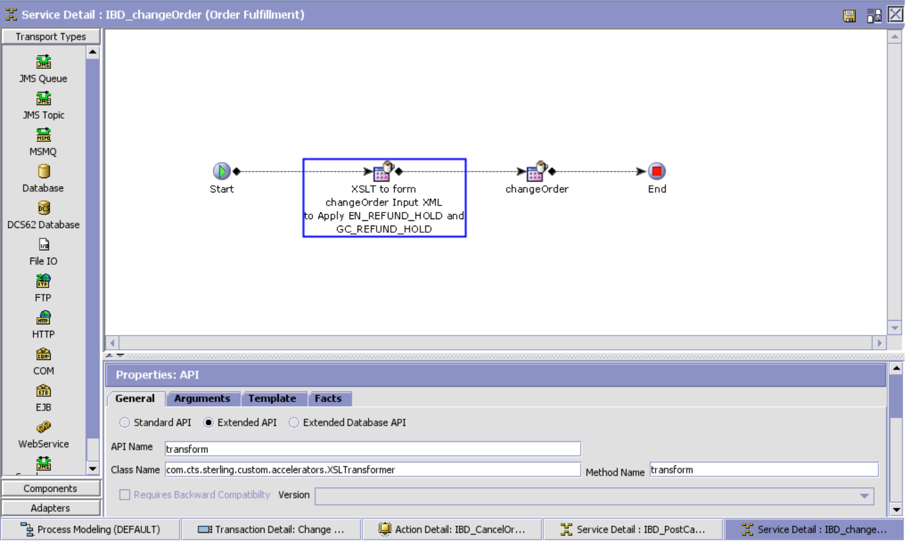

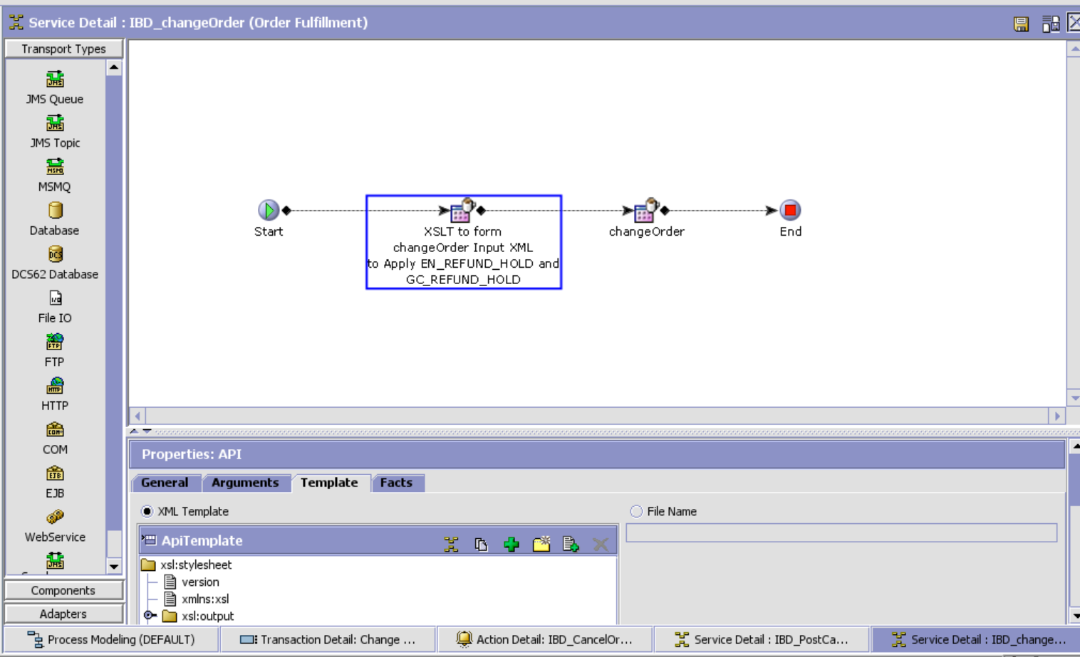

XSL Template:

<?xml version="1.0" encoding="UTF-8"?>

<xsl:stylesheet version="1.0" xmlns:xsl="http://www.w3.org/1999/XSL/Transform">

<xsl:output encoding="UTF-8" indent="no" method="xml" omit-xml-declaration="yes"/>

<xsl:strip-space elements="*"/>

<xsl:variable name="varGCPaymentType" select="count(/Order/OrderLines/OrderLine/Extn/TitanPaymentDetailList/TitanPaymentDetail[@PaymentType='Helios' or @PaymentType='Fastrack' or @PaymentType='WOT' or @PaymentType='Tanishq' or @PaymentType='Mia' or @PaymentType='GCZoya' or @PaymentType='Taneira' or @PaymentType='TQEVoucher' or @PaymentType='eGCHelios' or @PaymentType='eGCFT' or @PaymentType='eGCWOT' or @PaymentType='eGCTanishq' or @PaymentType='eGCMia' or @PaymentType='eGCZoya' or @PaymentType='eGCTaneira'])"/>

<xsl:variable name="varENPaymentType" select="count(/Order/OrderLines/OrderLine/Extn/TitanPaymentDetailList/TitanPaymentDetail[@PaymentType='Encircle'])"/>

<xsl:variable name="varTNPaymentType" select="count(/Order/OrderLines/OrderLine/Extn/TitanPaymentDetailList/TitanPaymentDetail[@PaymentType='NeuCoins'])"/>

<xsl:variable name="varOrderStatus" select="/Order/@Status"/>

<xsl:template match="/Order">

<xsl:element name="Order">

<xsl:attribute name="OrderHeaderKey">

<xsl:value-of select="/Order/@OrderHeaderKey"/>

</xsl:attribute>

<xsl:attribute name="Override">Y</xsl:attribute>

<xsl:attribute name="DocumentType">0001</xsl:attribute>

<xsl:attribute name="Action">MODIFY</xsl:attribute>

<xsl:element name="OrderHoldTypes">  
 <xsl:if test="($varGCPaymentType > '0')">  
 <xsl:element name="OrderHoldType">  
 <xsl:attribute name="HoldType">GC_REFUND_HOLD</xsl:attribute>  
 <xsl:attribute name="ReasonText">Gift Card Refund Hold</xsl:attribute>  
 <xsl:attribute name="Status">1100</xsl:attribute>  
 </xsl:element>  
 </xsl:if>  
 <xsl:if test="($varENPaymentType > '0')">  
 <xsl:element name="OrderHoldType">  
 <xsl:attribute name="HoldType">EN_REFUND_HOLD</xsl:attribute>  
 <xsl:attribute name="ReasonText">Encircle Refund Hold</xsl:attribute>  
 <xsl:attribute name="Status">1100</xsl:attribute>  
 </xsl:element>  
 </xsl:if>  
 <xsl:if test="($varTNPaymentType > '0')">  
 <xsl:element name="OrderHoldType">  
 <xsl:attribute name="HoldType">TN_REFUND_HOLD</xsl:attribute>  
 <xsl:attribute name="ReasonText">NeuCoins Refund Hold</xsl:attribute>  
 <xsl:attribute name="Status">1100</xsl:attribute>  
 </xsl:element>  
 </xsl:if>  
 </xsl:element>  
 </xsl:element>  
</xsl:template>

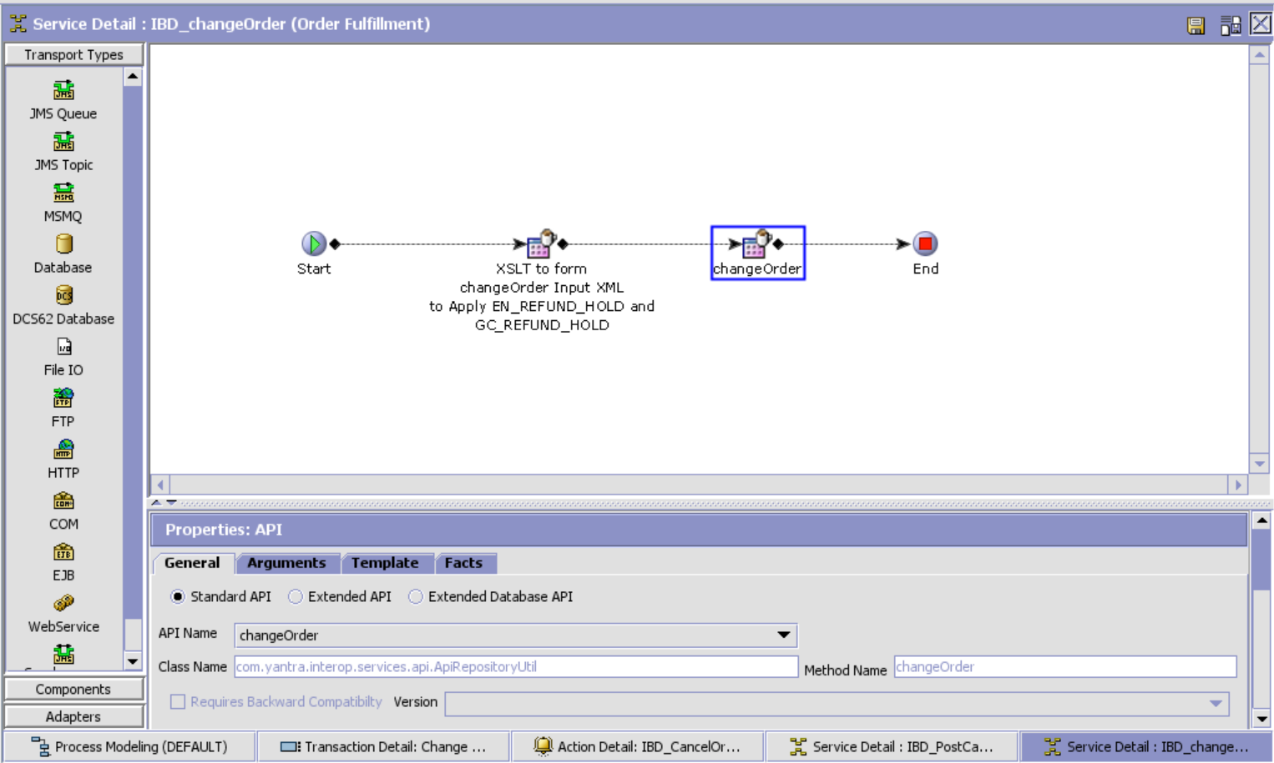

IBD_postCancelMsgtoQueue

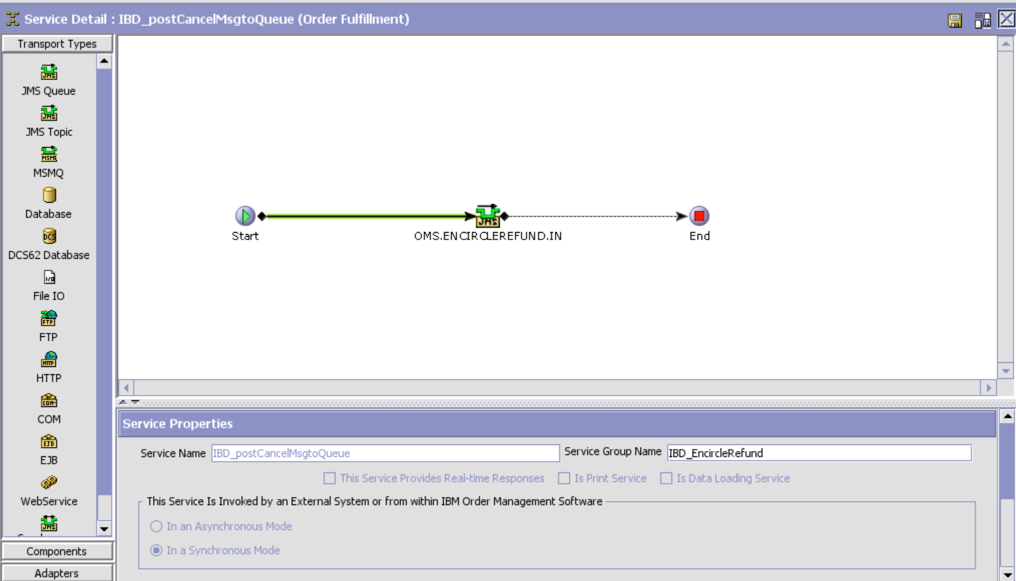

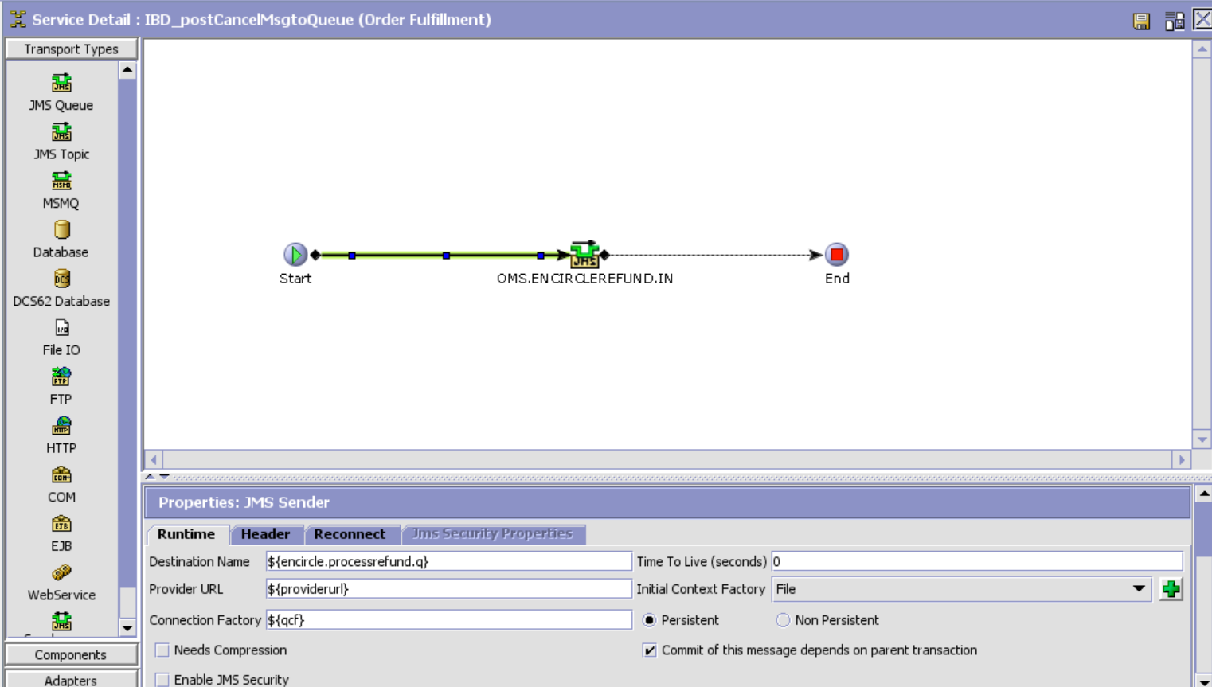

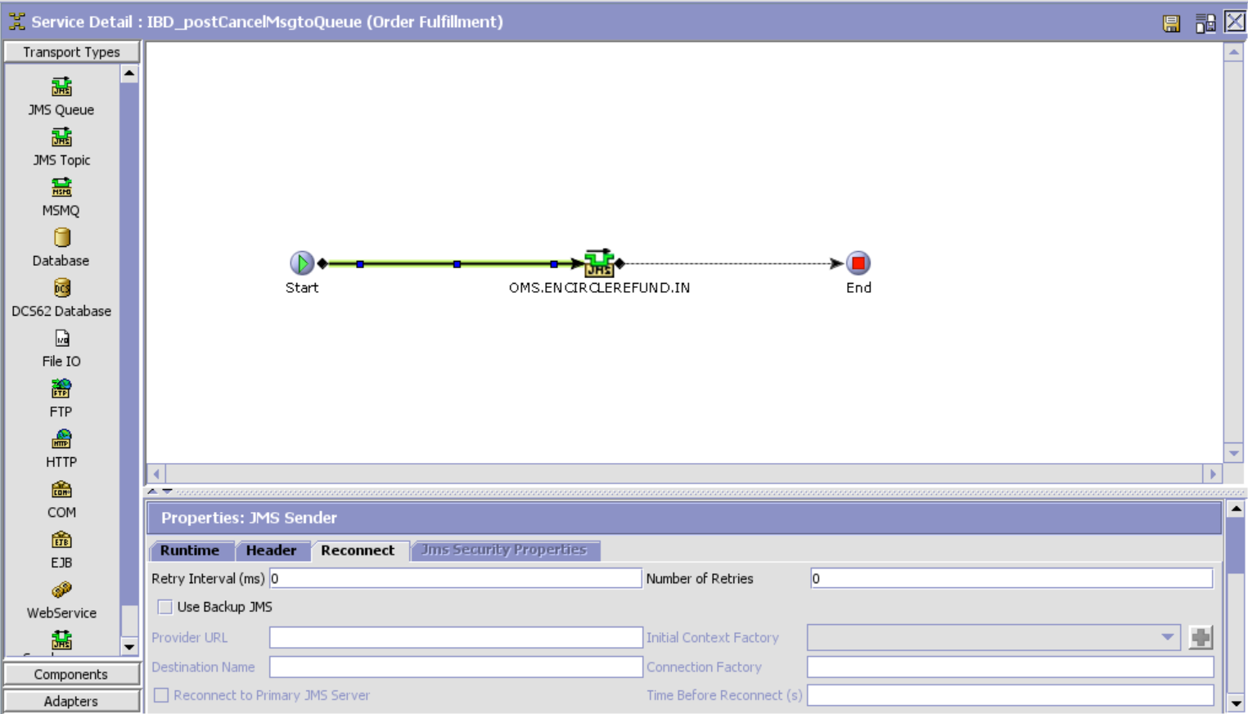

IBD_getCancelMsg_Async

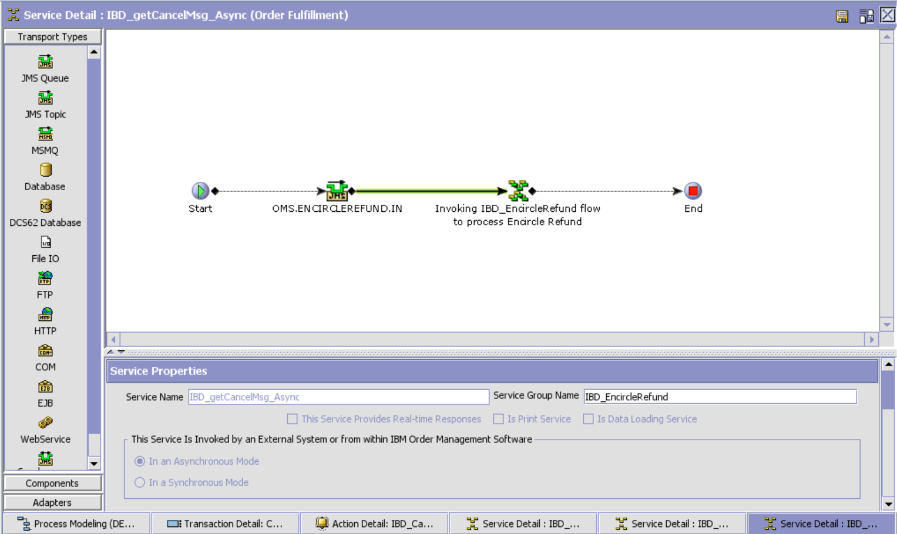

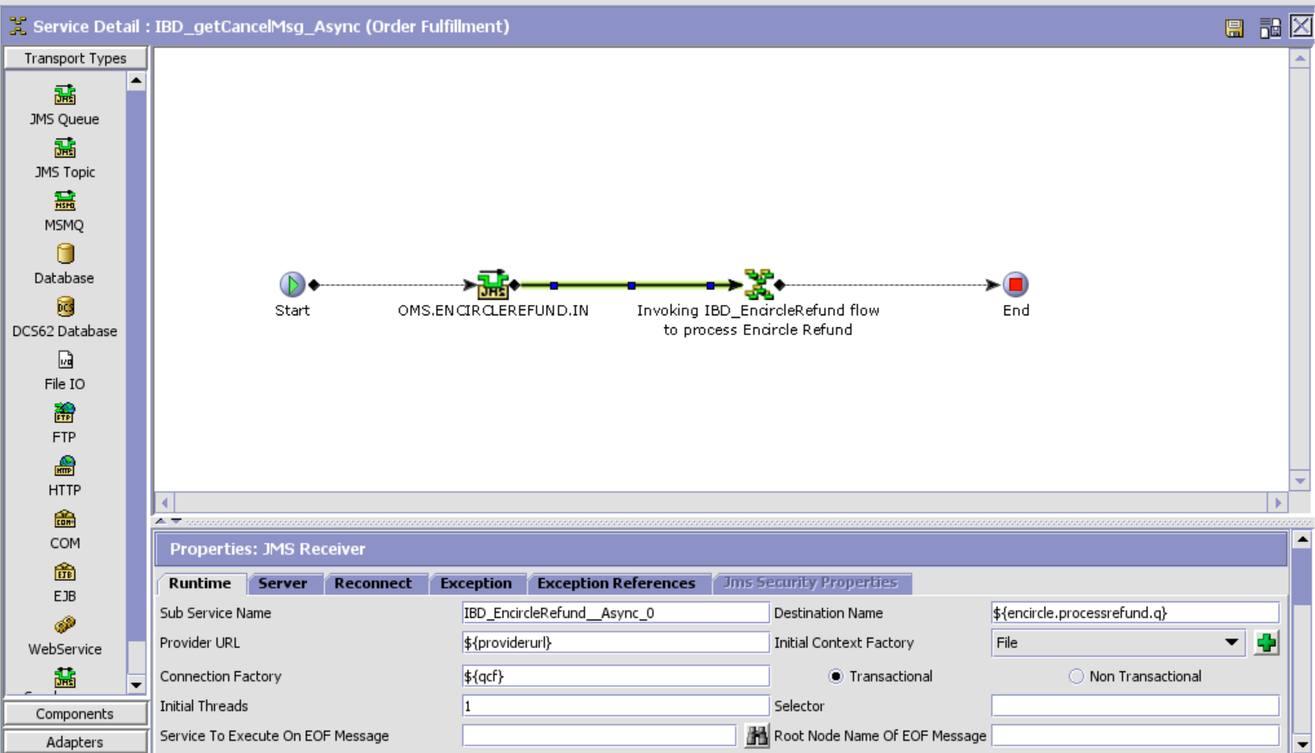

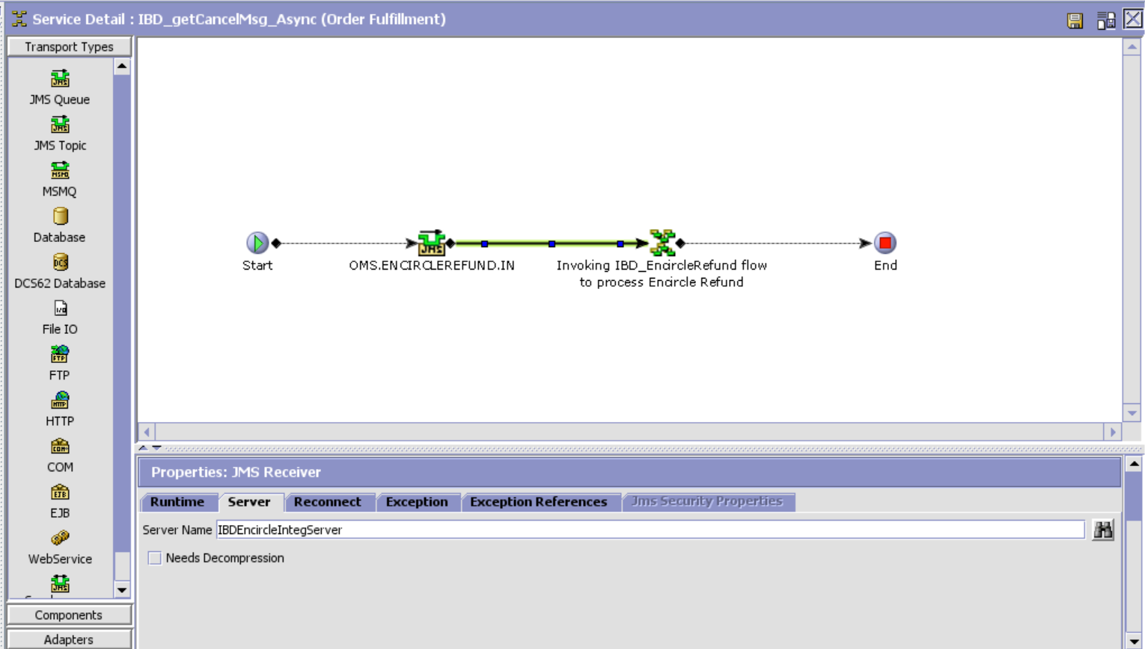

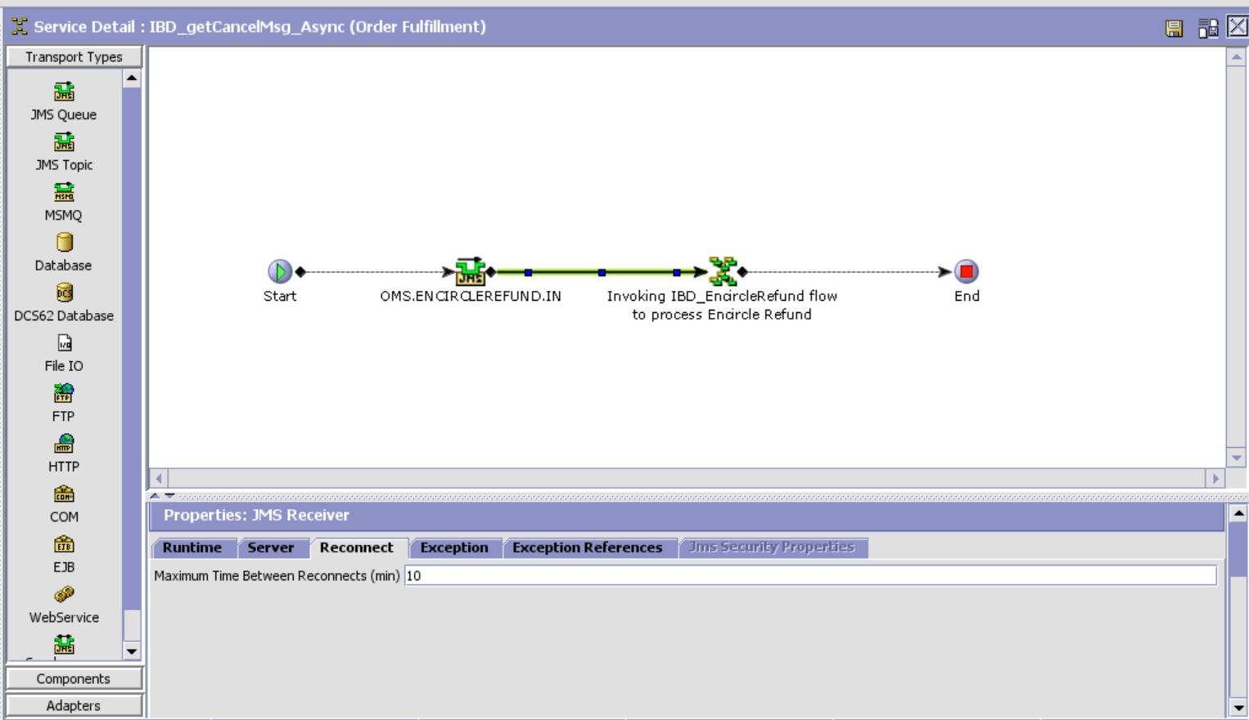

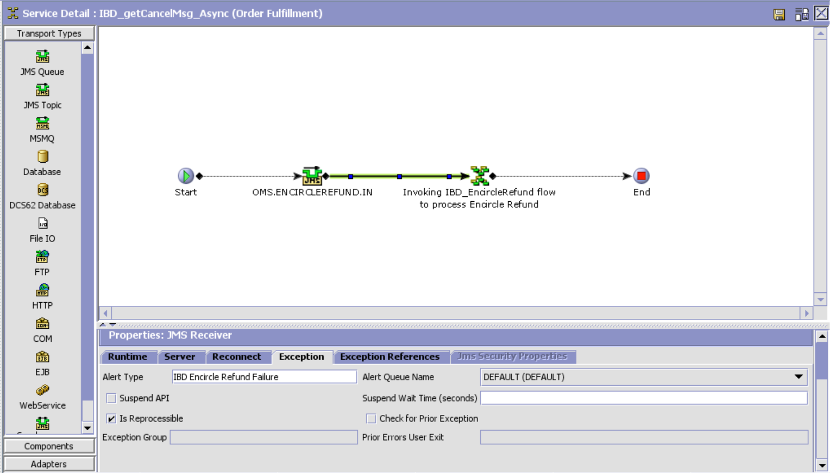

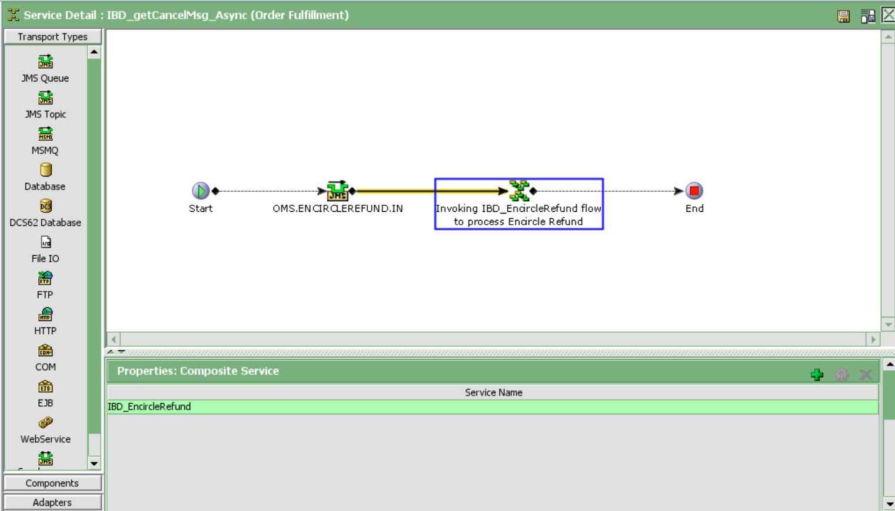

IBD_EncircleRefund

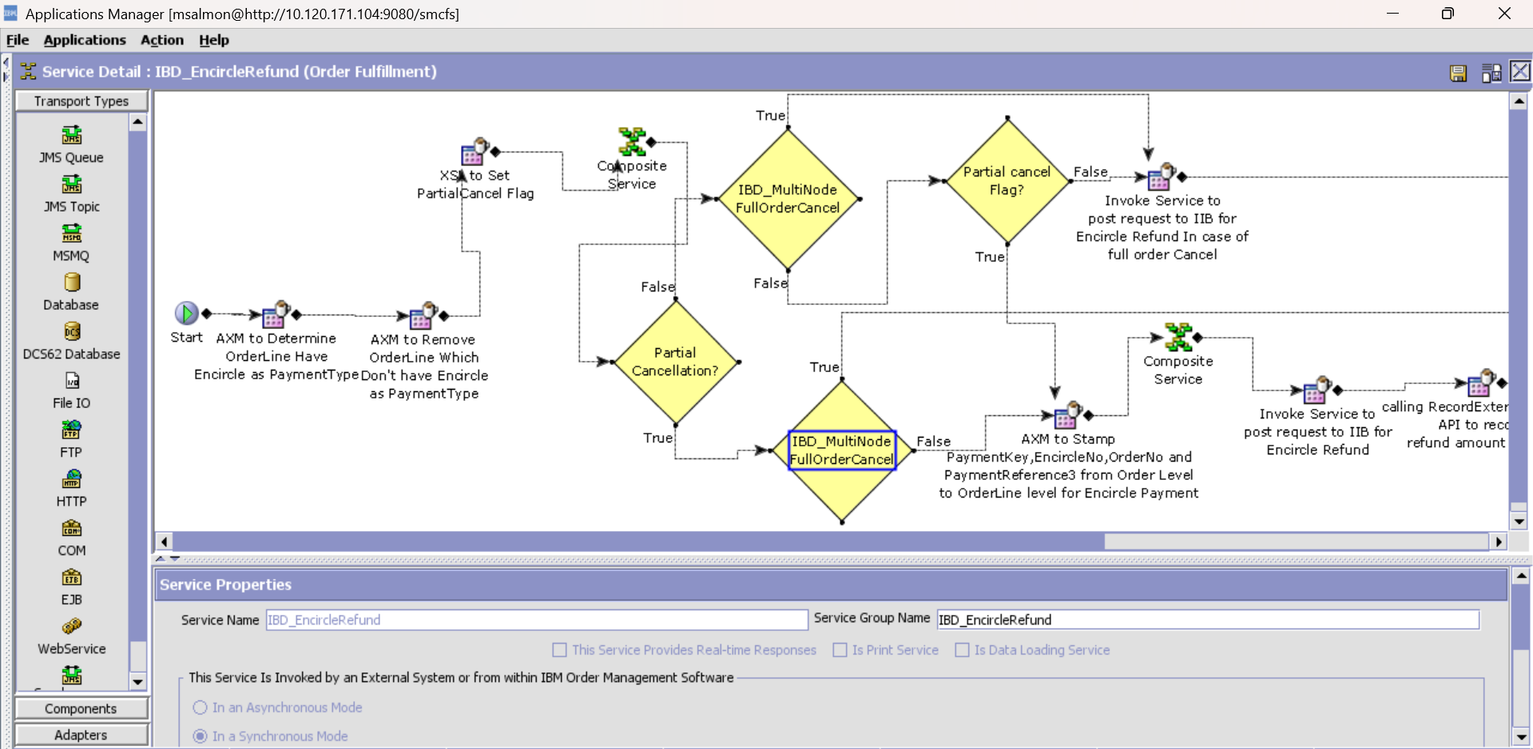

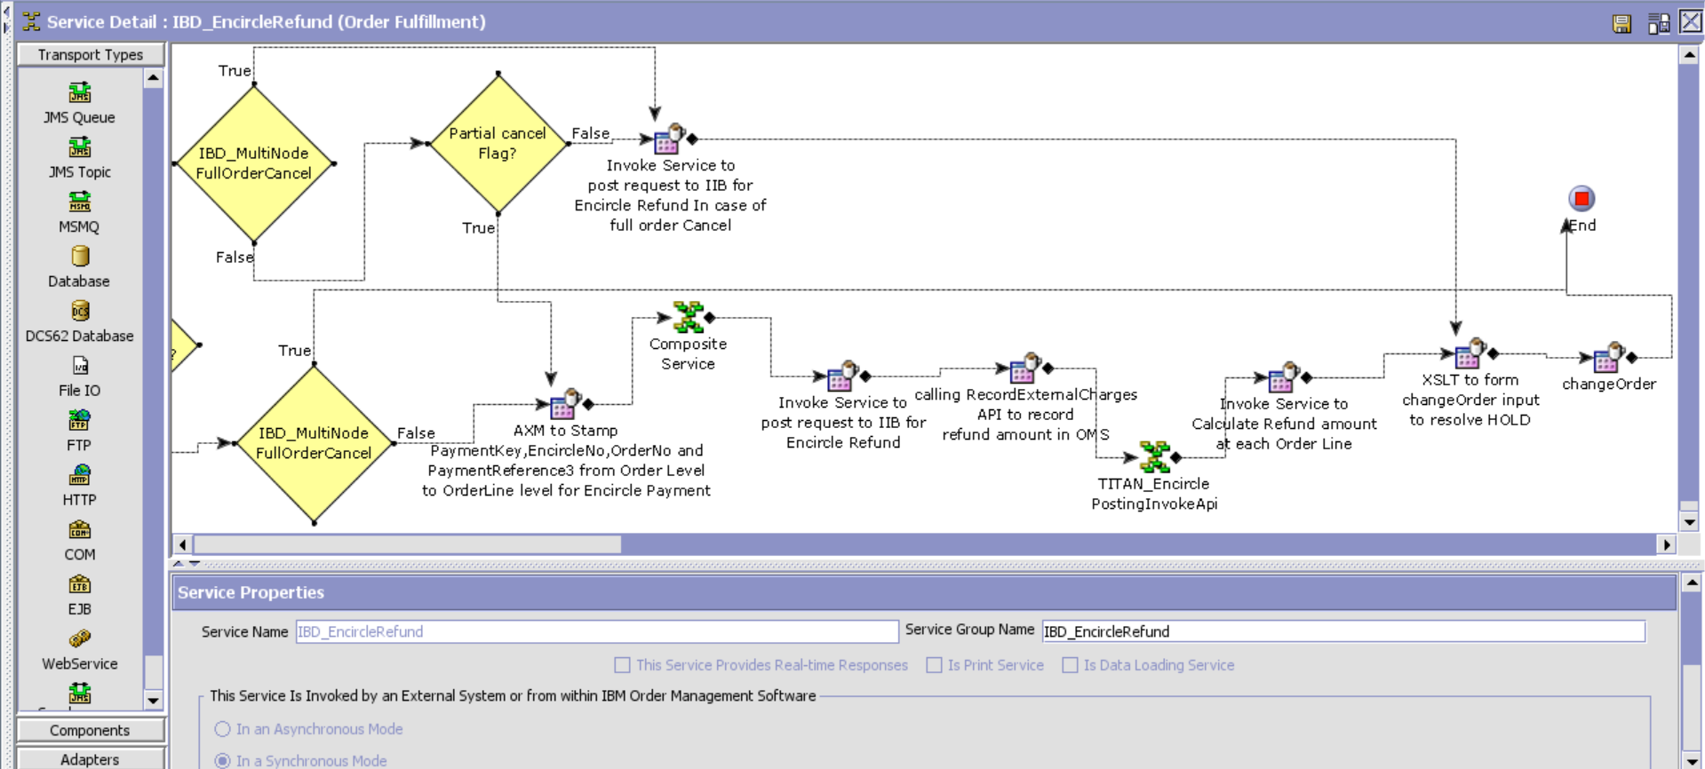

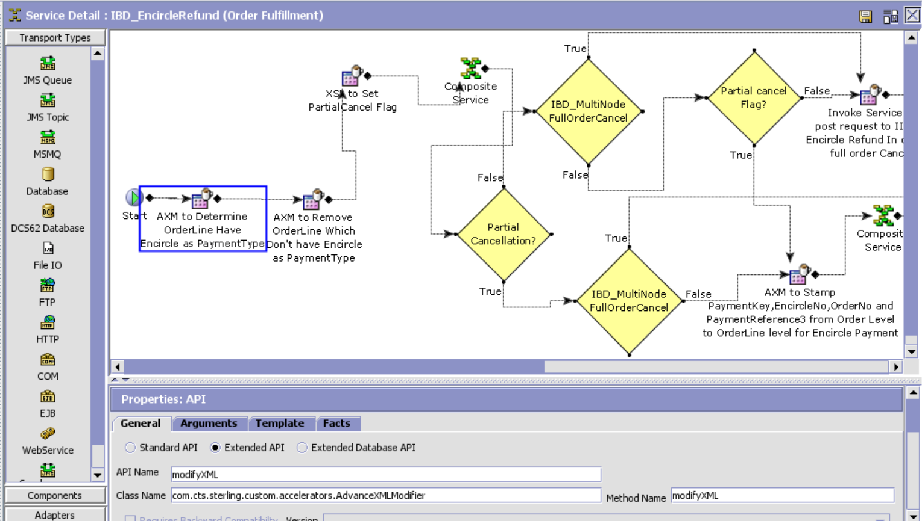

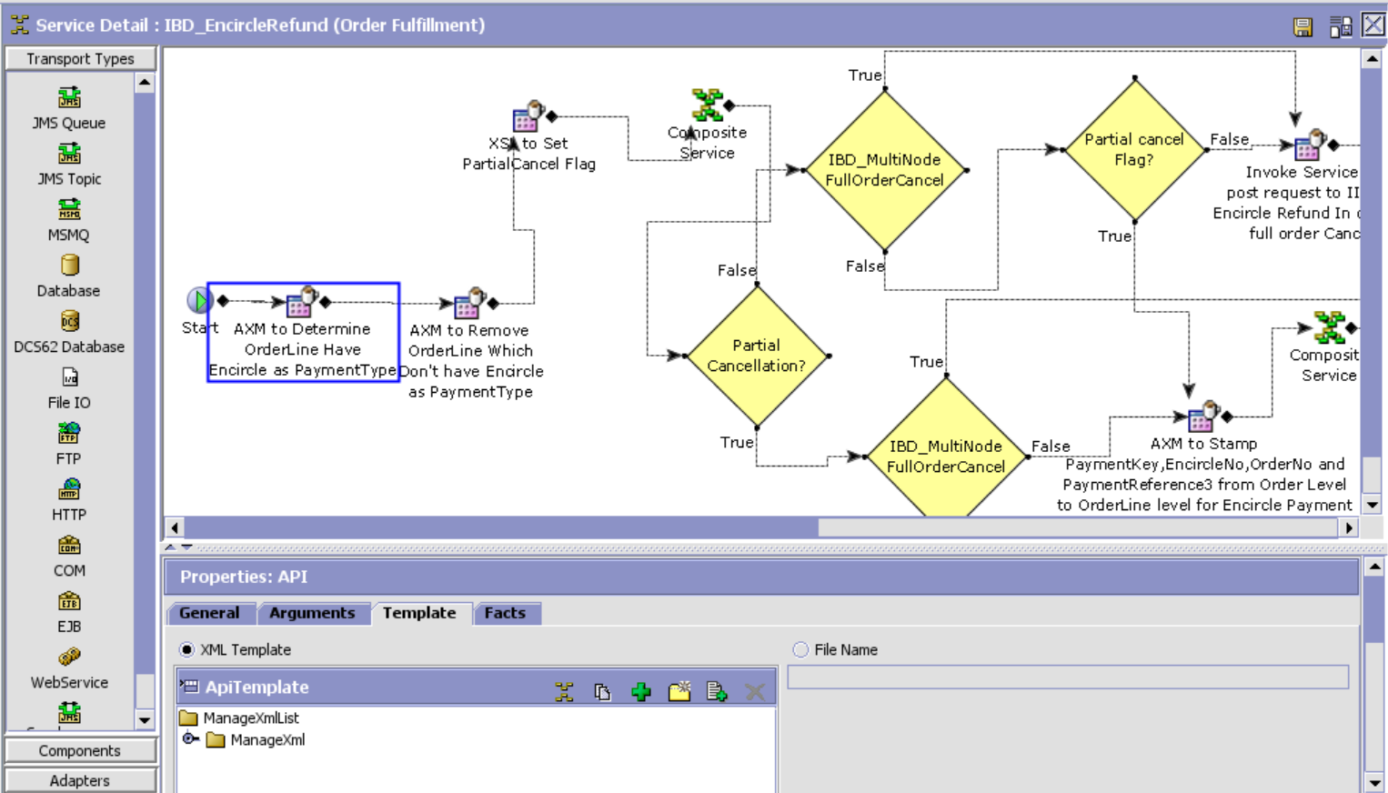

AXM Template:

<ManageXmlList>

<ManageXml Action="Manage" AttributeName="IsEncircelPayment"

AttributeValue="/Order/OrderLines/OrderLine[*]/Extn/TitanPaymentDetailList/TitanPaymentDetail[@PaymentType='Encircle']/@PaymentType"

Xpath="/Order/OrderLines/OrderLine[*]"/>

</ManageXmlList>

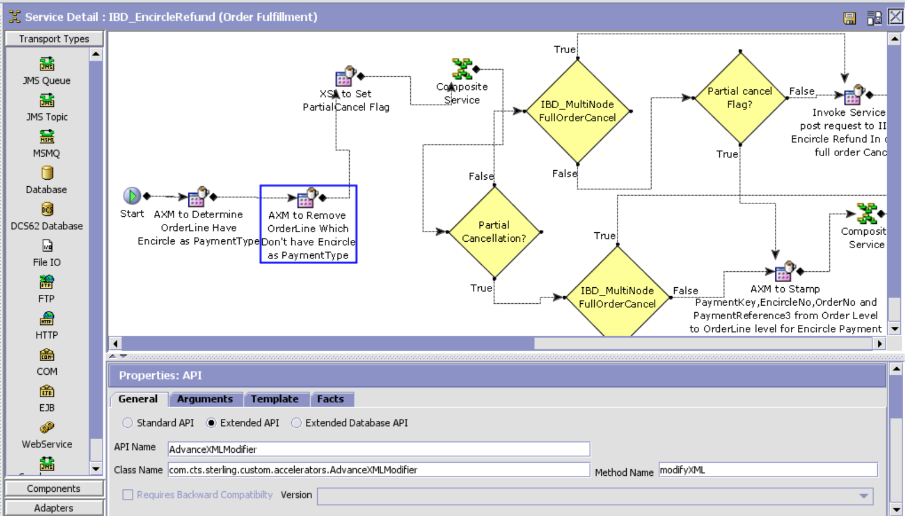

AXM Template:

<?xml version="1.0" encoding="UTF-8"?>

<ManageXmlList>

<ManageXml Action="Remove" Xpath="/Order/OrderLines/OrderLine[@IsEncircelPayment='']"/>

</ManageXmlList>

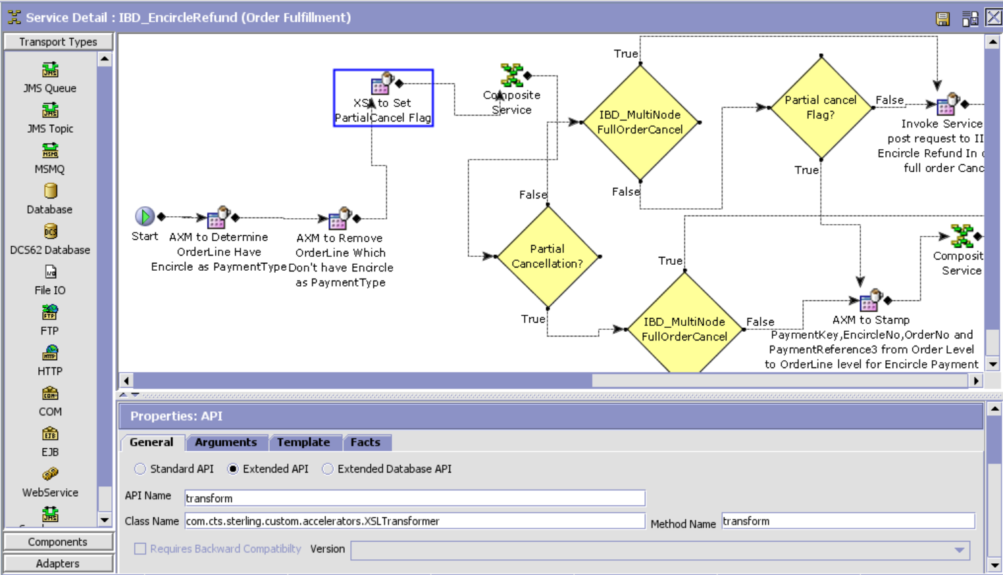

XSL Template:

<?xml version="1.0" encoding="UTF-8"?>

<xsl:stylesheet version="1.0" xmlns:xsl="http://www.w3.org/1999/XSL/Transform">

<xsl:output encoding="UTF-8" indent="no" method="xml" omit-xml-declaration="yes"/>

<xsl:strip-space elements="*"/>

<xsl:variable name="varTotalRecords" select="/Order/OrderLines/@TotalNumberOfRecords"/>

<xsl:variable name="varTotalCacelledOrderLines" select="count(/Order/OrderLines/OrderLine)"/>

<xsl:template match="@*|node()">

<xsl:copy>

<xsl:apply-templates select="@*|node()"/>

</xsl:copy>

</xsl:template>

<xsl:template match="/*">

<xsl:copy>

<xsl:apply-templates select="@*|node()"/>

<Order>

<xsl:if test=" $varTotalCacelledOrderLines != $varTotalRecords">

<xsl:attribute name="PartialCancel">

<xsl:value-of select="'Y'"/>

</xsl:attribute>

</xsl:if>

</Order>

</xsl:copy>

</xsl:template>

</xsl:stylesheet>

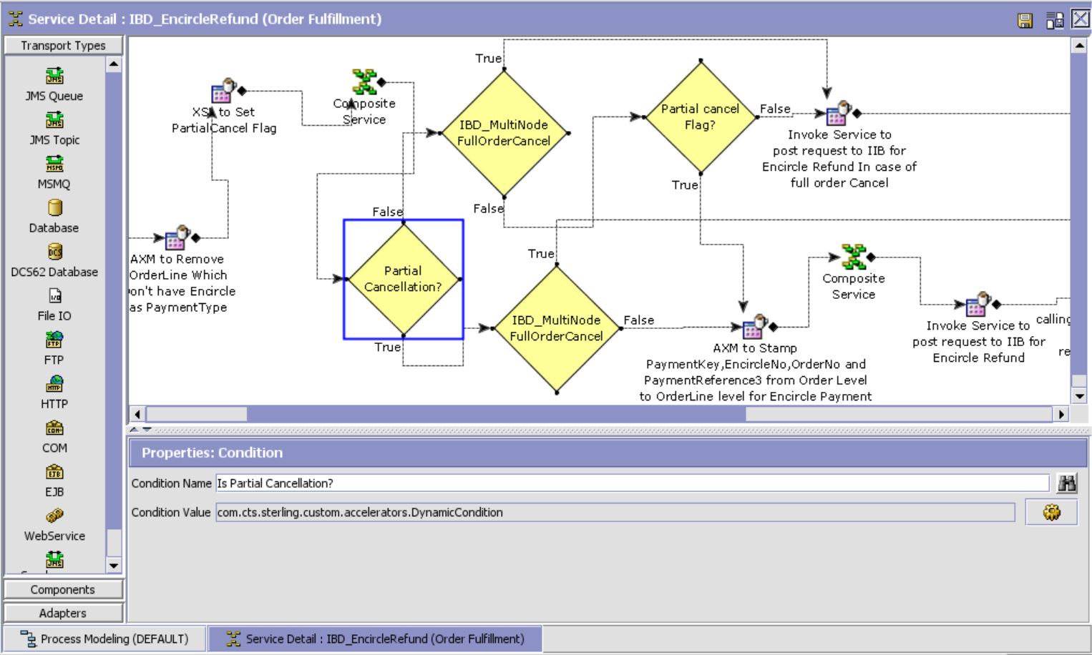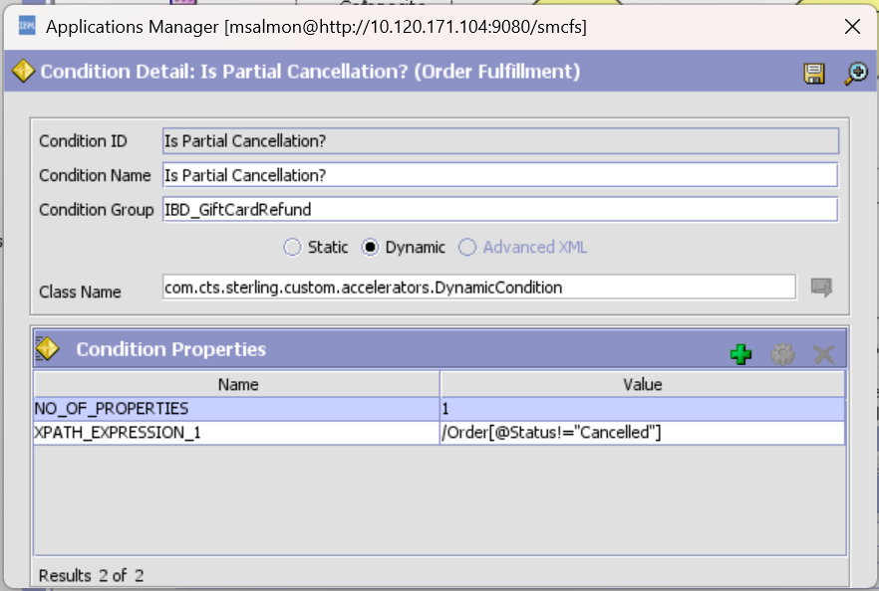

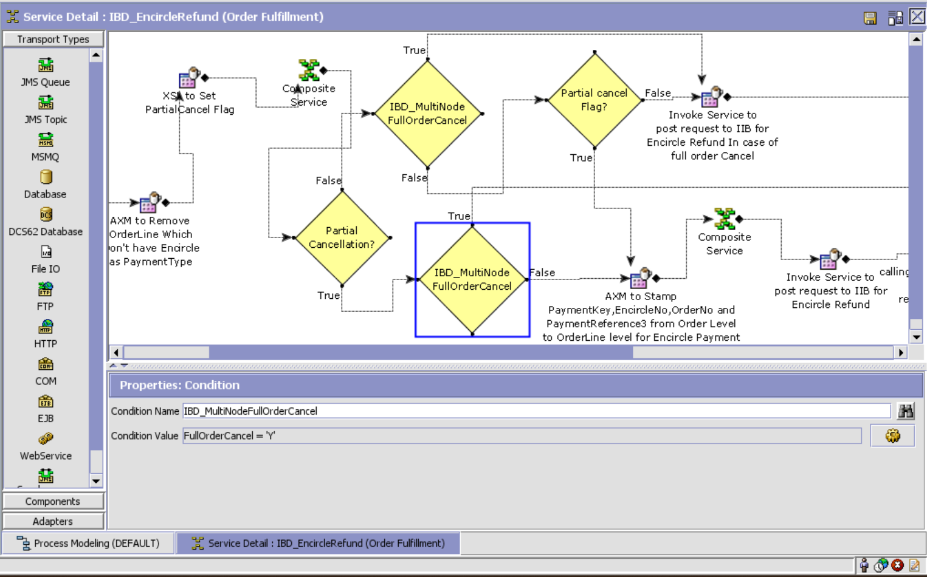

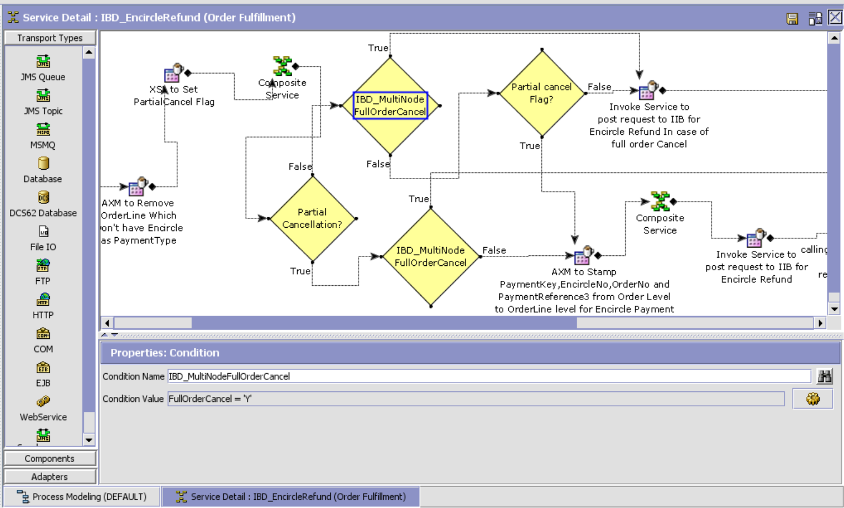

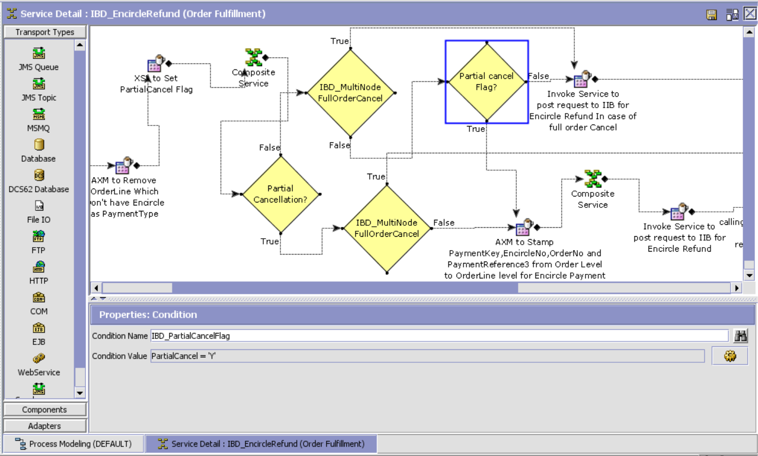

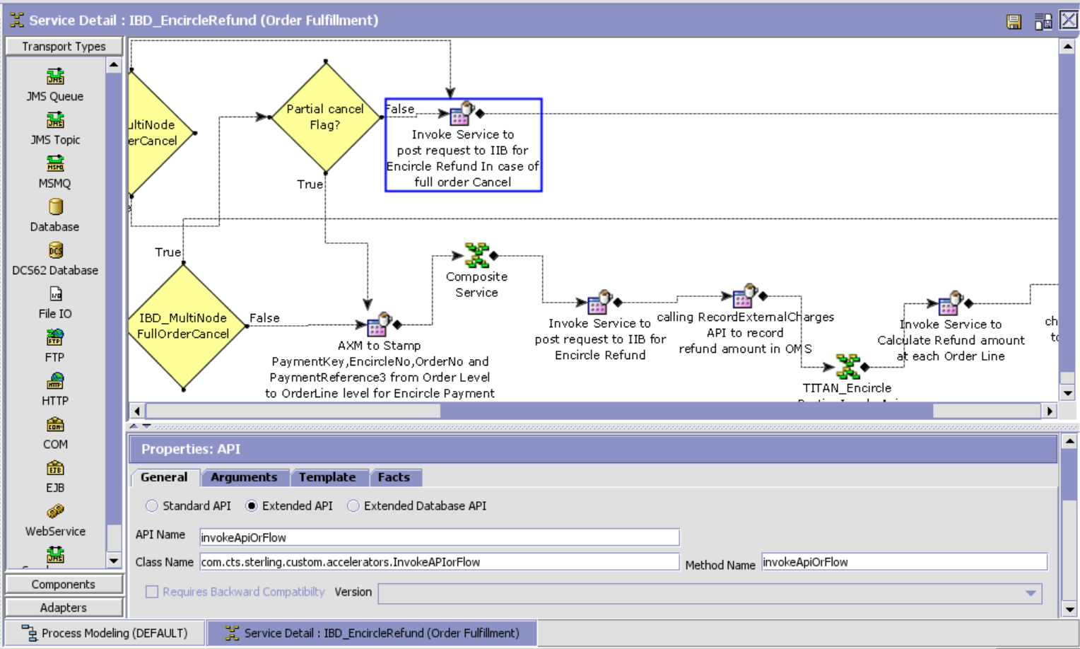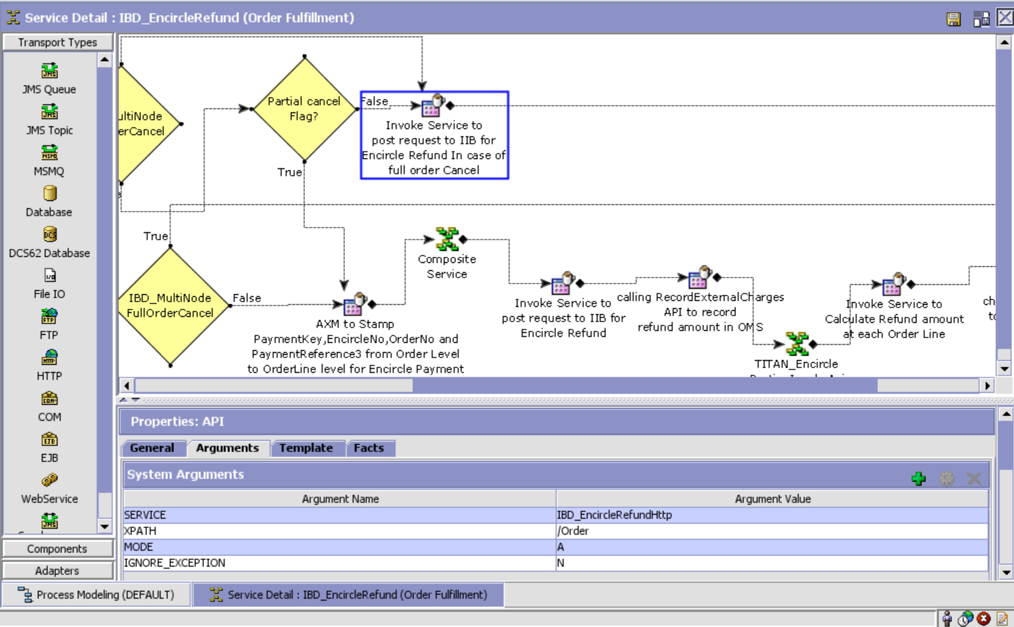

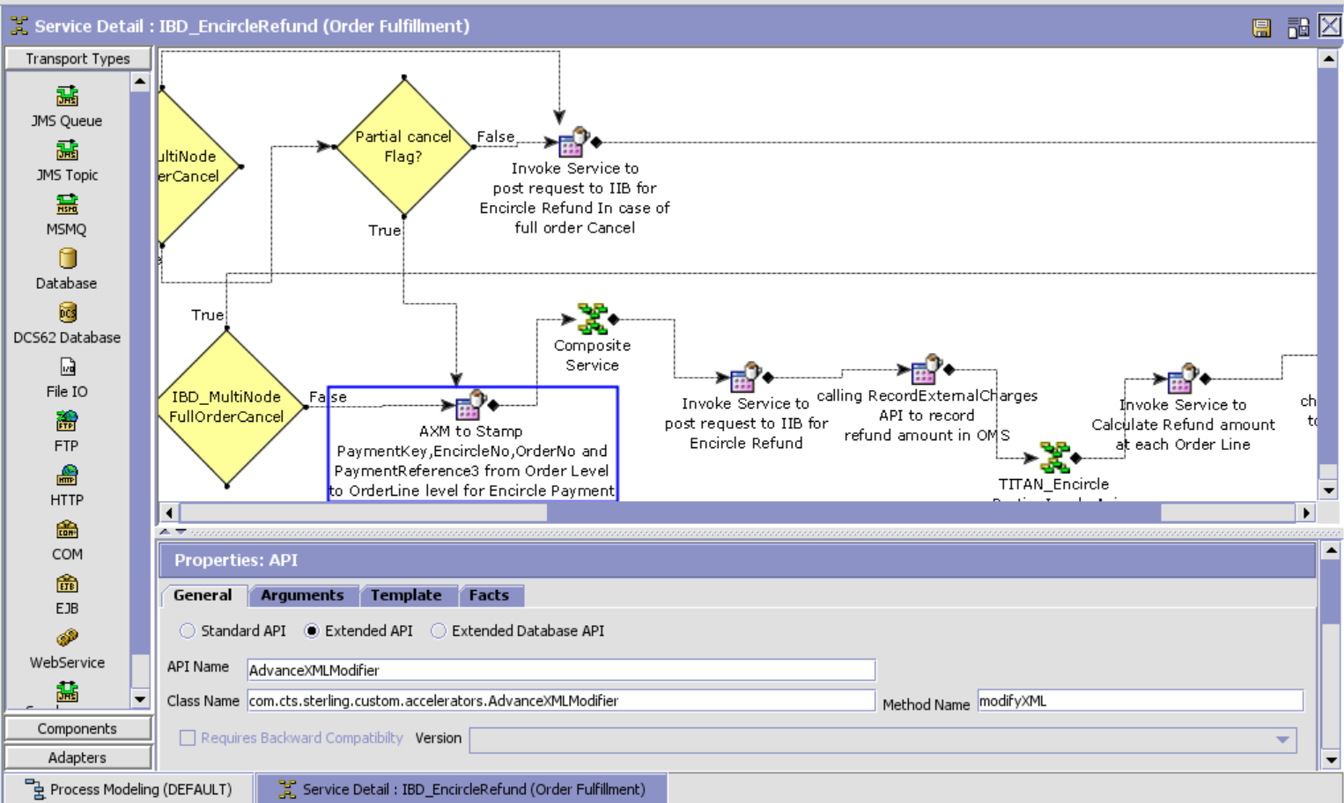

Template :

<?xml version="1.0" encoding="UTF-8"?>

<ManageXmlList>

<ManageXml Action="Manage" AttributeName="ExtnCountryCode"

AttributeValue="/Order/Extn/@ExtnCountryCode" Xpath="/Order/OrderLines/OrderLine[*]/Extn"/>

<ManageXml Action="Manage" AttributeName="PaymentKey"

AttributeValue="/Order/PaymentMethods/PaymentMethod[@PaymentType='Encircle']/@PaymentKey"

ElementName="TitanPaymentDetail" Xpath="/Order/OrderLines/OrderLine[*]/Extn/TitanPaymentDetailList/TitanPaymentDetail[@PaymentType='Encircle']"/>

<ManageXml Action="Manage" AttributeName="ExtnEncircleNo"

AttributeValue="/Order/Extn/@ExtnEncircleNo"

ElementName="TitanPaymentDetail" Xpath="/Order/OrderLines/OrderLine[*]/Extn/TitanPaymentDetailList/TitanPaymentDetail[@PaymentType='Encircle']"/>

<ManageXml Action="Manage" AttributeName="PaymentReference3"

AttributeValue="/Order/PaymentMethods/PaymentMethod[@PaymentType='Encircle']/@PaymentReference3"

ElementName="TitanPaymentDetail" Xpath="/Order/OrderLines/OrderLine[*]/Extn/TitanPaymentDetailList/TitanPaymentDetail[@PaymentType='Encircle']"/>

<!-- Stamping Order Number to Order Level -->

<ManageXml Action="Manage" AttributeName="OrderNo"

AttributeValue="/Order/@OrderNo" Xpath="/Order/OrderLines/OrderLine[*]"/>

<!-- Stamping Order Number to Order Level -->

<!-- Stamping ExtnBrand To orderLine -->

<ManageXml Action="Manage" AttributeName="ExtnBrand"

AttributeValue="/Order/Extn/@ExtnBrand"

ElementName="TitanPaymentDetail" Xpath="/Order/OrderLines/OrderLine[*]/Extn/TitanPaymentDetailList/TitanPaymentDetail[@PaymentType='Encircle']"/>

<!-- Stamping ExtnBrand To orderLine -->

</ManageXmlList>

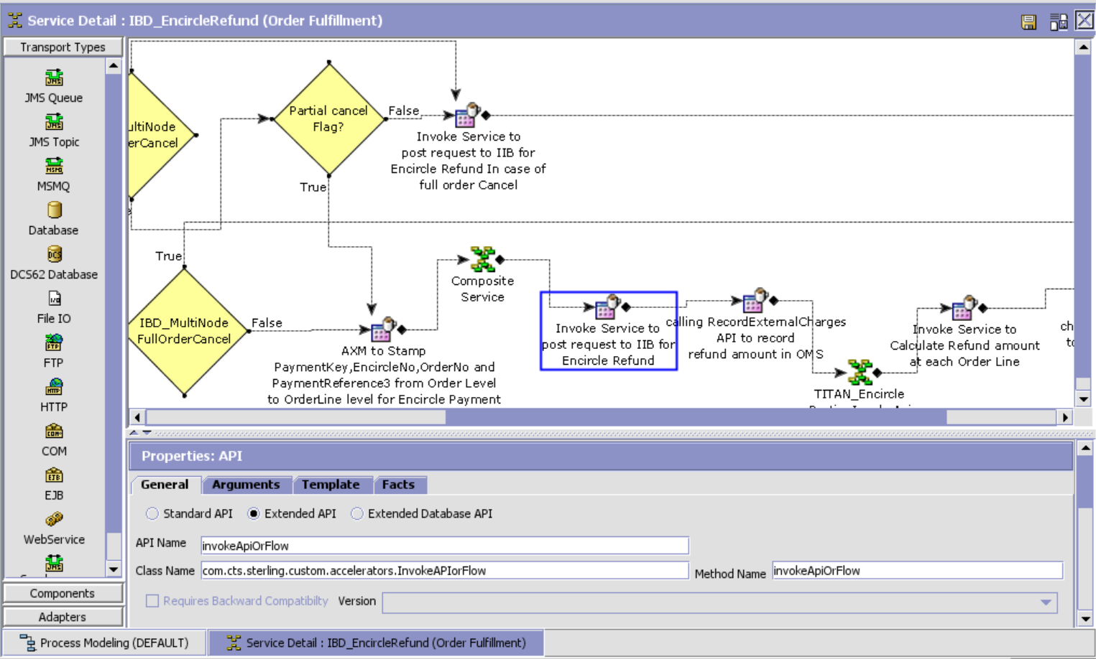

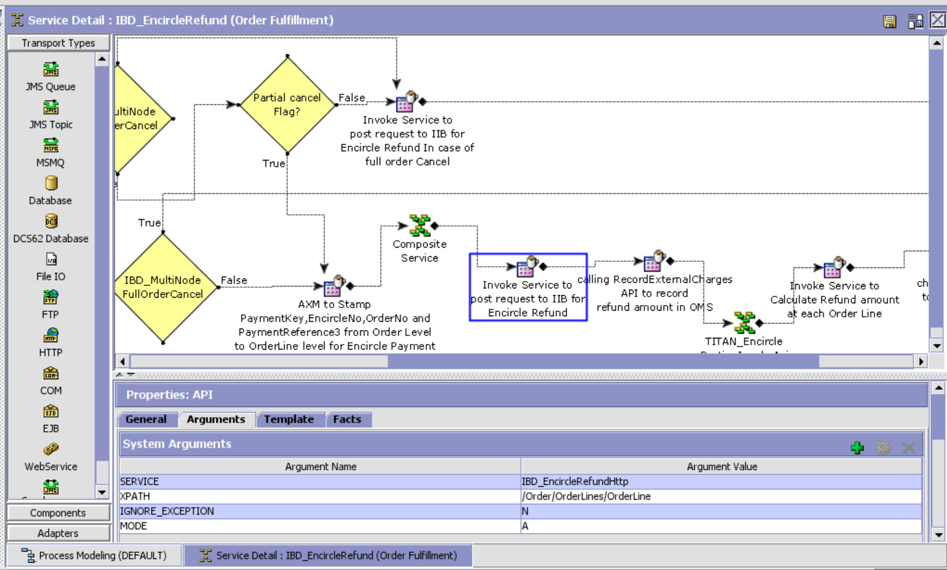

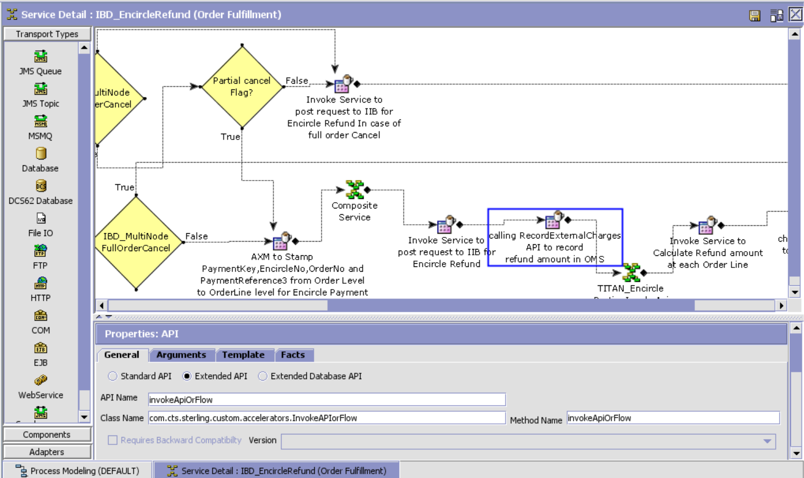

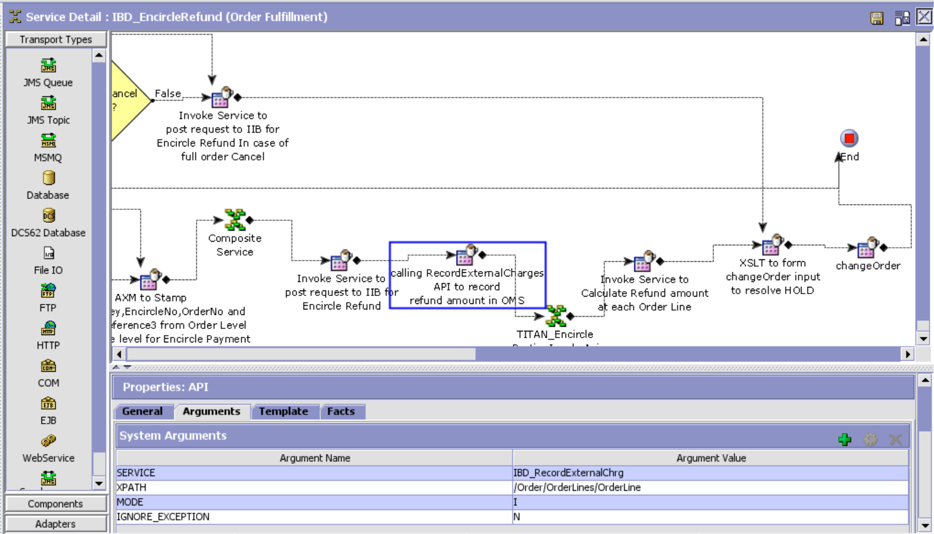

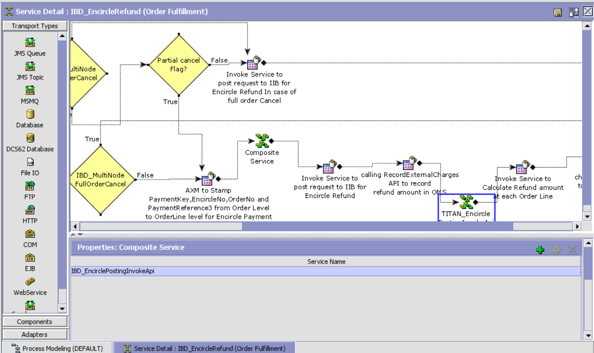

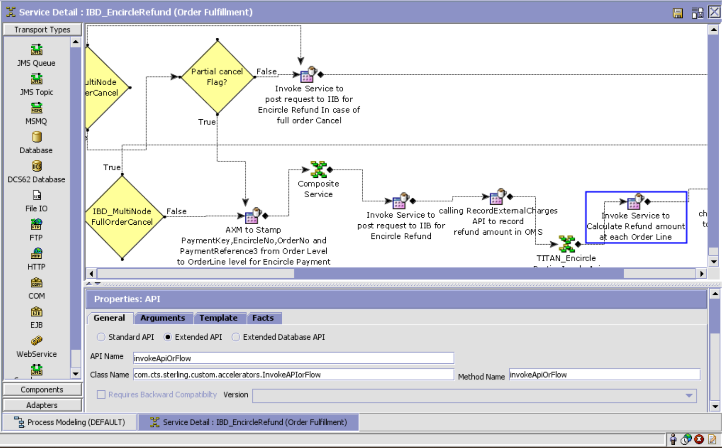

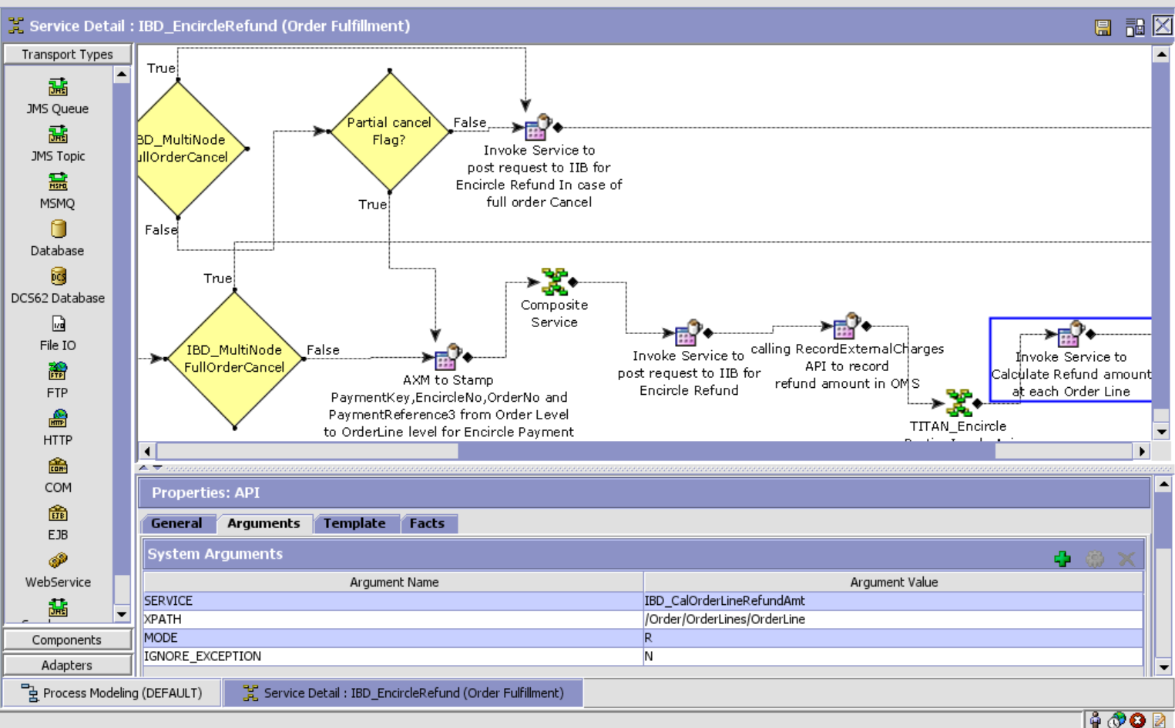

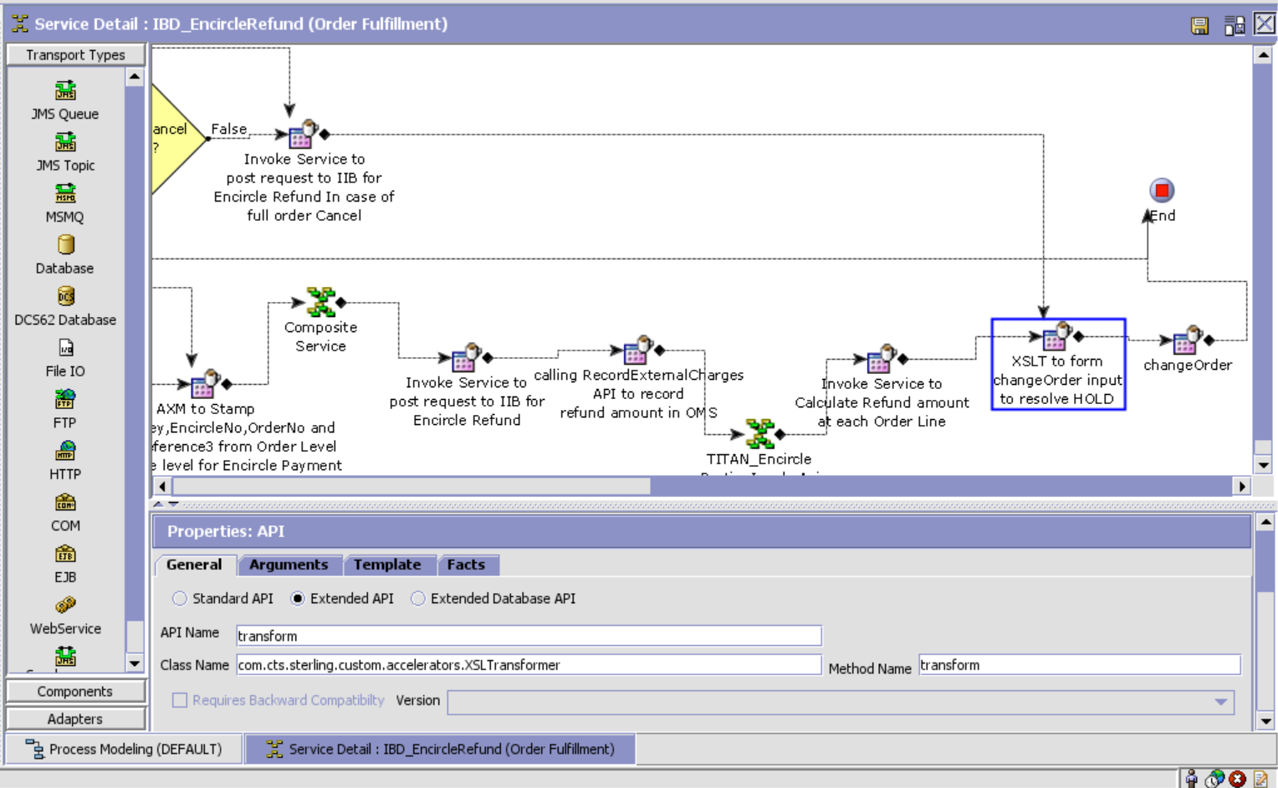

XSL: Template:

<?xml version="1.0" encoding="UTF-8"?>

<xsl:stylesheet version="1.0" xmlns:xsl="http://www.w3.org/1999/XSL/Transform">

<xsl:template match="/">

<xsl:variable name="varEncirclePointsRedeemed" select="sum(/Order/OrderLines/OrderLine/@EncirclePoints)"/>

<xsl:variable name="varEncirclePointsToRedeemed" select="/Order/Extn/@ExtnEncirclePointsToRefund"/>

<xsl:variable name="varNewExtnEncirclePointsToRefund" select="format-number((($varEncirclePointsToRedeemed)-($varEncirclePointsRedeemed)),'0.##')"/>

<xsl:element name="Order">

<xsl:attribute name="OrderHeaderKey">

<xsl:value-of select="Order/@OrderHeaderKey"/>

</xsl:attribute>

<xsl:attribute name="Action">MODIFY</xsl:attribute>

<xsl:attribute name="Override">Y</xsl:attribute>

<xsl:element name="Extn">

<xsl:attribute name="ExtnEncirclePointsToRefund">

<xsl:value-of select="$varNewExtnEncirclePointsToRefund"/>

</xsl:attribute>

</xsl:element>  
 <xsl:element name="OrderHoldTypes">  
 <xsl:element name="OrderHoldType">  
 <xsl:attribute

name="HoldType">EN_REFUND_HOLD</xsl:attribute>  
 <xsl:attribute name="Status">1300</xsl:attribute>  
 </xsl:element>  
 </xsl:element>  
 </xsl:element>  
</xsl:template>

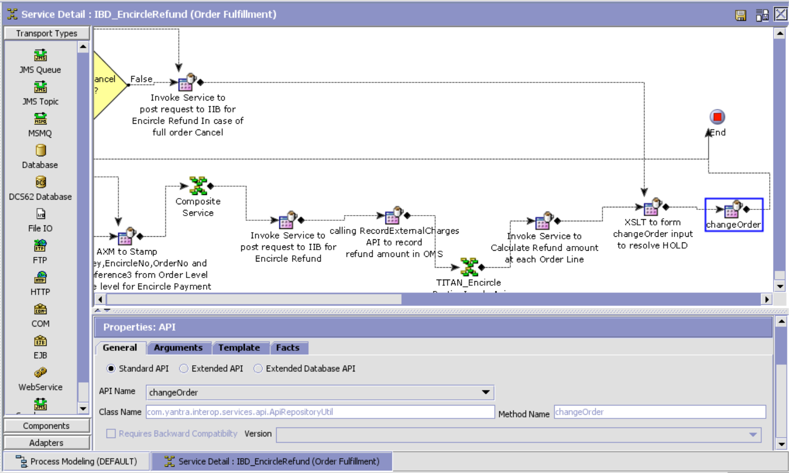

IBD_EncircleRefundHttp

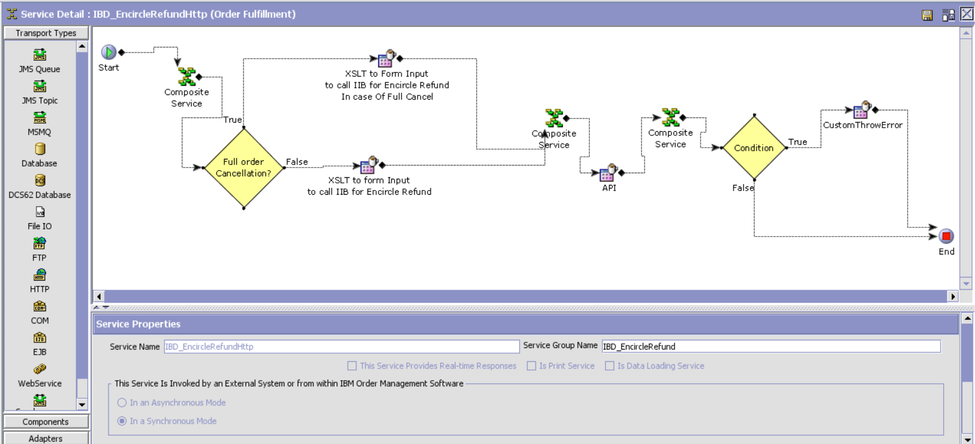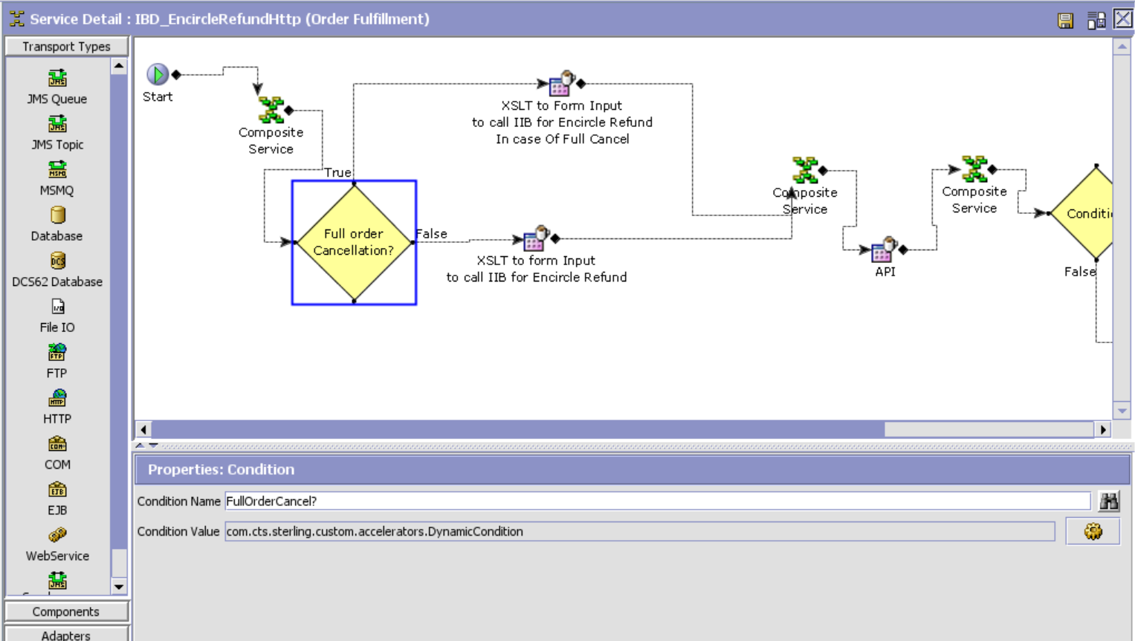

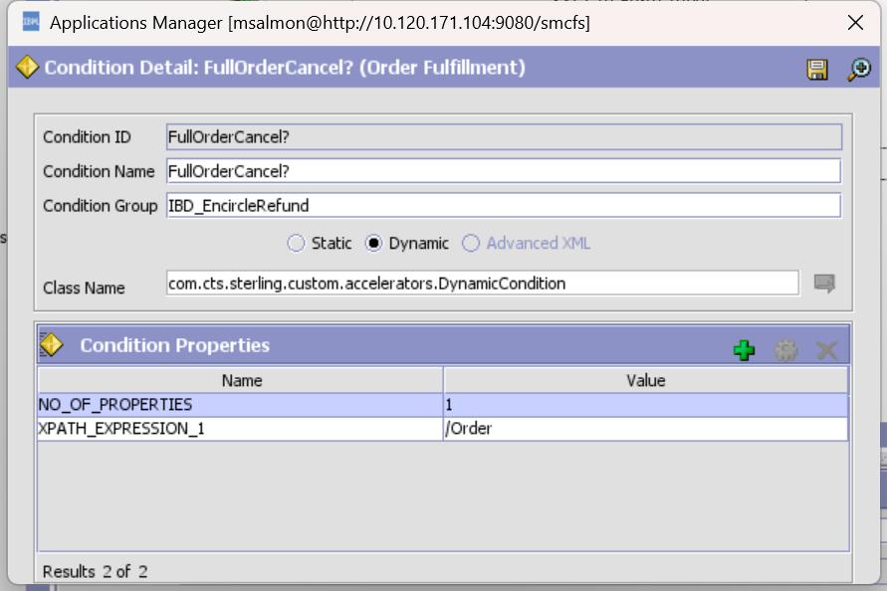

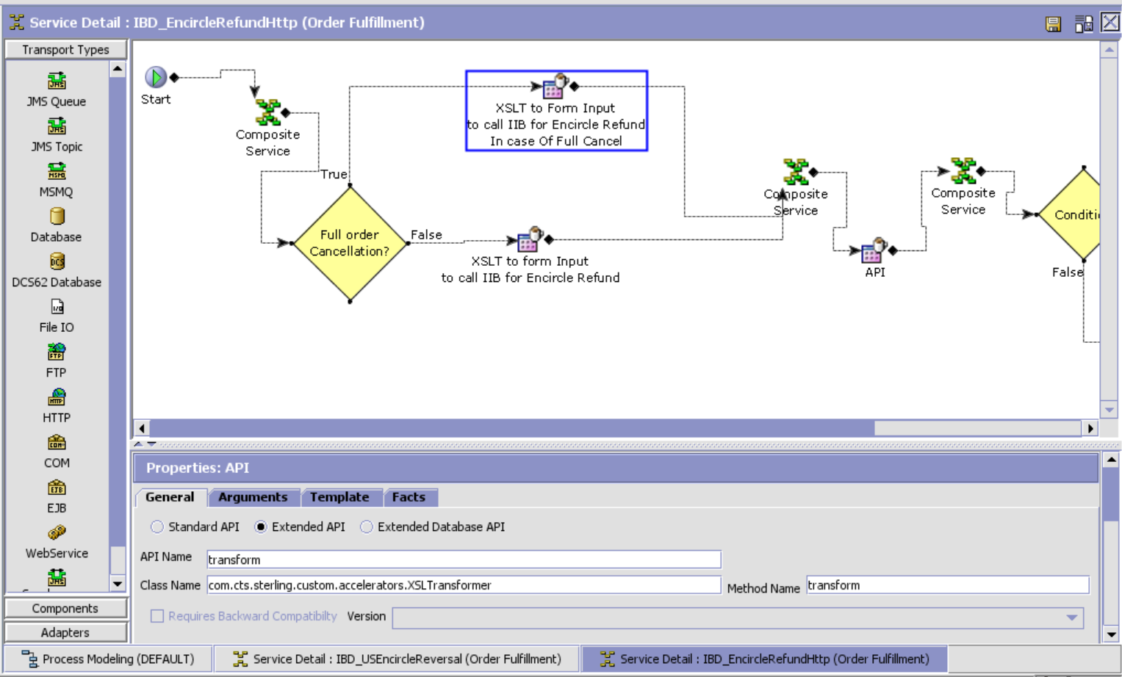

XSL Template

<xsl:stylesheet version="1.0" xmlns:xsl="[http://www.w3.org/1999/XSL/Transform">](http://www.w3.org/1999/XSL/Transform%22%3E) <xsl:variable name="varAmountPerUnit" select="OrderLine/Extn/TitanPaymentDetailList/TitanPaymentDetail[@PaymentType='Encircle']/@EncirclePointsPerUnit"/> <xsl:variable name="varCancelledQty" select="OrderLine/@ChangeInOrderedQty"/> <xsl:variable name="varReversalPoints" select="(($varAmountPerUnit)*($varCancelledQty)*(-1))"/> <xsl:template match="/"> <xsl:element name="Payment"> <xsl:attribute name="PaymentGateway">NetCarrots <xsl:attribute name="ChannelCode">tanishq <xsl:attribute name="OutletCode">tab <xsl:attribute name="OrganizationCode"> <xsl:value-of select="/Order/@EnterpriseCode"/> <xsl:attribute name="MembershipNo"> <xsl:value-of select="/Order/Extn/@ExtnEncircleNo"/> <xsl:attribute name="ExtnBrand"> <xsl:value-of select="/Order/Extn/@ExtnBrand"/> <xsl:attribute name="UniqueId"> <xsl:value-of select="/Order/@OrderHeaderKey"/> <xsl:attribute name="RRNumber"> <xsl:value-of select="/Order/PaymentMethods/PaymentMethod[@PaymentType='Encircle']/@PaymentReference3"/> <xsl:attribute name="ReversalPoints"> <xsl:value-of select="/Order/Extn/@ExtnEncirclePointsToRefund"/> <xsl:attribute name="CustomerPhoneNo"> <xsl:value-of select="/Order/@CustomerPhoneNo"/> <xsl:attribute name="CustomerEMailID"> <xsl:value-of select="/Order/@CustomerEMailID"/> <xsl:attribute name="CountryCode"> <xsl:value-of select="/Order/Extn/@ExtnCountryCode"/>

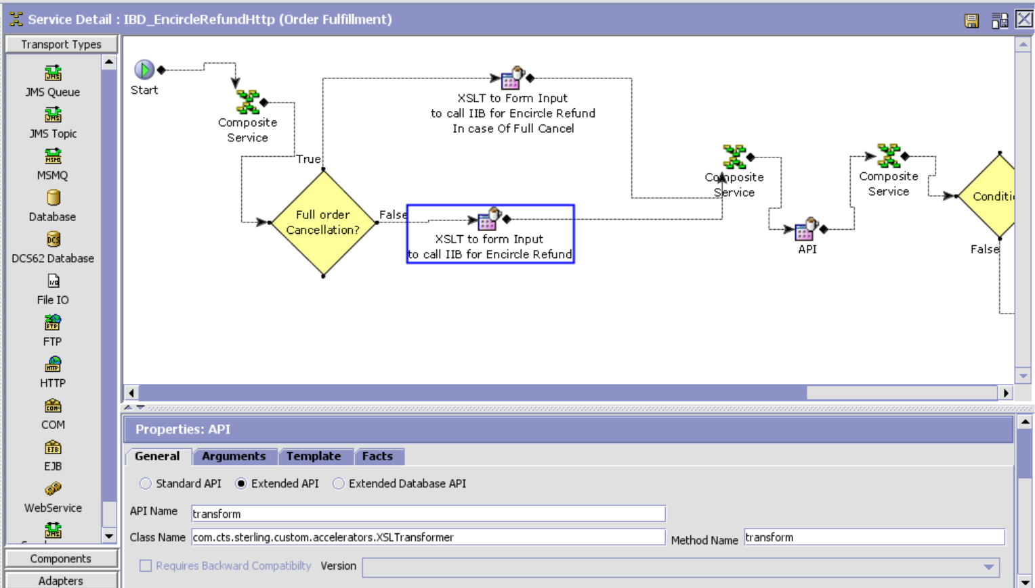

<xsl:stylesheet version="1.0" xmlns:xsl="[http://www.w3.org/1999/XSL/Transform">](http://www.w3.org/1999/XSL/Transform%22%3E) <xsl:variable name="varAmountPerUnit" select="OrderLine/Extn/TitanPaymentDetailList/TitanPaymentDetail[@PaymentType='Encircle']/@EncirclePointsPerUnit"/> <xsl:variable name="varCancelledQty" select="OrderLine/@ChangeInOrderedQty"/> <xsl:variable name="varReversalPoints" select="(($varAmountPerUnit)*($varCancelledQty)*(-1))"/> <xsl:variable name="varOrderLineStatus" select="(OrderLine/@Status)"/> <xsl:variable name="varEncirclePointsPerLine" select="OrderLine/Extn/TitanPaymentDetailList/TitanPaymentDetail[@PaymentType='Encircle']/@EncirclePointsPerLine"/> <xsl:variable name="varEncirclePoints"> xsl:choose <xsl:when test=" $varOrderLineStatus = 'Cancelled'"> <xsl:value-of select="floor($varReversalPoints+$varEncirclePointsPerLine)"/> xsl:otherwise <xsl:value-of select="floor($varReversalPoints)"/> </xsl:otherwise>

</xsl:choose>

</xsl:variable>

<xsl:template match="/">

<xsl:element name="Payment">

<xsl:attribute name="PaymentGateway">

<xsl:value-of select="OrderLine/Extn/TitanPaymentDetailList/TitanPaymentDetail[@PaymentType='Encircle']/@PaymentGateway"/>

</xsl:attribute>

<xsl:attribute name="ChannelCode">tanishq</xsl:attribute>

<xsl:attribute name="OutletCode">tab</xsl:attribute>

<xsl:attribute name="OrganizationCode">

<xsl:value-of select="/OrderLine/ItemDetails/@OrganizationCode"/>

</xsl:attribute>

<xsl:attribute name="MembershipNo">

<xsl:value-of select="OrderLine/Extn/TitanPaymentDetailList/TitanPaymentDetail[@PaymentType='Encircle']/@ExtnEncircleNo"/>

</xsl:attribute>

<xsl:attribute name="ExtnBrand">

<xsl:value-of select="OrderLine/Extn/TitanPaymentDetailList/TitanPaymentDetail[@PaymentType='Encircle']/@ExtnBrand"/>

</xsl:attribute>

<xsl:attribute name="UniqueId">

<xsl:value-of select="OrderLine/@OrderLineKey"/>

</xsl:attribute>

<xsl:attribute name="RRNumber">

<xsl:value-of select="OrderLine/Extn/TitanPaymentDetailList/TitanPaymentDetail[@PaymentType='Encircle']/@PaymentReference3"/>

</xsl:attribute>

<xsl:attribute name="ReversalPoints">

<xsl:value-of select="$varEncirclePoints"/>

</xsl:attribute>

<xsl:attribute name="CustomerPhoneNo">

<xsl:value-of select="/OrderLine/PersonInfoShipTo/@OtherPhone"/>

</xsl:attribute>

<xsl:attribute name="CustomerEMailID">

<xsl:value-of select="/OrderLine/PersonInfoShipTo/@EMailID"/>

</xsl:attribute>

<xsl:attribute name="CountryCode">

<xsl:value-of select="/OrderLine/Extn/@ExtnCountryCode"/>

</xsl:attribute>

</xsl:element>

</xsl:template>

</xsl:stylesheet>

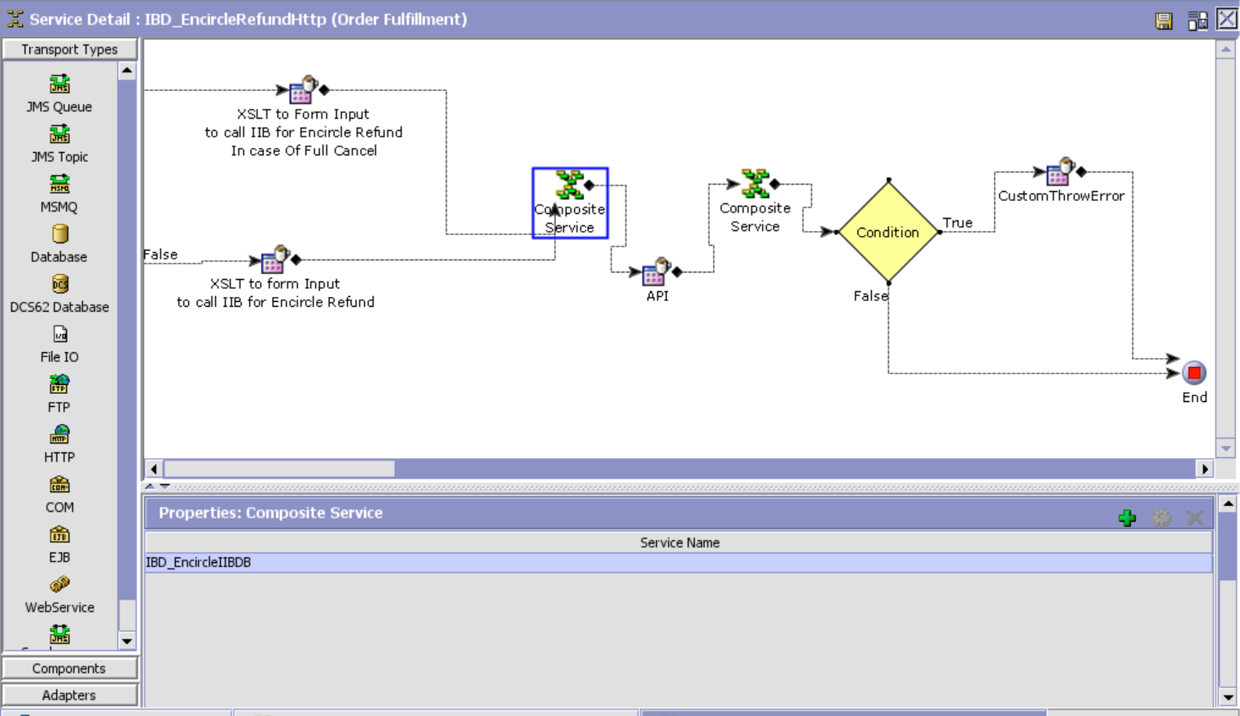

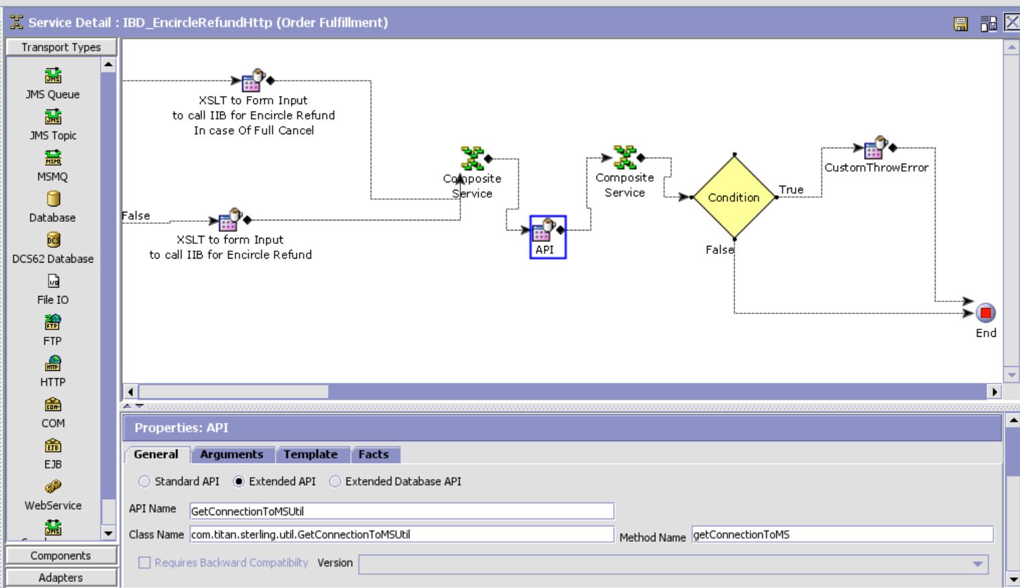

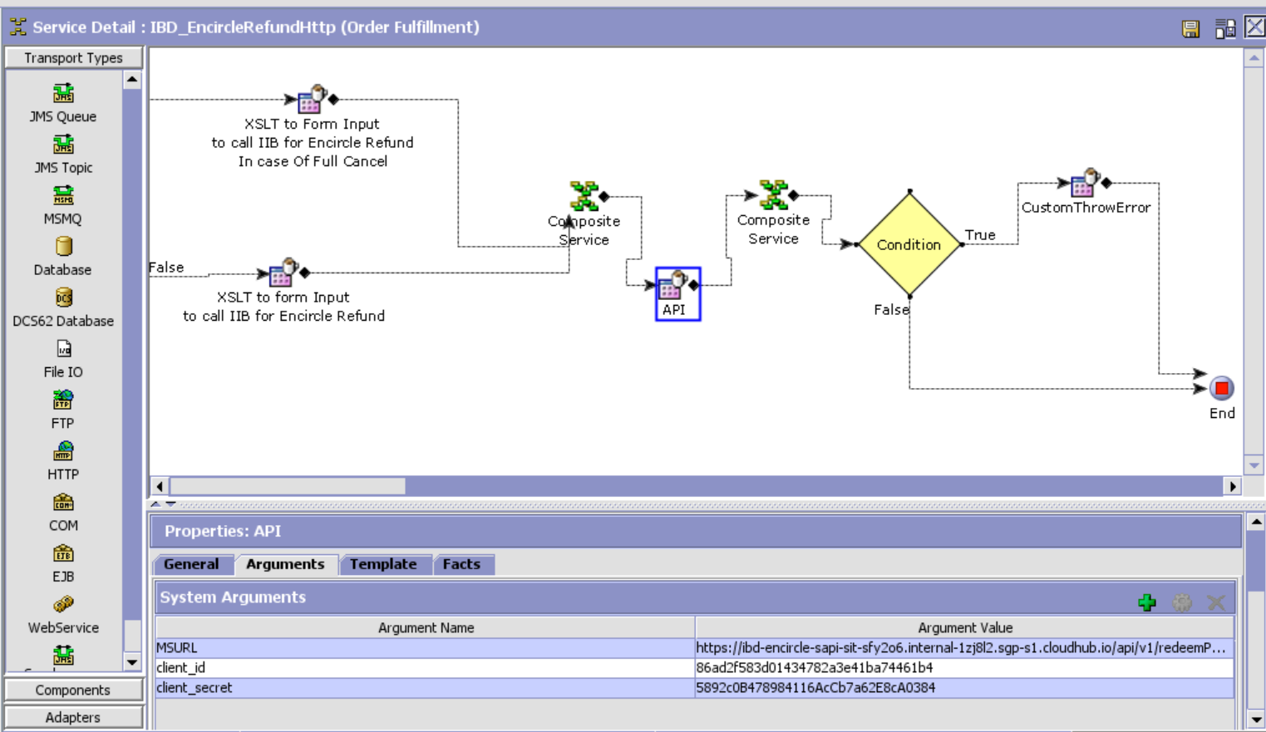

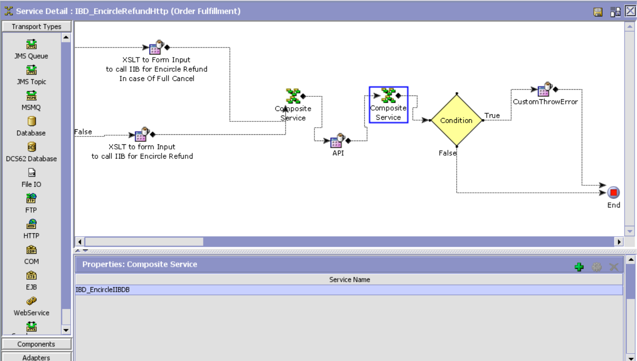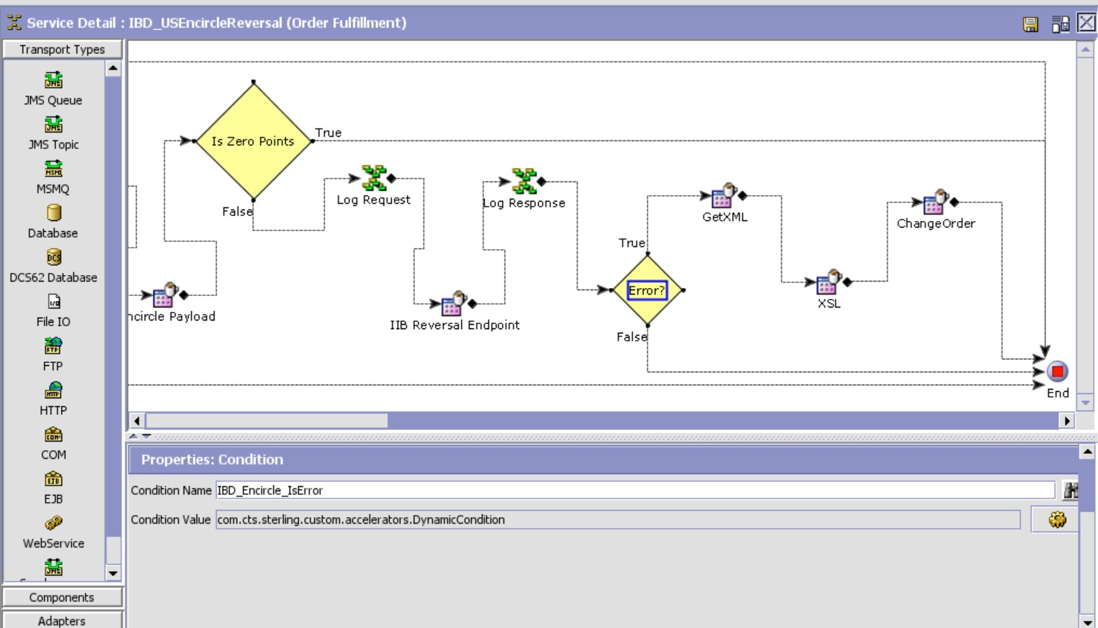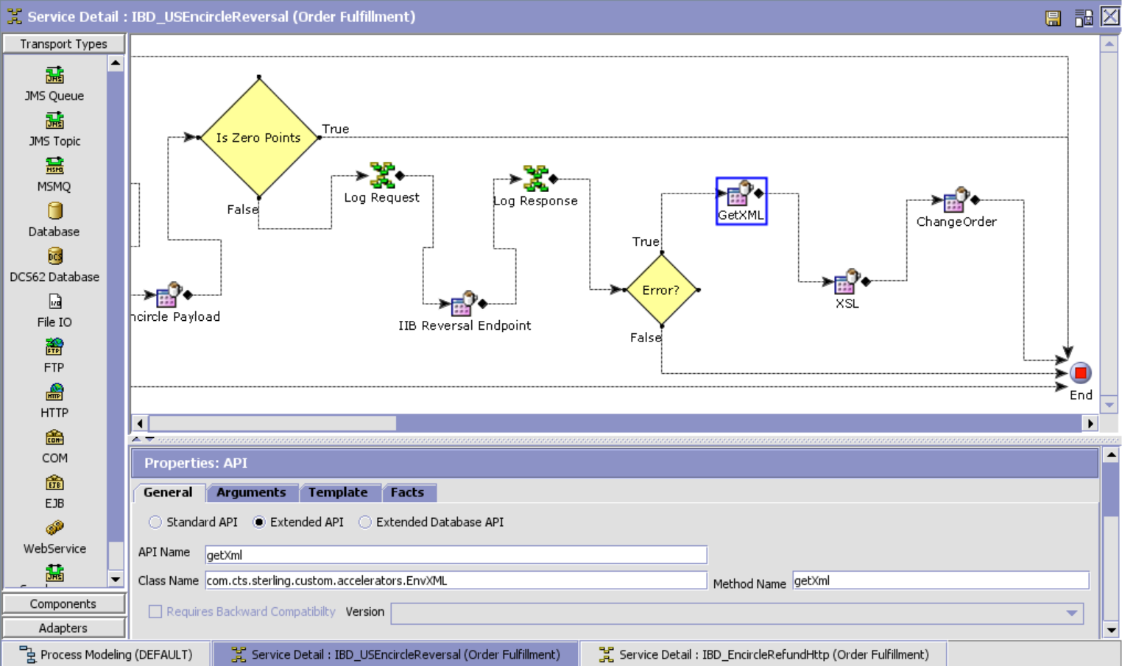

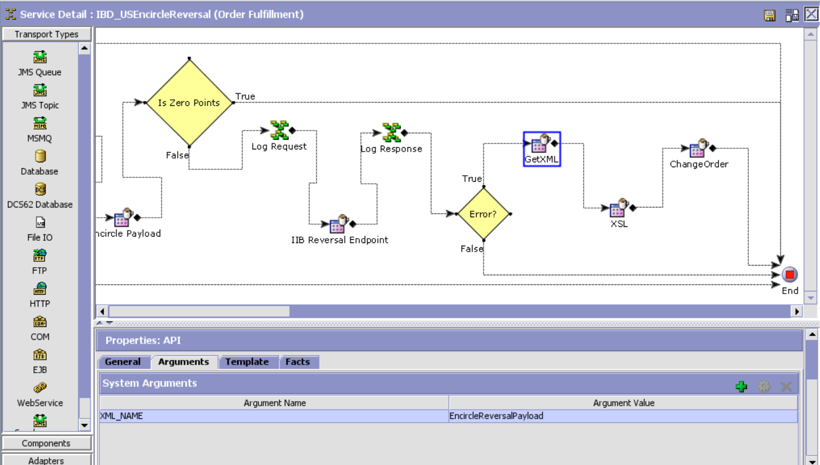

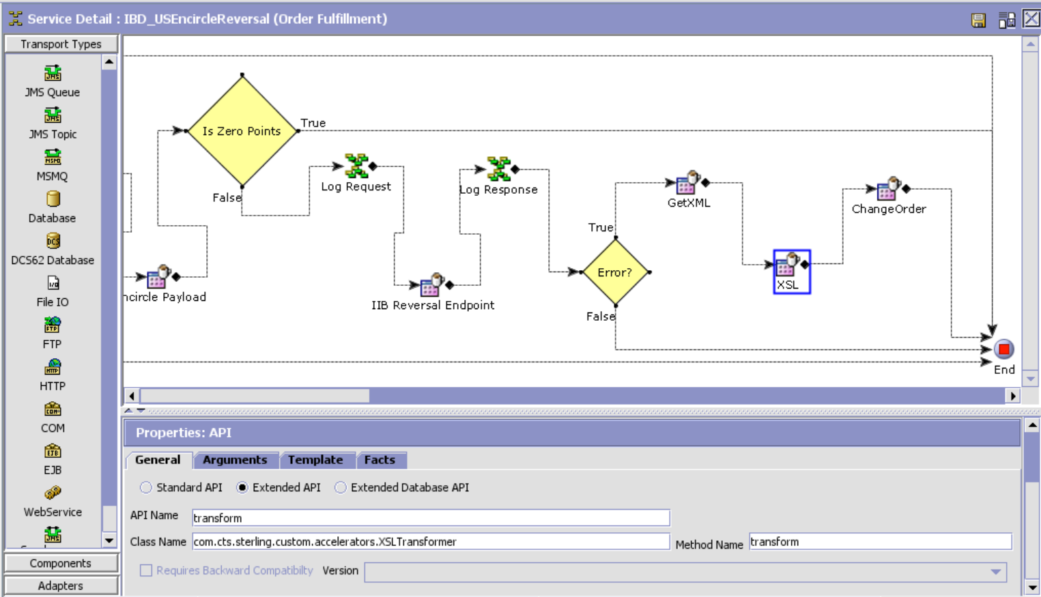XSL Template

<?xml version="1.0" encoding="UTF-8"?>

<xsl:stylesheet version="1.0" xmlns:xsl="http://www.w3.org/1999/XSL/Transform">

<xsl:template match="/">

<xsl:element name="Order">

<xsl:attribute name="OrderNo">

<xsl:value-of select="Response/Order/@OrderNo"/>

</xsl:attribute>

<xsl:attribute name="Action">MODIFY</xsl:attribute>

<xsl:attribute name="DocumentType">0001</xsl:attribute>

<xsl:attribute name="EnterpriseCode">TITAN_US</xsl:attribute>

<xsl:attribute name="Override">Y</xsl:attribute>  
 <xsl:element name="OrderHoldTypes">  
 <xsl:element name="OrderHoldType">  
 <xsl:attribute name="HoldType">EN_REFUND_HOLD</xsl:attribute>  
 <xsl:attribute name="Status">1100</xsl:attribute

</xsl:element>  
 </xsl:element>  
 </xsl:element>  
</xsl:template>

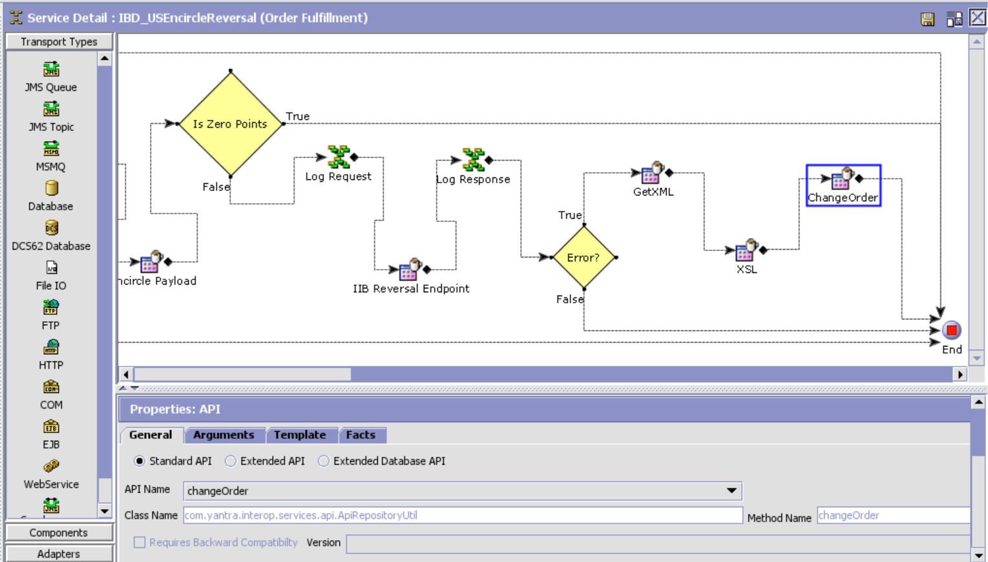

Encircle Refund

For US Enterprise:

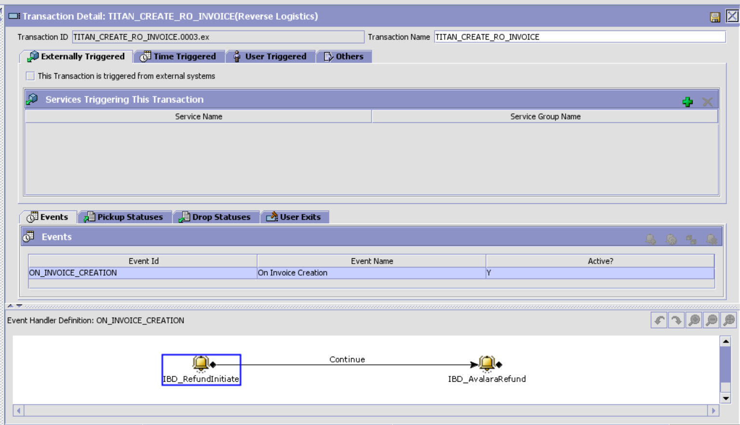

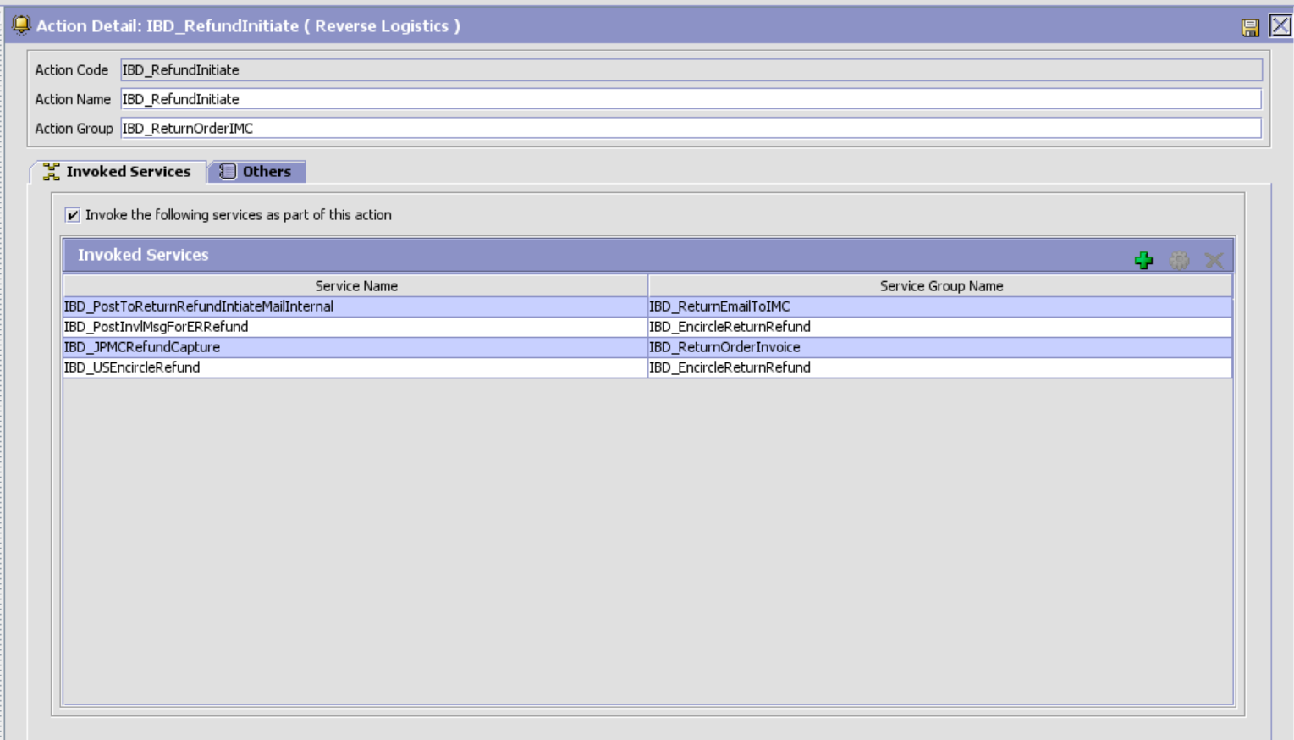

IBD_USEncircleRefund

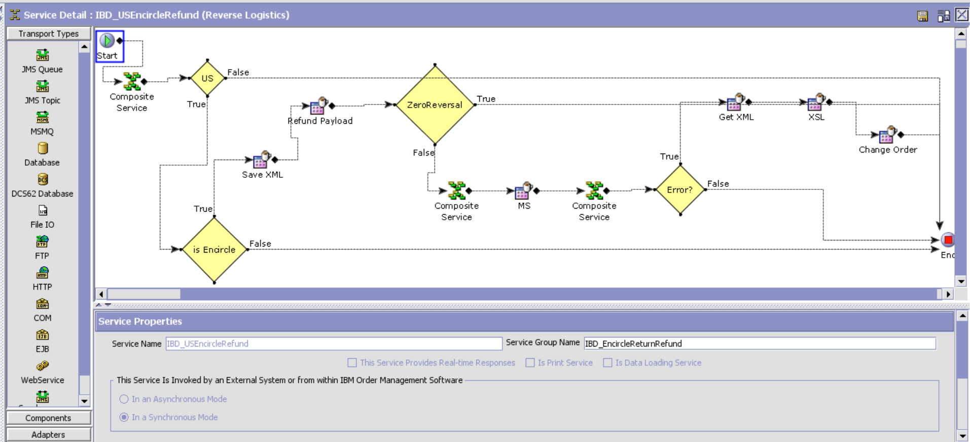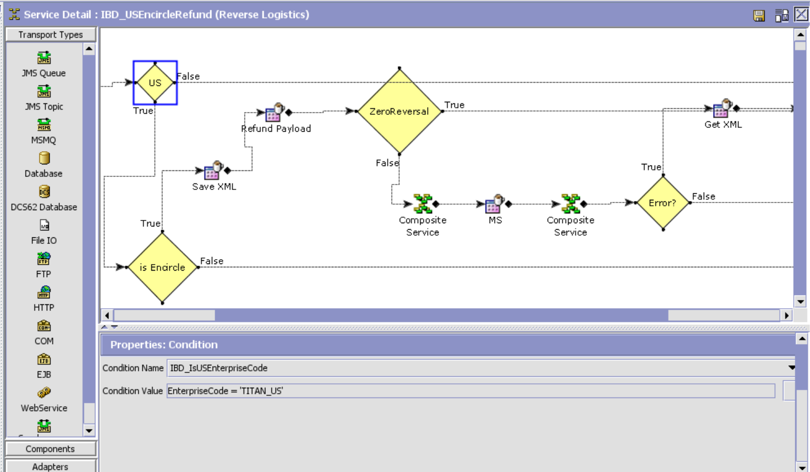

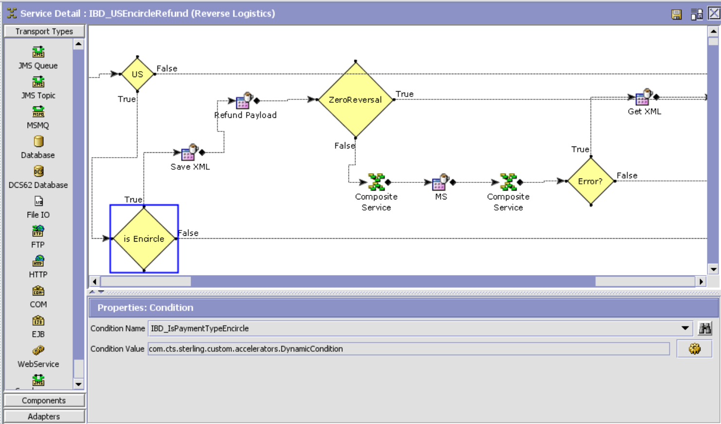

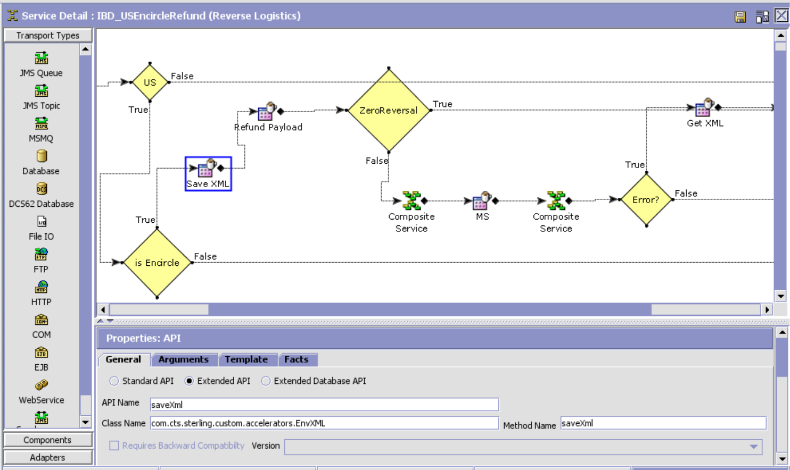

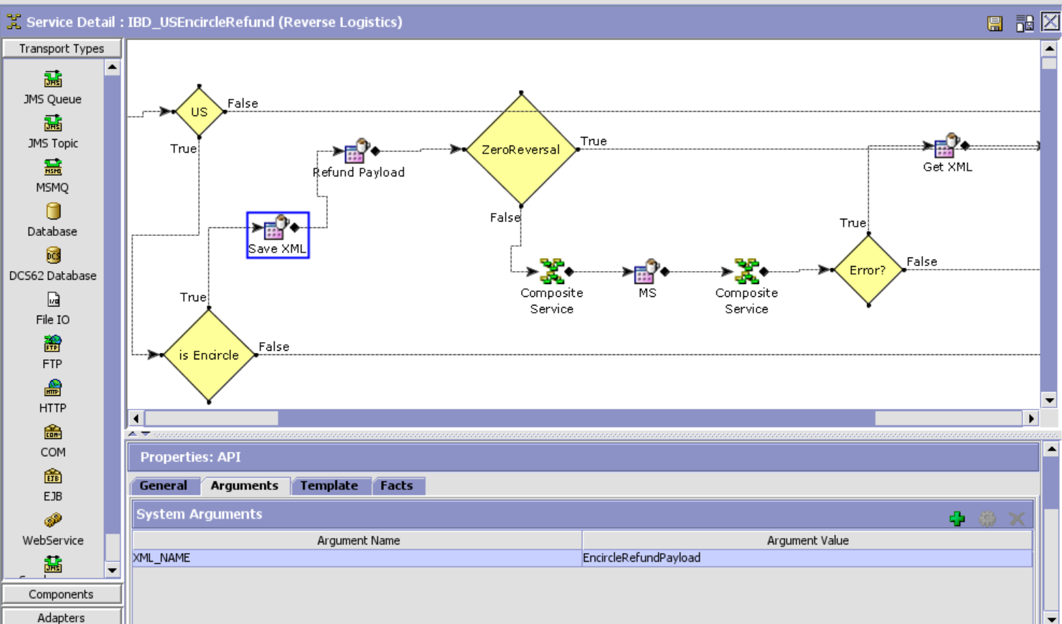

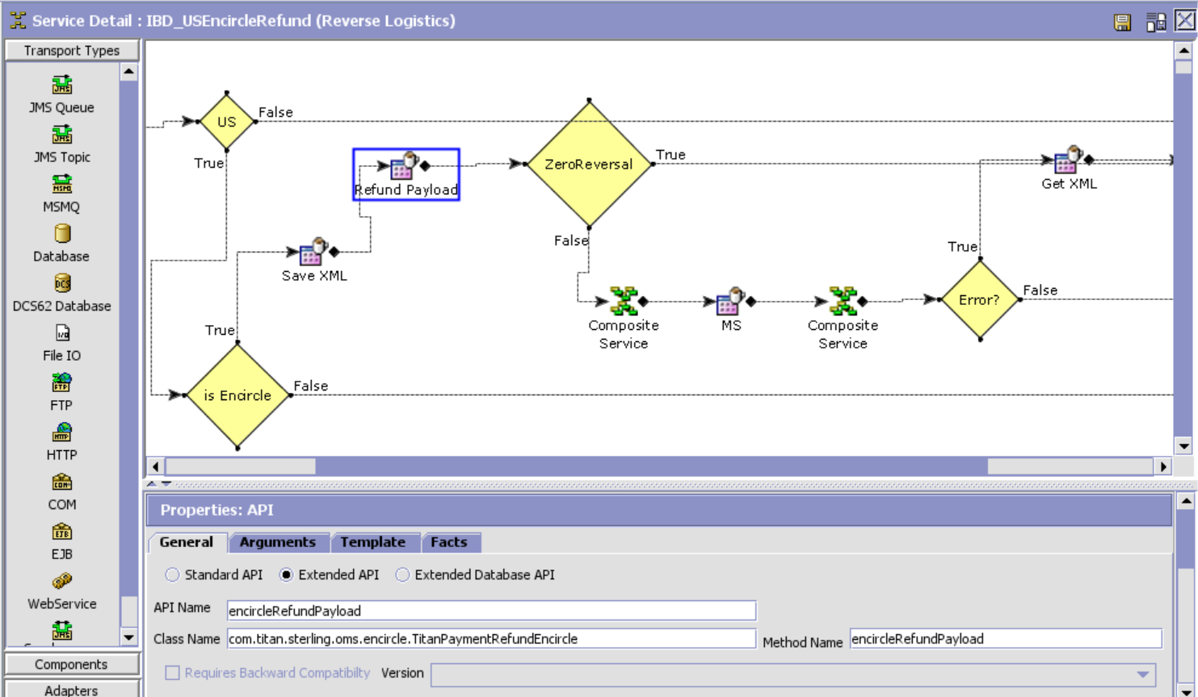

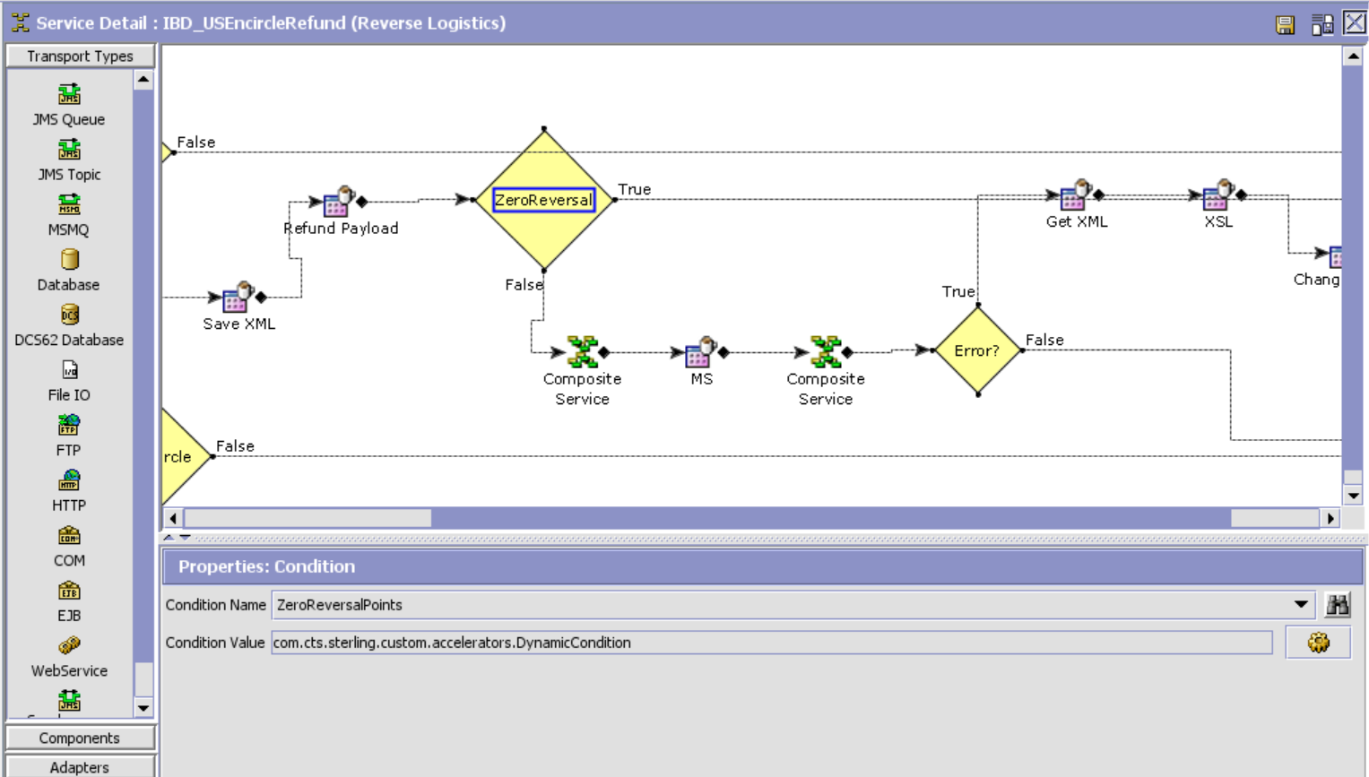

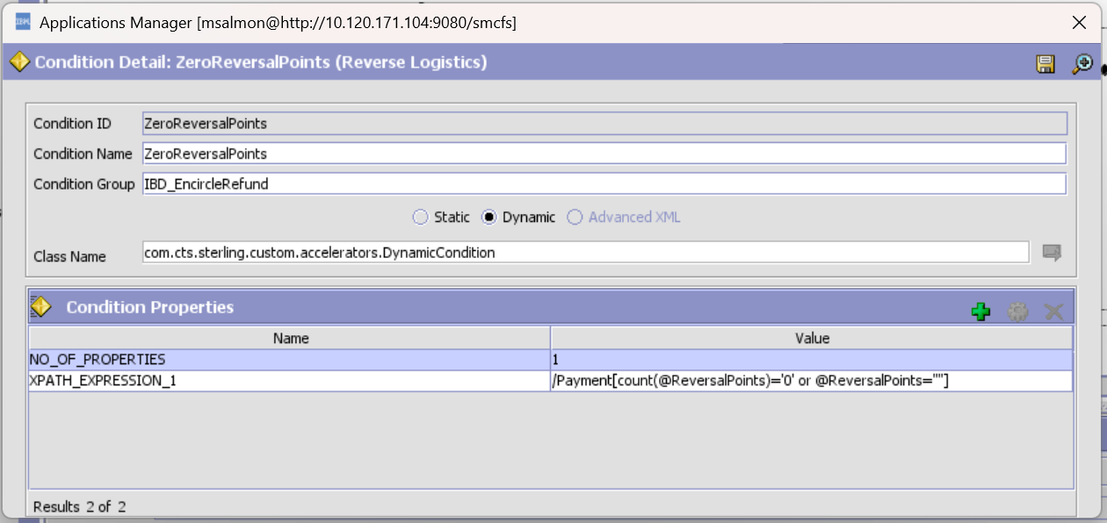

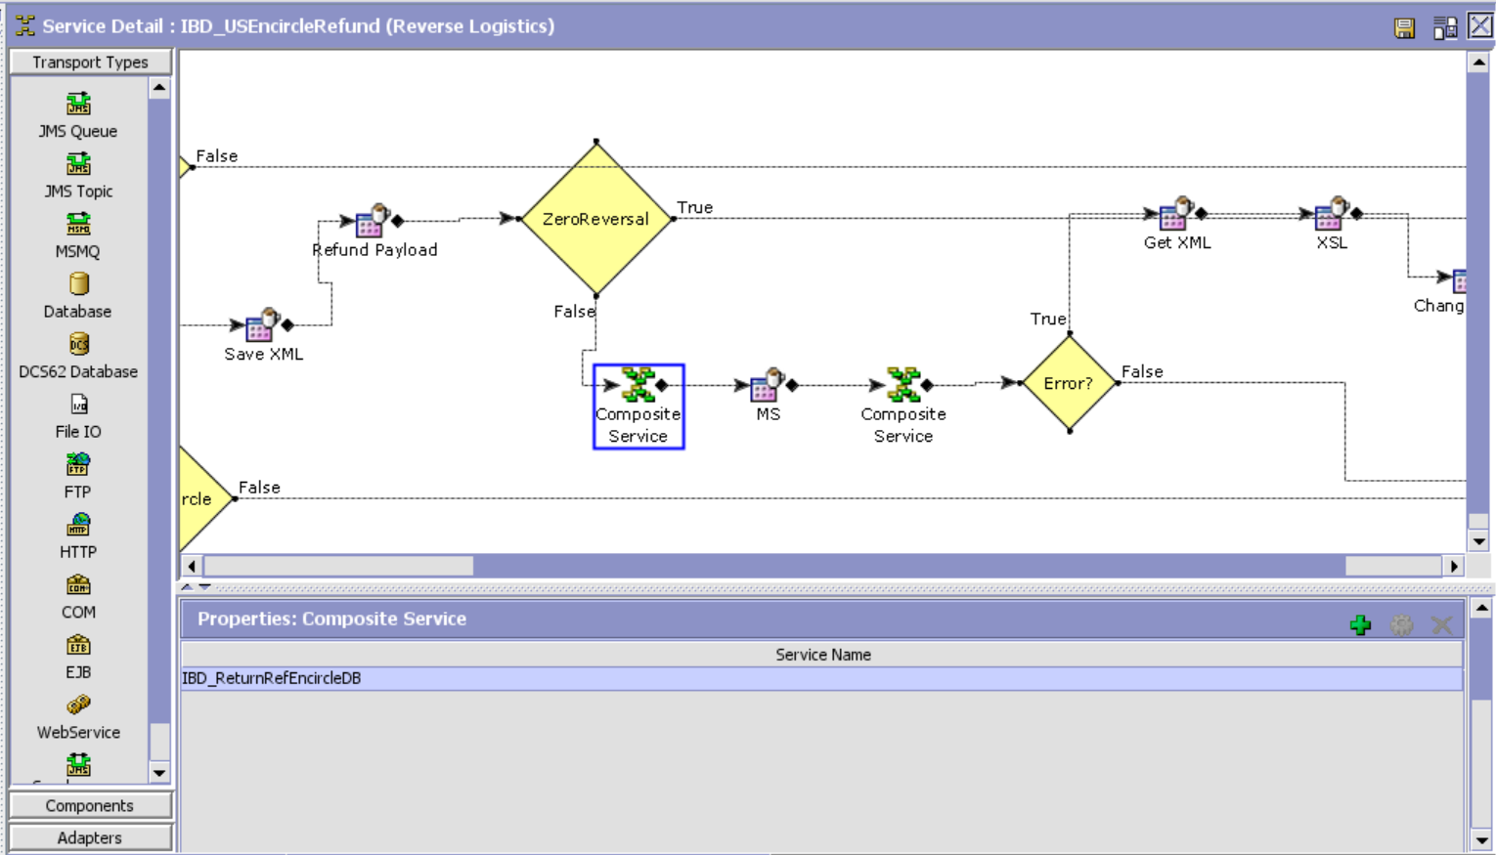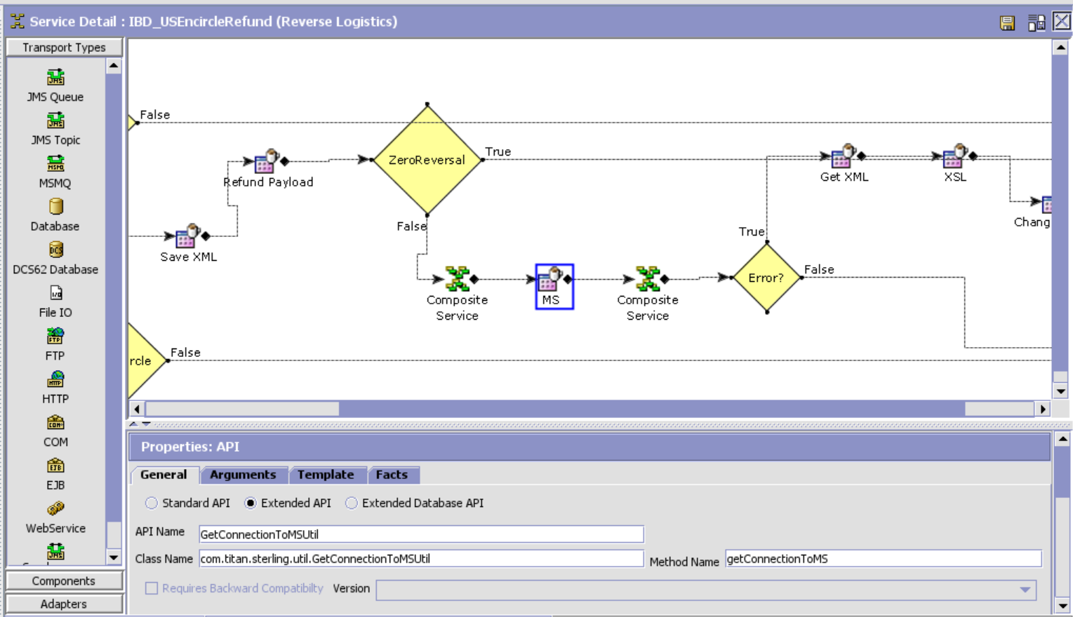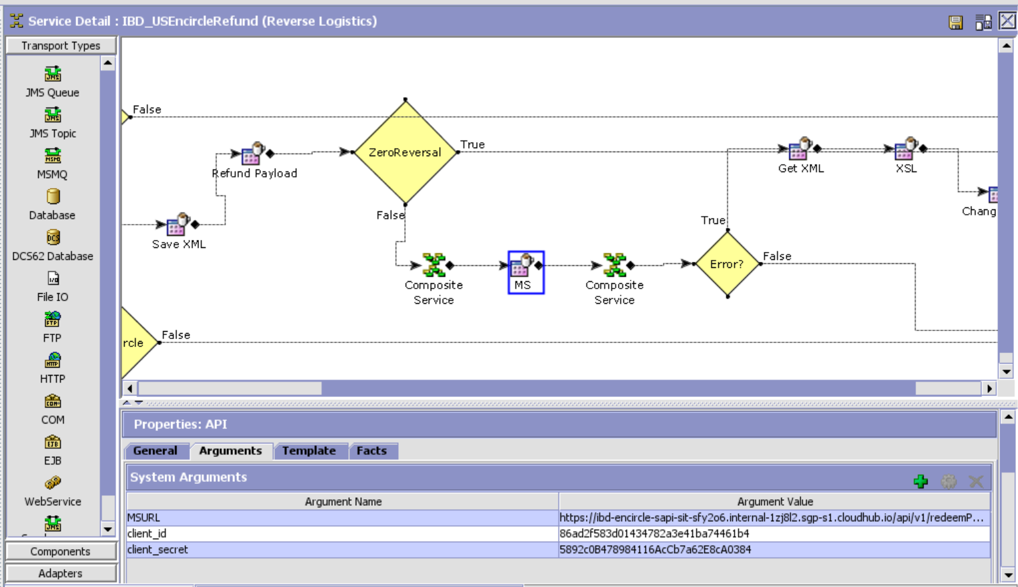

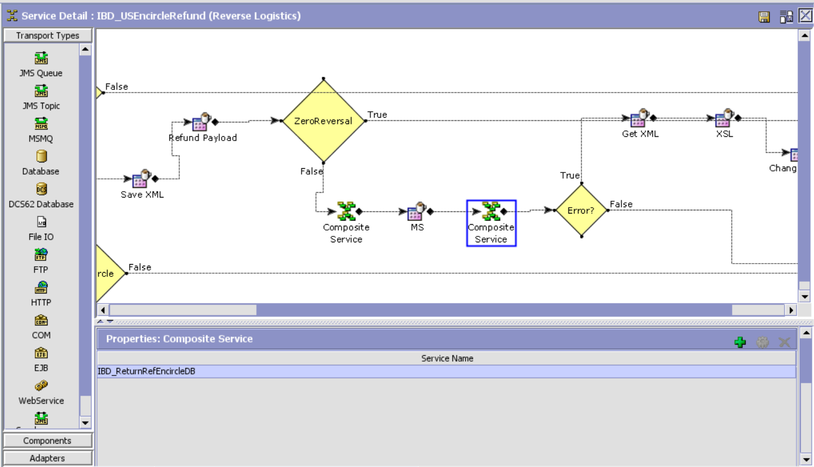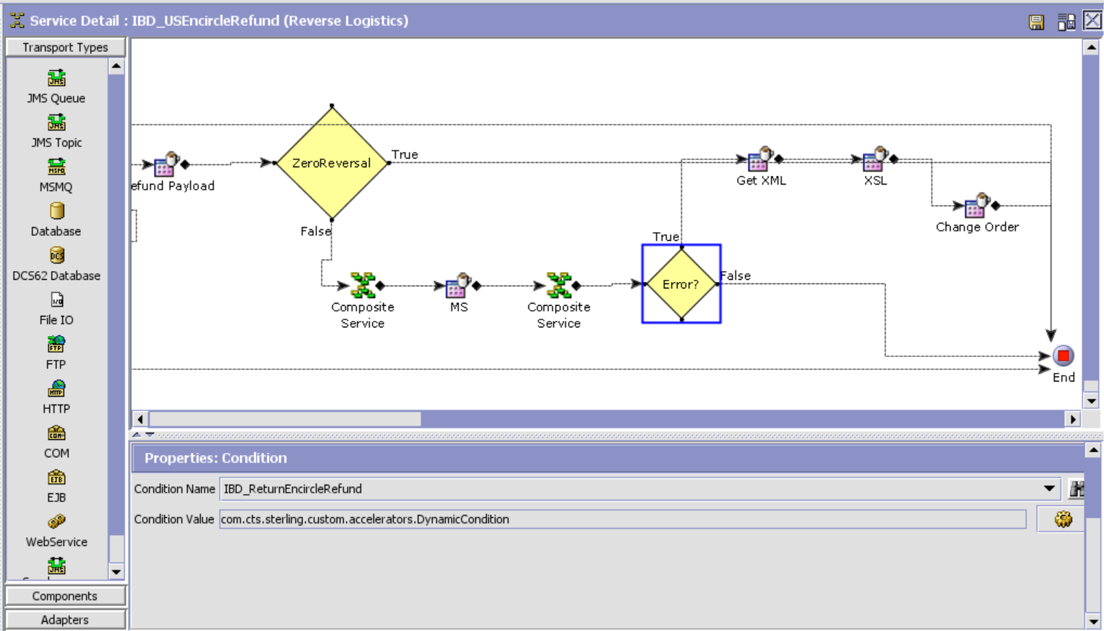

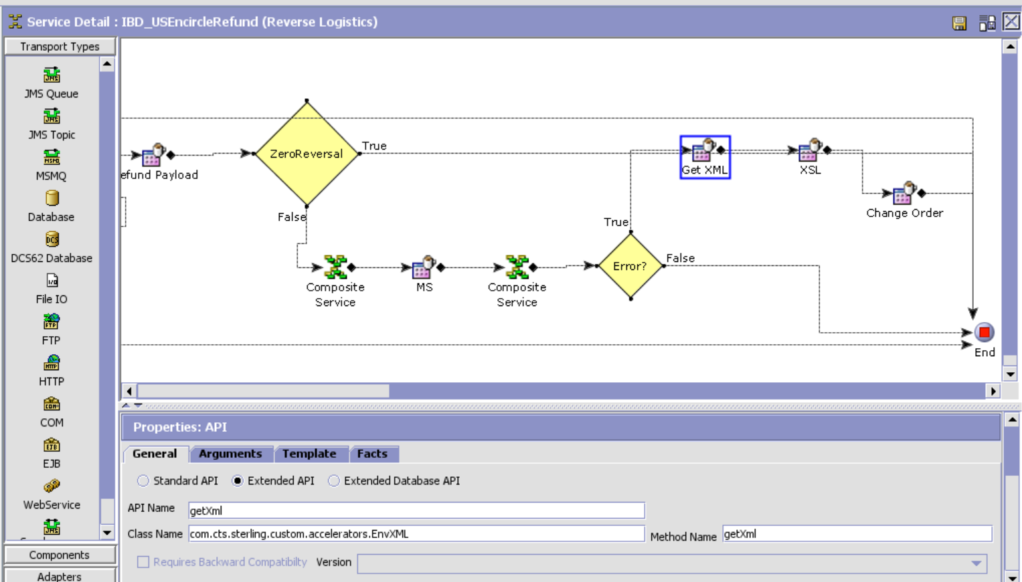

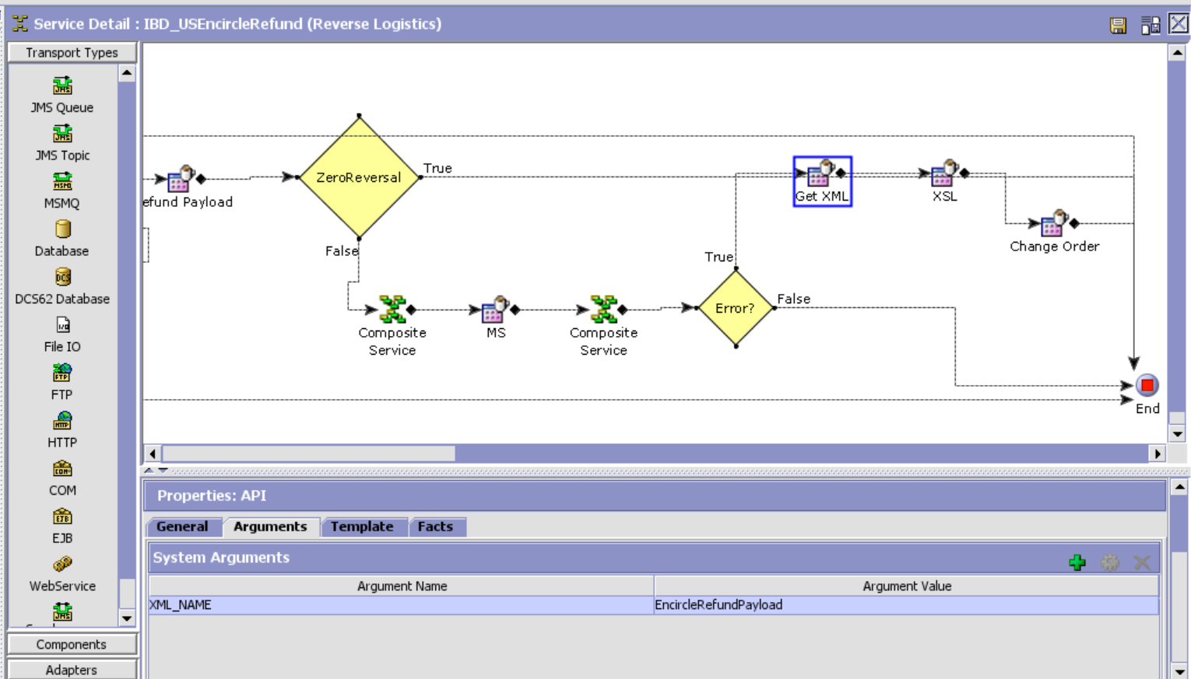

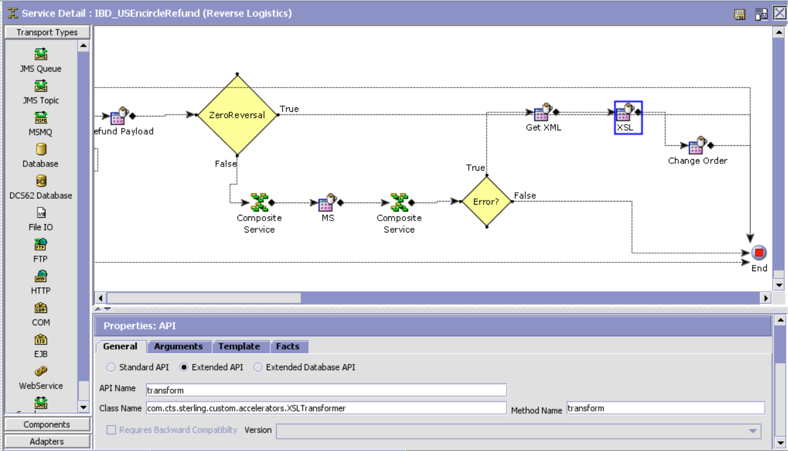XSL Template:

<xsl:stylesheet version="1.0" xmlns:xsl="http://www.w3.org/1999/XSL/Transform">

<xsl:template match="/">

<xsl:element name="Order">

<xsl:attribute name="OrderNo">

<xsl:value-of select="Response/Order/@OrderNo"/>

</xsl:attribute>

<xsl:attribute name="Action">MODIFY</xsl:attribute>

<xsl:attribute name="DocumentType">0001</xsl:attribute>

<xsl:attribute name="EnterpriseCode">TITAN_US</xsl:attribute>  
 <xsl:attribute name="Override">Y</xsl:attribute>  
 <xsl:element name="OrderHoldTypes">  
 <xsl:element name="OrderHoldType">  
 <xsl:attribute name="HoldType">EN_REFUND_HOLD</xsl:attribute>  
 <xsl:attribute name="Status">1100</xsl:attribute>  
 </xsl:element>

</xsl:element>  
 </xsl:element>  
</xsl:template>

